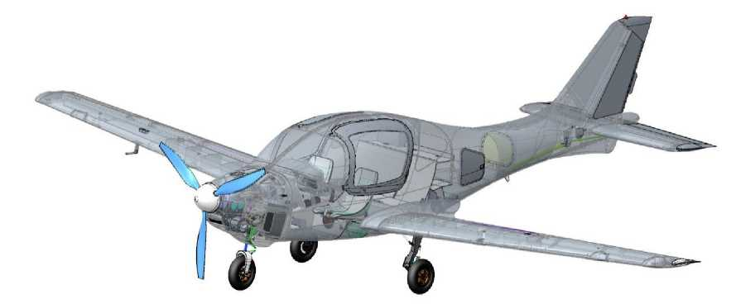

**ANG-01**

**MANAGEMENT**

**MAINTENANCE MANUAL**

**ON THE TECHNICAL OPERATION OF THE AIRCRAFT**

(Aircraft Maintenance Manual)

**ANG.01.AMM.02**



**INFORMATION ABOUT THE DOCUMENT**

**Title:** ANG-01 Aircraft Maintenance Manual

**Designation:** ANG.01.AMM.02 (Revision 2)

**Developer:** ANG Patriot-Ukraine LLC (Brovary, Ukraine)

**Purpose:** the document regulates specific rules for the operation and maintenance of the ANG-01 aircraft.

**Applicability:** ANG-01 series 1 aircraft

**Change registration sheet**

|  |  |  |  |  |
| --- | --- | --- | --- | --- |
| Editorial/Change | Page number | | | Date. |
| Changed | New | Canceled |
| Version 1  Change 0 | - | - |  | May. 18/2020 |
| Version 2  Change 0 | 2,3,4,5,7,9,18,20,23,28,34,35,38, 39,55,56,58,84,86,90-95 | 101-120 | - | June. 23/2020 |
|  |  |  |  |  |
|  |  |  |  |  |
|  |  |  |  |  |
|  |  |  |  |  |
|  |  |  |  |  |

**Sheet of approval from the CAA**



TABLE OF CONTENTS

INFORMATION ABOUT THE DOCUMENT 2

SECTION1. INTRODUCTION 4

Definition of terms 6

Abbreviations. 7

SECTION2. DESIGN DESCRIPTION 9

* 1. Classification, purpose of the aircraft 10
  2. Types of order, equipment 10
  3. General information 11
  4. Fuselage 12
  5. Wing and mechanization 18
  6. Control system 21
  7. Power plant 23
  8. Chassis and hydraulic system 31
  9. Electrical system 35
  10. Instrumentation equipment 36
  11. Power tools and rescue equipment 44
  12. Ground equipment 48
  13. Stencils, signs 50

SECTION3. OPERATIONAL RESTRICTIONS 53

* 1. Weight and centering 54
  2. Wing control system and mechanization 55
  3. Power plant 56
  4. Conditions of the base 57
  5. Transportation 57
  6. Resources and service life 58

SECTION4. AIRCRAFT OPERATION 59

* 1. Transportation 60
  2. Assembling the aircraft 63
  3. Aircraft leveling 65
  4. Determining mass and centering 69
  5. Parking and mooring 70
  6. Refueling with fuel and operating fluids liquids 72
  7. Loading crew and luggage compartments 73
  8. Taxiing and taxiing the aircraft 74
  9. Testing the engine 75
  10. Aircraft cleaning and washing 76
  11. Minor repair of the aircraft skin 77
  12. Setting up instrumentation 79

SECTION5. SERVICE REGULATIONS 85

* 1. Frequency of maintenance 86
  2. General requirements for the organization of work 87
  3. Work codes and their content 87
  4. List of works to be performed after the control flight 88
  5. Safety precautions for maintenance work 89
  6. Pre-flight maintenance 90
  7. Line maintenance (A-Check, B-Check) 92
  8. Basic maintenance (C-Check) 95

SECTION6. STDM INFORMATION 99

* 1. Nomenclature of of devices 100
  2. Nomenclature of the tool 101
  3. Nomenclature of of consumables 101

APPENDIX 1 103

APPENDIX 2 105

APPENDIX 3 107



**SECTION 1. INTRODUCTION**

The ANG-01 Aircraft Maintenance Manual (hereinafter referred to as AMM, Aircraft Maintenance Manual or Manual) is available in Ukrainian and English, and the translation is equivalent. The customer (operator) may translate the AMM into another language at his/her own responsibility.

The AMM contains the data necessary for the operation of the aircraft on its composition and functioning of systems, components, and assemblies.

Execution of excavation work not provided for by the AMM or with materials, equipment or tools not recommended in SECTION 6 is the responsibility of the operator.

The AMM is the only operational document that regulates ANG-01 aircraft maintenance, its scope and frequency. The technology of work performance is set out in the form of technological maps.

The legal basis for the operation of the ANG-01 is the national legislation of the country of registration.

An existing AMM is no substitute for competent theoretical and practical training. Failure to comply with the provisions of the AMM, as well as the lack of proper training of maintenance personnel, can lead to aircraft failure, loss of aircraft, or tragic consequences.

Technical personnel are allowed to operate the ANG-01 aircraft with a B1+B2 or B1.3 certificate and only after a detailed study of the available AMM.

The holder of the AMM is the ANG-01 Aircraft Developer, ANG Patriot-Ukraine LLC (Brovary, Kyiv region, Ukraine), which is fully responsible for the timely and correct introduction of all changes and additions to the AMM.

The Developer shall not be obliged to provide the existing Manual in printed form, unless otherwise specified in the Agreement with the Customer.

Current editorial office Guides always available on

[http://www.angpatriotua.com.](http://www.angpatriotua.com/)

Permission to print the Guidelines is granted to third parties. Preferred print format: A4 size.

It is also convenient to have an electronic version of the Guidelines on your tablet or smartphone.

You should regularly (at least once a month) check the ANG-01 Aircraft Developer's website for AMM updates.

You should also regularly check engine and equipment manufacturers' websites for Service Bulletins (SBs),

software updates, and the CAA website of the country of registration of the aircraft for mandatory Airworthiness Directives (ADs). Links to these websites are provided in SECTION 5.

The responsibility for tracking the above information lies with the aircraft operator.

The list of damages that may occur in operation and in which the operation of the aircraft is permitted until the C-check is performed is given in APPENDIX 1.

The list of malfunctions with which the aircraft is allowed to operate before maintenance (MMEL, Master Minimum Equipment List) is given in APPENDIX 2.

AMM amendments and supplements are issued instead of or in addition to the existing material in the form of separate standard sheets.

These changes or additions are noted in the Change Registration Sheet, marked with a vertical line in the fields to the right opposite the changed part.

In the lower left part of the amended page, in the line of the Revision number, the text "Amendment" with the revision number is placed. Also, instead of the revision number and the date of the previous revision/amendment, a new revision/amendment number with the new date is placed.

In the printed version of the Guidelines, the previous version of the changed page is removed and destroyed.

**WARNING:** The operation of the ANG-01 airplane without AMM, Formulary and Logbook is PROHIBITED.

**Definition of terms**

Information that is critical or of particular importance is indicated by CAUTION, WARNING, and NOTE in bold, capitalized type. The importance of the instructions is further emphasized by the color-coding (red, brown, and green, respectively) of the block of text. Each of these terms is defined below.

**CAUTION**: means that failure to comply with the relevant procedure or conditions may

cause harm to health.

**WARNING**: means that failure to follow the appropriate procedure or

conditions can cause damage to the aircraft.

**NOTE**: draws attention to the special circumstances in which it is necessary to

emphasis, provides the necessary information and explanatory material.

All numerical values are given in the metric system.



**Abbreviations.**

ACK-Aircraft control knob (aitcraft control knob)

AD-Airworthiness Directive;

ADAHRS-Sensor for speed, altitude, angle of attack and position angles

AFM-Flight Operations Manual

AMM - Technical Operation Manual

ALB-Aircraft Logbook

ANL-Airborne nav light

AS-Automatic speed

CAA-Competent authority (Civil Aviation Authority)

CAS-Calibrated airspeed indicator (calibrated)

CI-Control item according to MMEL (Control Item)

CB-Circuit breaker - automatic circuit breaker

CG-Center of gravity of the aircraft

CS-23-Airworthiness standards

ECK-Engine control knob (engine control knob)

ECU - Engine control unit

EMS-Engine monitoring unit

ELA-Light aircraft

ELV-Elevator control (elevator)

EOM-Engine operation mode

ISA-International Standard Atmosphere

MAC-Middle Aerodynamic Chord of the wing

RDR-Directional control (rudder)

SB-Service Bulletin

GNSS-Satellite navigation system (global nav satellite syst)

SP-Plane of symmetry of the plane (symmetry plane)

STB-Horizontal stabilizer (stabilizer)

STDM-Spare tools, devices and materials

STROBE - Onboard flashing light

TK-Technology card (technology kard)

VPP-Variable pitch propeller (variable pitch propeller)



The page is intentionally left blank



**SECTION 2. DESCRIPTION OF THE DESIGN**

**DESCRIPTION  
CONSTRUCTIONS**

TABLE OF CONTENTS

* 1. Classification, purpose of the aircraft of an airplane 10
  2. Types of order, equipment 10
  3. General information 11
  4. Fuselage 12
  5. Wing and mechanization 18
  6. Control system 21
  7. Power plant 23
  8. Chassis and hydraulic system 31
  9. Electrical system 35
  10. Instrumentation equipment 36
  11. Power tools and rescue equipment 44
  12. Ground equipment 48
  13. Stencils, signs 50

**Introduction**

The section defines the classification and purpose, equipment options of the ANG-01 aircraft, information on its design and functional purpose of its main components.

The text and graphic material presented is sufficient to present the design of the ANG-01 aircraft for its proper maintenance.



* 1. **Classification, purpose of the aircraft**

The ANG-01 belongs to the ELA1 class (with a maximum takeoff weight of up to 1200 kg).

The ANG-01 airplane of normal category, not for acrobatic use, is designed to carry up to 5 people (including up to 2 pilots) in non-commercial recreational or route flights, during the day, in simple meteorological conditions.

* 1. **Types of order, equipment**

Depending on the order, the ANG-01 aircraft can be delivered in different types of orders:

* Aircraft (fully assembled, on which the Manufacturer has performed all acceptance testing procedures);
* KIT-kit (a set of parts, components and assemblies for self-assembly of the aircraft by the Customer).

The configuration of each individual ANG-01 airplane (or group of airplanes) for all types of orders is specified in the Agreement between the Manufacturer and the Customer.

The set of documentation for all types of orders includes:

|  |  |  |
| --- | --- | --- |
| *-* | Aircraft Flight Manual | ANG.01.AFM.02 |
| - | Aircraft Maintenance Manual | ANG.01.AMM.02 |
| *-* | Aircraft Formular | ANG.01.AFR.02 |
| - | Aircraft Log book | ANG.01.ALB.02 |
| *-* | Operators manual | for Rotax 915 iS3A |
| *-* | Engine Log Book | for Rotax 915 iS3A |

A complete list of documentation is provided in Section 2.2 of the Aircraft Form ANG.01.AFR.02.

In addition, when ordering the ANG-01 aircraft as a KIT kit, the documentation set also includes the KIT Assembly Manual ANG.01.SM.02.

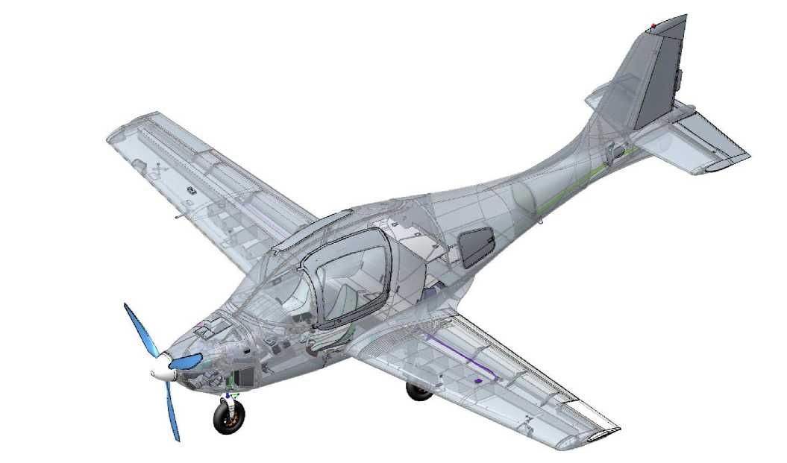

* 1. **General information**

The ANG-01 airplane is a normal aerodynamic design, a strutless low-wing aircraft with a fuselage, deck tailplane, and trapezoidal wing.

Steering surfaces: two-section elevator (electrically driven trimmer on the right section), single-section ailerons, single-section directional rudder (with trimmer plate). All surfaces with aerodynamic horn compensators.

Wing mechanization: two-section flap.

Landing gear: retractable in flight, three-pillar, with a nose steerable prop.

Powerplant: single piston engine, pulled by a 3-blade variable pitch propeller.

General view of the airplane (the skin is made translucent):

The main geometric dimensions of the ANG-01 aircraft required for its operation and maintenance are reflected in the AFM.



* 1. **Fuselage**
     1. Constructional scheme

The fuselage has a variable cross-section close to a rectangular shape. The engine compartment is located in the nose, the central part has a leaky cockpit (for pilots and passengers) and luggage compartment, and the tail has the fuselage.

General view of the fuselage:

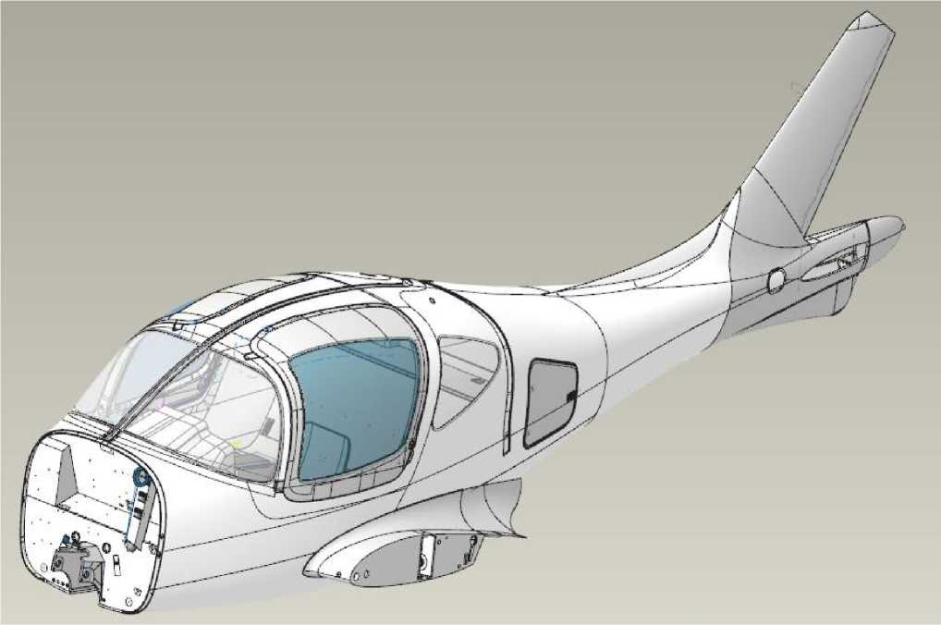

To enter and exit the cab, there are two doors on the left and right sides that open forward and upward, they are also emergency exits (checks on the door hinges). Access to the luggage compartment is through the hatch behind the cab (on the port side).

Glazing: the front of the cab is equipped with a two-section fixed lamp, on the sides the glazing is mounted in the doors, in the rear part of the section of fixed glass in the passenger area.

The fuselage is made entirely of sandwich composite (carbon fiber, foam, and binder).

Structural and power scheme: a monocoque made of one piece with vertical plumage, the supporting skin is supported by a power kit, which is its only integral structure:



**DESCRIPTION  
CONSTRUCTIONS**

* of the frames;
* wing spar box;
* front and rear fuselage irons ;
* nose landing gear niche and center armrest;
* pilot, passenger and luggage compartment floors;
* beam of the pilots' seats;

Longitudinal section of the fuselage:

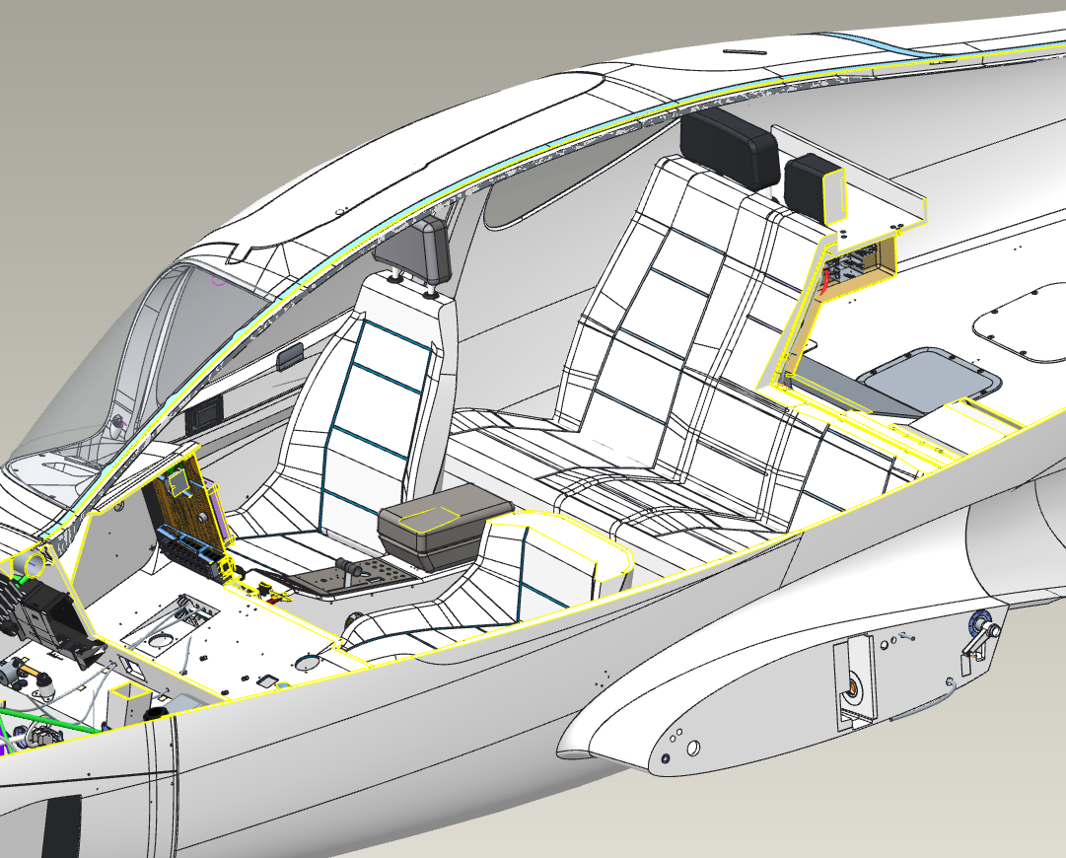



* + 1. Engine compartment layout

The compartment contains the engine with gearbox, injector, turbine, muffler and engine cooling systems (oil and water radiators), generators, air filter box with flap, air and oil filters.

In addition to the engine components, the engine compartment also houses the pipelines and air intake to the cab, the cab heating system, the hydraulic power plant, and the chassis brake components.

The front chassis support is located in the lower area of the compartment, on the protruding box of the niche. The battery is located in a separate compartment.

The engine is mounted on a welded steel engine frame through shock absorbers, which is fixed to the power frame No. 1 (with a fireproof coating).

The engine compartment is closed by upper and lower hoods, which are fixed to the frame No. 1 and to each other by rails and locks of the "Juice" type.

The cowls have a hole for the propeller shaft (integrated into the propeller rotor), a cutout for the front landing gear support, and separate air intakes for the coolant and oil radiators.

General view of the engine compartment:

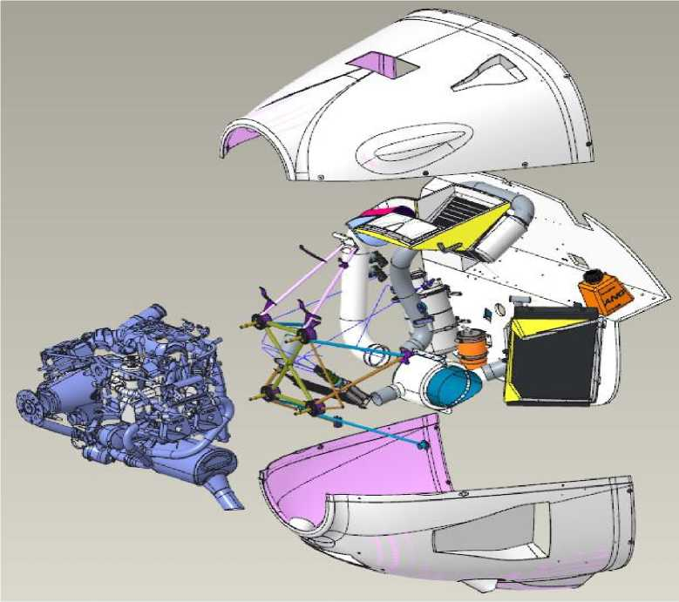



* + 1. Layout of the central compartment (cab)

The cockpit is five-seat, with 1 or 2 pilots seated side by side in the front, and 1 to 3 passengers on the rear sofa. The cabin is not airtight and is equipped with ventilation and air heating.

In the forward area of the cockpit (between the headlamp and the pilots' footwell, behind the No. 1 frame, offset to the left), there is an equipment niche. It contains screen systems, backup flight instruments, flight navigation and radio communication equipment, consoles, and toggle switches. All of this equipment is mounted on the instrument panel, which is fixed in this niche. The niche provides ventilation and heat dissipation, which is released during the operation of the devices.

The niche also contains the piping for the cabin ventilation system. Offset to the right is the small trunk ("glove compartment" for small items and documentation). On the partition of the small trunk is a fuse box for the aircraft's electrical system.

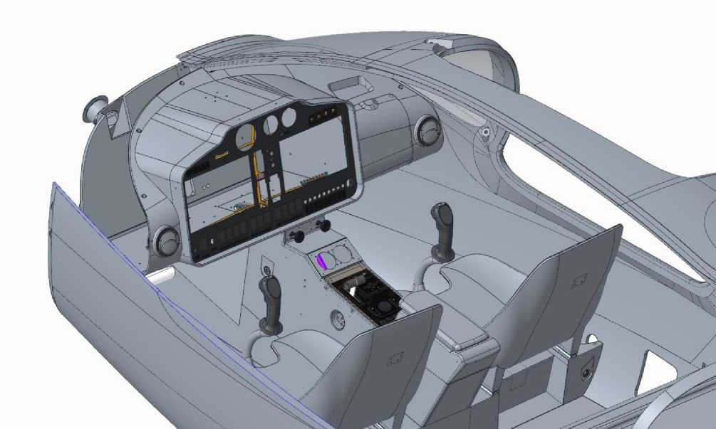

General view of the front and center areas of the cab (without installed units and equipment):

In the central area of the cockpit, at the bottom, on the pilots' seat beam, the pilots' seats are mounted (on pitch and roll actuators). In the lower part of the beam, the elements of the mechanical control system and the autopilot servos are mounted.

The central armrest is located in the central area of the cockpit, in the middle between the pilots. It houses the intercom, landing gear release/removal panel, crane and backup landing gear release cylinders (in the armrest), and electrical harnesses.

For access to the wing console fasteners during their installation, there are hatches on the sides in the lower part of the central area.

In the rear area of the cabin, there is a passenger sofa, under which the wing spar box passes. Behind the back of the sofa, which separates the passenger and luggage areas, there are ADAHRS sensors of the flight and navigation complex and a consumable fuel tank with two electric pumps.

There is a service hatch in the passenger floor (access to the aneroid membrane line and electrical harnesses). The passenger seat has a service hatch (access to the aneroid and fuel lines, electrical harnesses, control rods and rockers, flap shaft and flap actuator).

There is a luggage compartment in the rear of the center compartment.

There are service hatches in the luggage compartment floor and rear area of the luggage compartment (on the No. 2 frame) (access to the control rods and rockers and electrical harnesses).



* + 1. Layout of the tail section

**DESCRIPTION  
CONSTRUCTIONS**

The compartment contains vertical and horizontal winglets with control surfaces, a fixed vertical stabilizer with directional control, and a tail fairing.

Vertical winglets: arrow-shaped, symmetrical profile, made in one piece with a fuselage made of fiberglass composite materials (to ensure radio transparency, as it houses the radio communication antenna). Structural and power scheme: single spar monocoque, without nerves. On the spar, in the rear part of the keel, there are 2 brackets for the rudder hinge assemblies.

Horizontal winglets: arrow-shaped, asymmetrical profile, one-piece construction, glued into the fuselage, made of fiberglass composite materials. Structural and power scheme: single spar monocoque, with two nerves. On the spar, in the rear part of the stabilizer, there are 3 brackets (during the manufacture of the spar) of the rudder hinge assemblies for the left and right sections. The middle hitch assembly is common to both sections.

Hatches are symmetrically located in front of the plumage, on the left and right sides of the aircraft (access to the control system and electrical harnesses and to the spars No. 4 and 5). The ANL tail is mounted on the fuselage skin in the tail area.



* 1. **Wing and mechanization**
     1. Constructional scheme

The wing of the airplane is trapezoidal in plan, without geometric torsion.

Structural and power scheme: two-cantilever, monocoque, single spar, with a rear wall and an onboard nerve center.

The wing consoles are made entirely of sandwich composite (carbon fiber, foam, and binder). The upper and lower spar shelves are made of carbon fiber rods with a square cross-section.

* + 1. Layout

Structurally, the wing is made of left and right consoles, with the spars integrally integrated into them. Two aileron hinge brackets and four wing flap rails are molded to the rear wall of each cantilever during the skin manufacturing process.

The consoles contain the control system aileron rods and oscillators, flap drive shaft, and wiring harnesses (ANL). The right console also contains the Pitot tube elements: wiring harnesses (heating controller and Pitot tube pneumatic line).

To service the elements in the consoles, there are 2 hatches on the lower surface.

In the middle part of each console, there is one fuel tank. In the upper part of the consoles is the neck of the corresponding caisson tank.

Sectional view of the wing console (without installed elements):

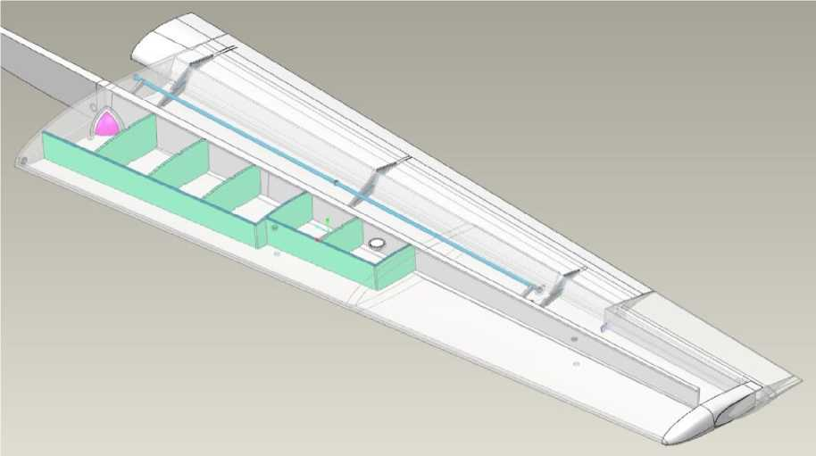



The consoles are mechanically connected to the fuselage in the spar box and fuselage tie-ins (by specially designed steel elements). The front assembly of the consoles is also attached to the fuselage with special steel elements.

Fastening of consoles:

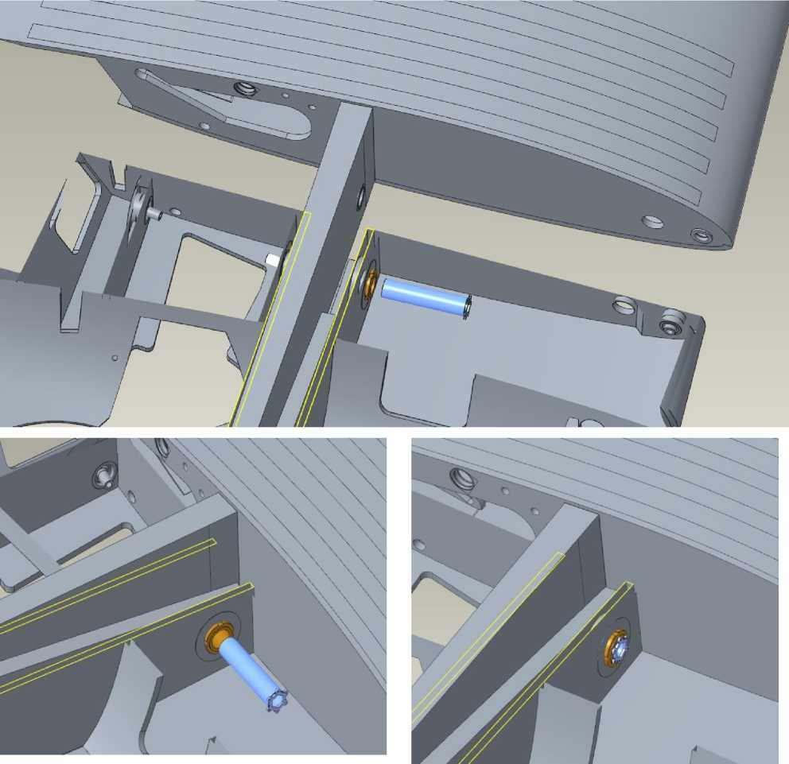

The consoles are secured together by a steel fixing bolt, which is fastened with six fixing screws. The fixing bolt connects 5 holes to each other.



* + 1. Mechanization

Mechanization of the trailing edge of the wing: Fowler flap (single-slide, retractable), with a maximum deflection angle of 30°. Intermediate positions are 10° and 20°.

The flap is released and retracted by a servo located in the fuselage and the corresponding part of the shaft (connected to the consoles during their installation).

Flap release and cleaning system:

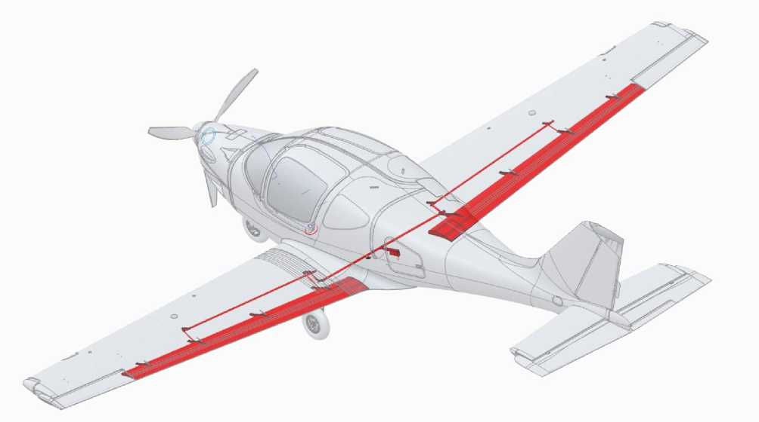

Flap release and retraction control is performed from the *EFC67-P* console designed and manufactured by *Microel s.r.l. (Italy),* see section 2.10.7 for location:

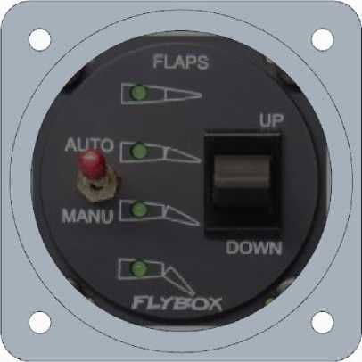



* 1. **Control system**

The control system of the aircraft is traditional, 3-channel: longitudinal channel (elevator), transverse channel (ailerons) and path channel (directional control).

The control system is mechanical, consisting of controls (ACK and left and right pilot pedals, which are mechanically interconnected), mechanical elements (rods and rockers) and steering surfaces.

All rods and rockers of the control system are made of composite materials. There are no cables or spring devices in the system.

All joints of the control system are equipped with spherical bearings.

All control surfaces are single-slotted, equipped with aerodynamic horn and weight compensation. The elevator is two-section, while the ailerons and rudder are single-section. To increase efficiency, the elevator is equipped with special turbulence generators.

An electric trimmer is mounted on the right section of the elevator to reduce the effort required to deflect the ACK (controlled by a button on the ACK).

A trimmer plate is installed on the directional rudder for track balancing during cruise speed flight.

Autopilot servos are installed in the longitudinal and lumbar channels of the control system.

General view of the control system in the longitudinal channel:

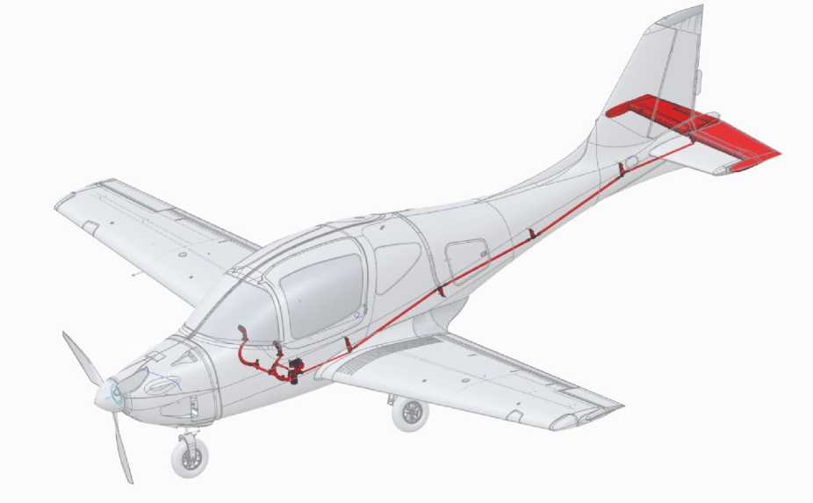

General view of the control system in the lumbar canal:

General view of the control system in the track channel:

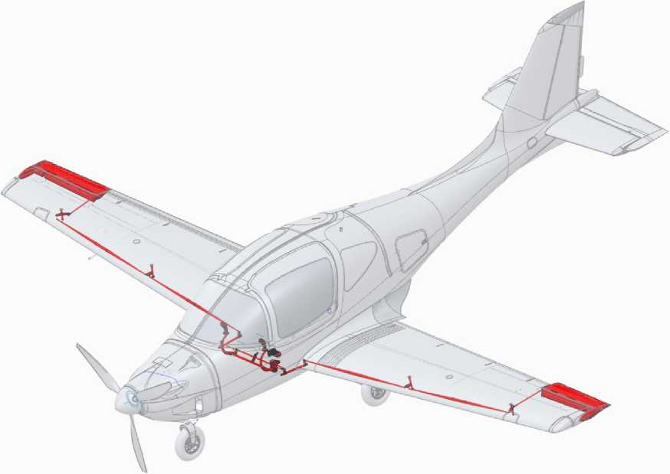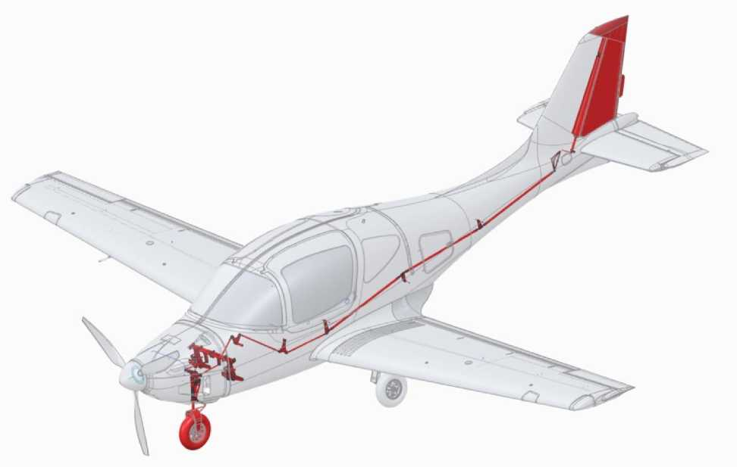



* 1. **Power plant**

**DESCRIPTION  
CONSTRUCTIONS**

* + 1. Engine.

*The Rotax 915 iS 3A* engine was developed and manufactured by *BRP-Rotax GmbH (Austria*): piston, gasoline, 4-stroke, 4-cylinder, with an opposed cylinder arrangement.

Engine power (nameplate, in ISA):

* Maximum mode: 104 kW (141 hp) at 5800 rpm;
* Rated output: 99 kW (135 hp) at 5500 rpm.

Propeller drive through a reduction gearbox with a gear ratio of 2.47. Fuel-air mixture is created by injection. To increase power, the engine is equipped with a turbocharger and intercooler.

The engine cooling system is combined: liquid cooling of the cylinder heads and air cooling of the cylinders. The engine is equipped with a closed-loop lubrication system.

The complete *BRP-Rotax* engine kit and detailed engine design are described in the Engine Manual "Operators manual for Rotax engine type 915 I A series".

The main units of this set:

* Engine;
* Gearbox;
* Injector (1 per 2 cylinders), receiver;
* The throttle valve;
* Intercooler (radiator);
* Turbocharging with a gas exhaust valve;
* Silencer;
* Ring gear motor;
* Oil tank;
* Oil filter;
* The pump is lubricated;
* Coolant pump;
* Air, oil, and fuel pipelines;
* Electric starter;
* Generator;
* Starter relay;
* Generator rectifier regulator;
* Engine fuse box;
* Engine control and monitoring unit (ECU);
* Sensors (shaft speed, cylinder head temperature, exhaust gas temperature, oil temperature and pressure, throttle position, alternator terminal voltage, etc.).

Composition of equipment not included in the engine kit:



* The radiator is oil-filled;
* Coolant radiator;
* Coolant overflow tank;
* Lubricant and coolant pipelines;
* Fuel system pipelines;
* Pipeline of the cab heating system;

Casing of the cab heating system;

* Fuel filter;
* Air filter;
* Intercooler box flap;
* Intercooler box;
* Oil system thermostat;
* Thermostat of the liquid cooling system;
* Fuel pressure sensor;
* Master relay.

General view of the engine kit with equipment (blue color shows the units of the engine kit, green color shows the equipment not included in the engine kit):

View from the left:

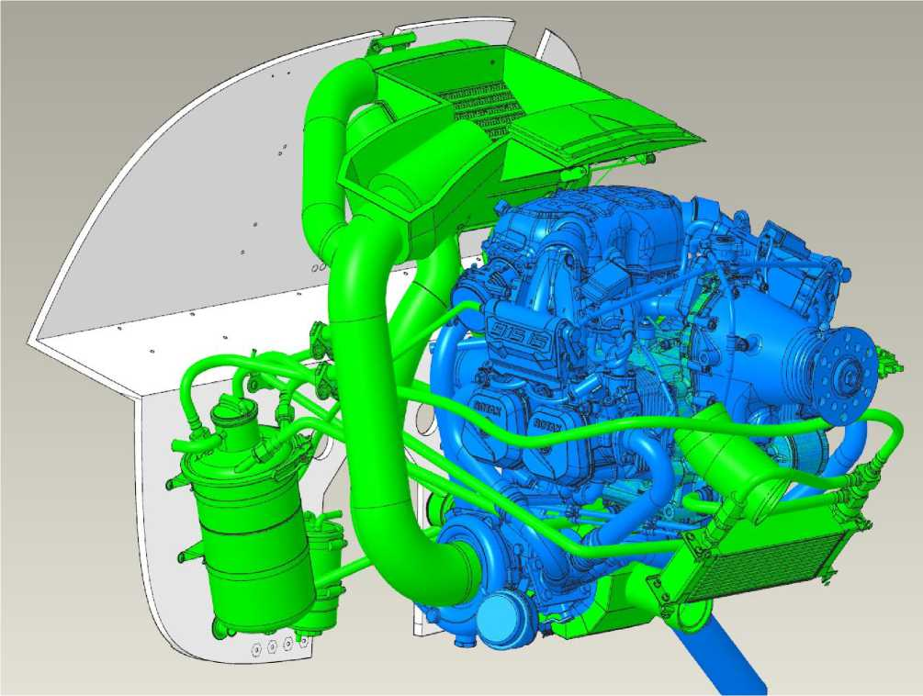

The view from the right:

**DESCRIPTION  
CONSTRUCTIONS**

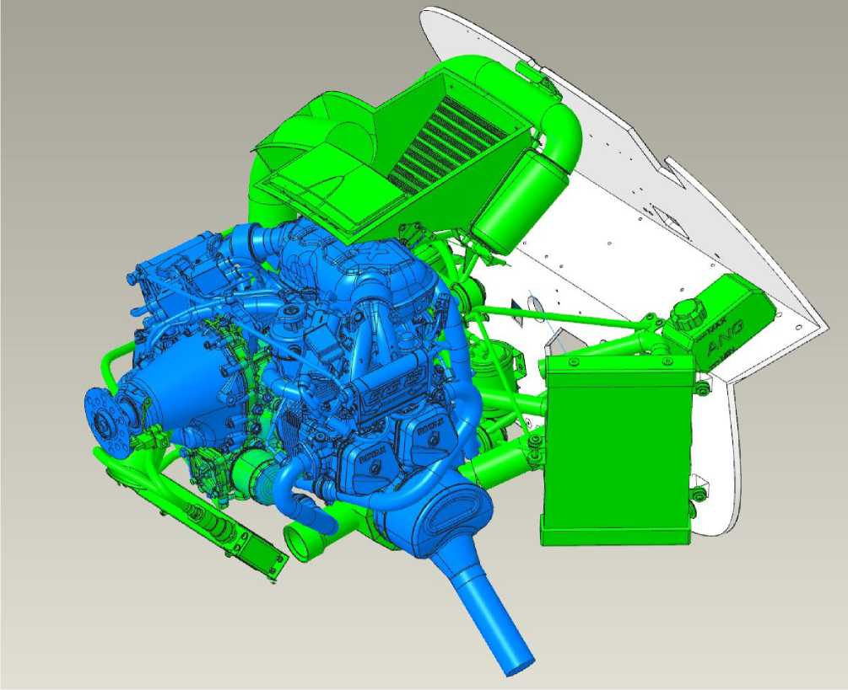

* + 1. Air screw

The propeller is an in-house developed and manufactured ANG propeller with a diameter of 1820 mm. The propeller is a torsionally rigid, three-blade, variable pitch.

The blades are made of composite materials, the leading edge is protected from mechanical damage by a polyurethane cover. The blades are not heated.

Elements of the propeller:

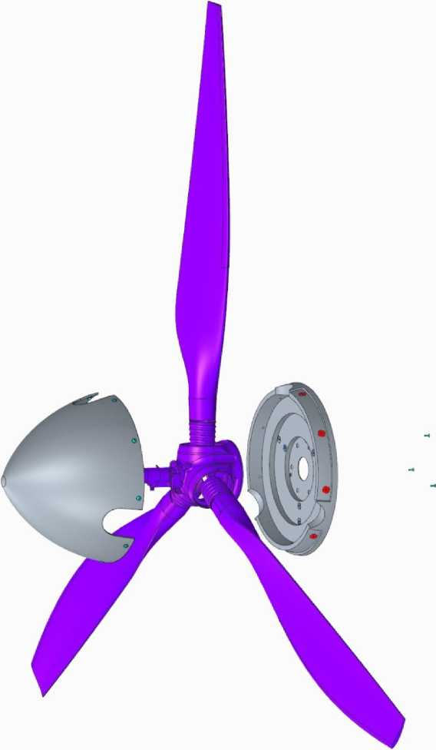

Aluminum alloy bushing with a mechanism for changing the pitch. The pitch control actuator is electric and is located on the bushing (under the roll). The pitch control signal is transmitted to the actuator from the setpoint (in the cab) via a sliding contact.

* + 1. Management and control bodies

To control the power plant, the crew is provided with current information:

* Engine speed;
* Temperature of the cylinder heads (rear);
* Exhaust gas temperature;
* Coolant temperature;
* Lubricant temperature;
* Lubricant pressure;
* Air pressure in the receiver;
* Throttle position;
* Instant fuel consumption ;
* Fuel pressure in the engine fuel ramp;
* Fuel remaining in the tanks (total);
* Voltage at the battery terminals;

Total engine operating time (hours).

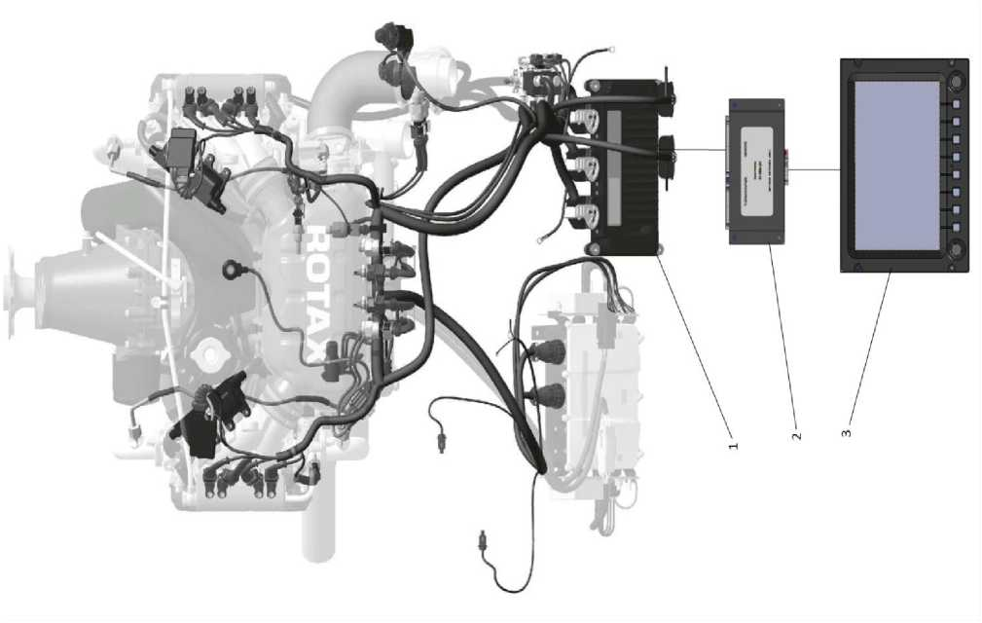To display this information, the ECU receives it from the engine sensors and additional sensors and transmits it via the CAN bus to the EMS unit for display on the multifunctional displays of *the Dynon SkyView SV1100* system:

**DESCRIPTION  
CONSTRUCTIONS**

The displays also show alarms of emergency parameters of the power plant, the *Dynon SkyView SV1100* system generates the appropriate sound alarm and transmits it to the on-board communication system.

Power plant controls in the cockpit:

* Throttle control knob (ECK);
* Screw control panel.

The ECK is mechanically connected to the throttle by a cable. The ECK is mounted on the center armrest between the pilots. All other engine control commands are executed by the ECU. Next to the ECK is a stencil that clearly indicates the purpose of this engine control ("TRUST LEVER"), the relative scale and the minimum and maximum positions ("MIN" and "MAX"). See section 2.10.7 .for the location of the ECK and stencil

The control panel for the PR-1 variable pitch propeller (see Section 2.10.7 for location), designed and manufactured *by Microel s.r.l. (Italy)*, operates in manual and automatic modes, switched by a toggle switch on the panel. In the manual mode, the pilot sets the required engine speed with a setpoint (crematorium), which in the automatic mode is set and maintained by the ECU depending on the throttle position. Then the electrical control signals are transmitted to the VPP control relays, which are transmitted to the electric drive via a sliding contact. The control panel is equipped with a screen that displays the set engine speed.

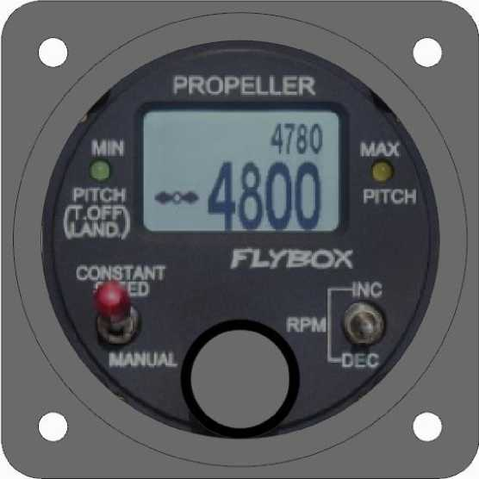

* + 1. Fuel system

**DESCRIPTION  
CONSTRUCTIONS**

The fuel on the aircraft is placed in two cantilevered caisson tanks (110 liters each) and one consumable fuselage tank (70 liters each). Thus, the maximum total capacity of the fuel system without taking into account the undrained residual is 290 liters.

The consumption tanks are located between the passenger sofa and the luggage compartment of the central fuselage compartment below, so the fuel from the console tanks flows into them by gravity.

The fuel tank is equipped with 2 interchangeable constant-flow pumps of the MAM00023M type (designed and manufactured by *Magnetti Marelli, Italy)*, which also have a built-in fuel level sensor (fuel gauge). They pump fuel to the fuel filter located in the engine compartment and then to the engine injector through the injection pipeline located between the cockpit subframe and the lower fuselage skin along the plane of symmetry and to the right of the landing gear niche box.

Schematic of the fuel system:

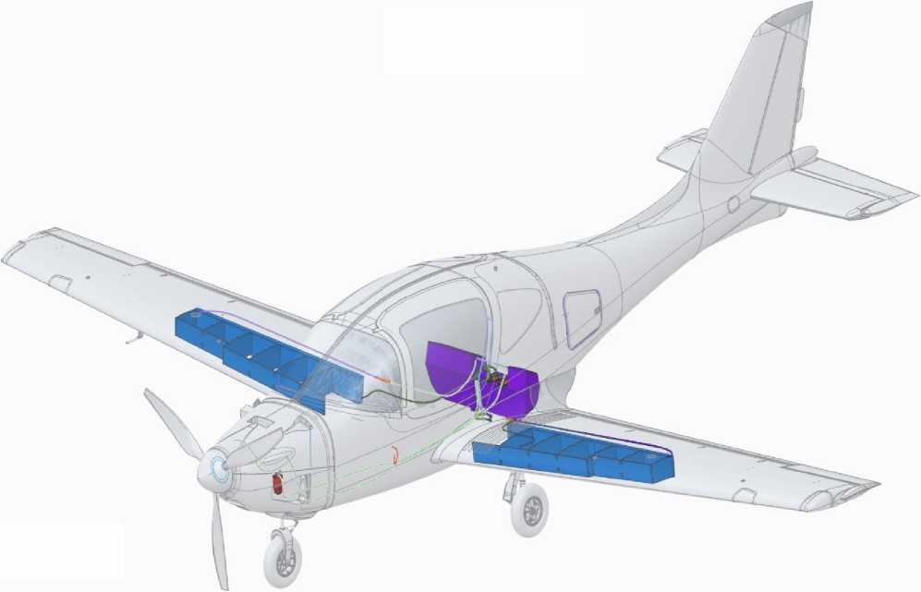

Excess fuel is drained back into the consumption tank from the injector fuel ramp via a drain line, which is also located between the cockpit underframe and the lower fuselage skin on the SP and to the left of the landing gear niche box.

Drainage in the console and consumption tanks is made centrally, U-shaped tube (to prevent fuel spillage into the central compartment)



is discharged to a pipe under the fuselage. In cantilevered tanks, additional drainage is provided through the holes in the caps.

Refueling is carried out exclusively through the necks of the cantilever tanks.

**WARNING:** The use of fuels other than those specified in section 3.3 may damage fuel system and engine connections, piping, and equipment.

The cantilevered caisson tanks and the fuselage fuel tank are an integral part of the wing and fuselage, and their inner surfaces are treated with a special gasoline-resistant sealant.

The fuel system and drainage pipelines are made of aluminum tubes that are fixed to the aircraft structure. In the mast compartment and at the junction of the consoles, the pipelines are made of gasoline-resistant hoses.

The necks of the cantilevered tanks are made of aluminum alloy, equipped with a drainage hole, and can be closed by turning 90° and locking the closed position.

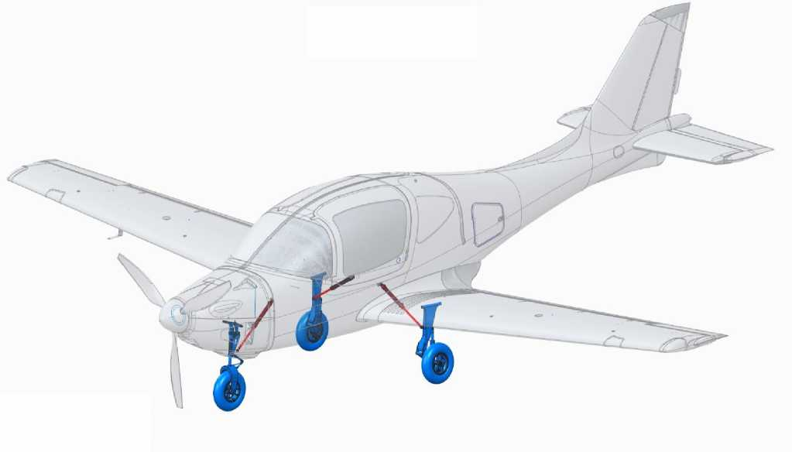

**DESCRIPTION  
CONSTRUCTIONS**

The cleaning and discharge cylinders are of the same design for all supports, differing only in the stroke (shorter for the bow support):

* 1. **Chassis and hydraulic system**
     1. Constructional scheme

The chassis is three-pillar, three-wheeled, with two single-axle main legs and a single-axle nose support.

All the supports are removed in flight: the nose backward along the flow, the main ones under the fuselage across the flow. There are no external flaps.

The nose support is equipped with a centering mechanism for cleaning.

All supports are equipped with gas-oil shock absorbers. The bow support is telescopic, the main supports are lever type.

Bow support with a pivot mechanism, kinematically linked to the steering pedals (wheel rotation angle ±30° at full pedal travel).

All wheels are equipped with cast magnesium disks of ANG type of our own design and chamber pneumatics of the same type and size *MITAS 4.00-6, 400x100 mm (Czech Republic)*.

Fork and upper rocker of the nose support made of composite material.



* + 1. Brakes

The main supports are equipped with hydraulically operated disc brakes, and there is no anti-skid control:

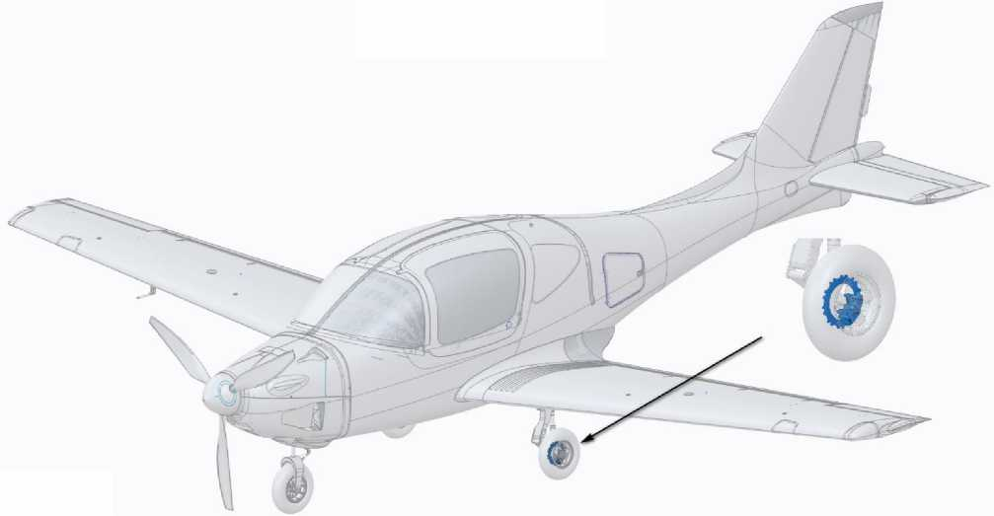

Hydraulic brake lines for automotive brakes: operate without switching on the hydraulic power plant, the tanks are located in the engine compartment.

Braking is performed by pressing the brake pedals, which are located on the control pedals along the course of both the left and right pilots, so that each of them can apply the brakes independently.



* + 1. Release/retrieve control chassis

**DESCRIPTION  
CONSTRUCTIONS**

The position of each landing gear (retracted or released) is monitored by the corresponding green LEDs (red in intermediate positions) on the "LANDING GEAR" landing gear remote control, which is located on the central armrest within reach of both pilots (see section 2.10.7 for location).

LEDs control, position control, switching on the hydraulic power plant and signaling to the footrest actuators are performed by a special electronic device located under the chassis control panel.

The retracted or released position of each support is determined by a hydraulic lock position sensor built into each cylinder.

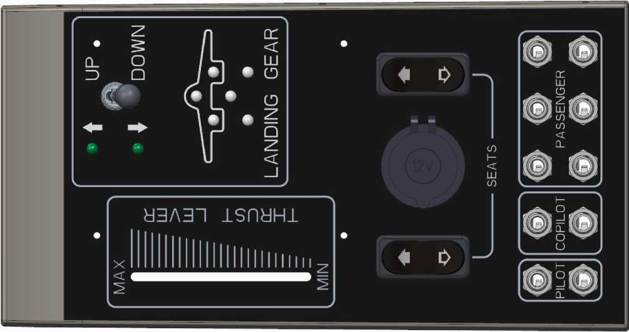

Landing gear control panel (together with pilot seat position adjustment panel and intercom panel):

When the toggle switch on the chassis control panel is turned on and the selected position is locked, the electric drive hydraulic station is switched on for release or cleaning (respectively, in the "UP" or "DOWN" position), the working fluid pressure enters the cylinders on the corresponding side (for release or cleaning). In the event of a malfunction of the hydraulic power plant or a power outage, only the chassis can be released from the backup system. To do this, set the three-position valve (see figure in section 2.8.4) theto outlet position. This opens the fitting of the carbon dioxide cylinder (in the cylinder above the valve), the pressure of this gas moves the spool, closing the pressure line of the power plant and pressing on the outlet cavity of each cylinder.



* + 1. Hydraulic system

The only purpose of the hydraulic system is to ensure the release and cleaning of the chassis.

Pressure source (15 MPa): *SAE J1171 MARINE* electric drive hydraulic station, which is a reverse gear pump in a single unit with a 2.5-liter tank and safety valves.

Hydraulic fluid: *ATF DEXTRON* grease. Hydraulic system pipelines: *HYDROSCAND* oil hoses.

In the fixed position, the release cylinder acts as a rigid rod and takes the load on the supports. The cylinder is released by supplying hydraulic fluid to the opposite spool. The cylinder's closing elements are equipped with position detection limit switches.

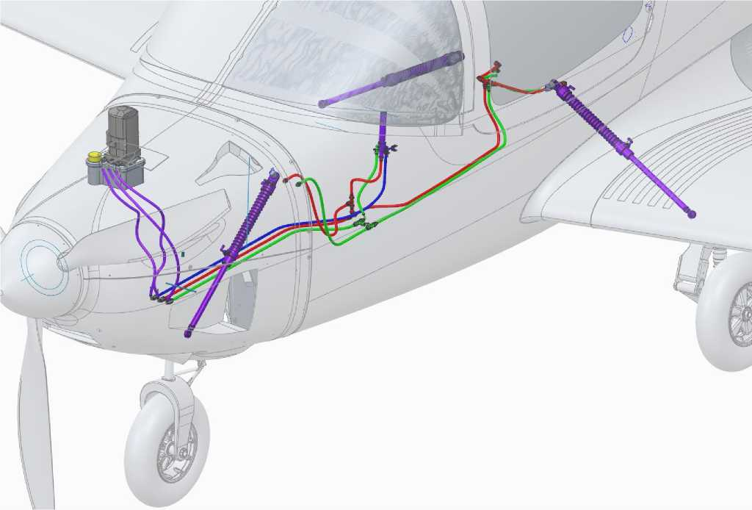



* 1. **Electrical system**

**DESCRIPTION  
CONSTRUCTIONS**

Generator #2 is built into the engine. Generator No. 1 is a source of electricity exclusively for the engine (injector, ignition system, ECU, etc.). Both generators are electrically isolated and mounted on the same stator, each connected to the engine fuse box.

On-board 12 V 24 Ah lithium-iron-phosphate battery (recommended type *YLP24*), located in a separate compartment on the frame No. 1. It is possible to install another battery with similar characteristics and weight and dimensions.

Access to this compartment is through a separate hatch on the right side of the aircraft. The compartment is equipped with terminals for connecting the onboard network and a temperature sensor (for temperature indication).

Power supply to the onboard network from generator No. 2 is possible only after the engine speed reaches 1800 rpm.

In case of failure of generator No. 1, the engine power supply is automatically switched to generator No. 2. In this way, it is disconnected from the onboard consumer network, providing power exclusively to the engine. At the same time, the "WARN EMS" light indicator on the dashboard is activated.

The battery provides power:

* during maintenance: all consumers (30 minutes, in ISA);
* when starting the engine: starter and ECU;
* in flight, in case of generator failures: all consumers (15 minutes, in ISA).

Consumers of power supply - instrumentation according to the section [2.10.](#bookmark49" \o "Current Document)

Diagrams of the aircraft electrical system are given in APPENDIX 3 (divided by functional purpose).



**2.10 Instrumentation equipment**

* + 1. Basic flight and navigation equipment

The main flight and navigation equipment is the *Dynon SV1100* system developed and manufactured by *Dynon Avionics (USA)*.

The material contained in this AMM is sufficient to fully operate the *Dynon SV1100* system, but a separate system manual is available at [http://docs.dynonavionics.com](http://docs.dynonavionics.com/) (*Dynon Avionics* does not provide hard copies of the manual).

Elements of the system:

|  |  |  |  |
| --- | --- | --- | --- |
|  | * Heated pitot tube *Dynon Heated AOA/Pitot Probe* | | (1 pc.); |
|  | * Display. | *Dynon SV-HDX1100* | (1/2 pc.) |
|  | * ADAHRS main module | *Dynon SV-ADAHRS-200* | (1 pc.); |
|  | 1. The ADAHRS module is backup | *Dynon* SV-ADAHRS-201 | (1 pc.); |
|  | * Temperature sensor | *Dynon SV-OAT-340* | (2/3 pcs.) |
|  | * GNSS module | *Dynon SV-GPS-250* | (1 pc.); |
|  | * Motor communication module | *Dynon SV-EMS-221* | (1 pc.); |
|  | * Autopilot remote control | *Dynon SV-AR-PANEL/V* | (1 pc.); |
|  | * Remote control of the radio station | *Dynon SV-COM-PANEL/V* | (1 pc.); |
|  | * Autopilot servo drives | *Dynon SV-52* | (2 pcs.); |
|  | * Transponder | *Dynon SV-XPNDR-261* | (1 pc.); |
|  | * Backup power supply battery | *Dynon SV-BAT-320* | (1/2 pc.) |

Location of the system elements on the aircraft:

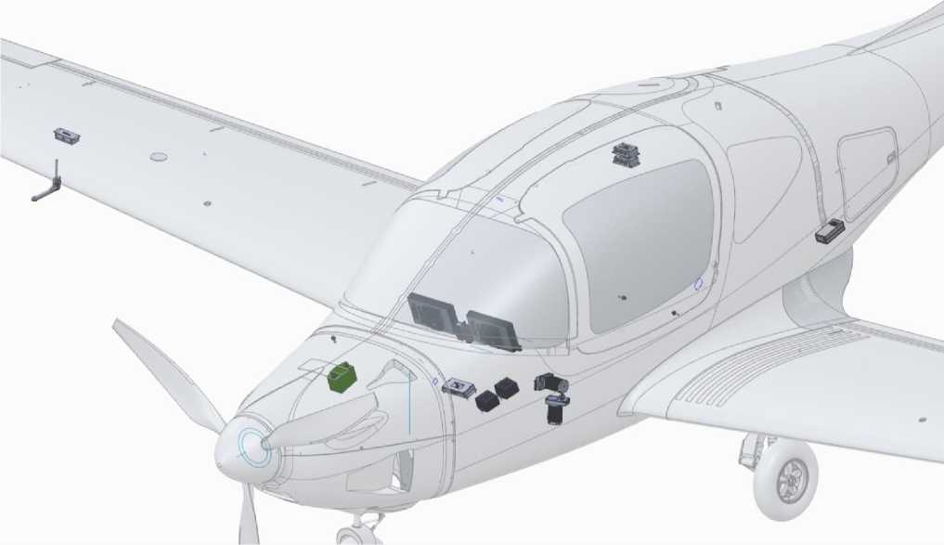

All system elements are interconnected by special interference-proof wires and connectors, the length of the wires does not exceed recommendations of the Dynon SW1100 system developer, all system elements receive 12 V DC power supply from the onboard power supply system, through the generator regulator-rectifier. In case of power failure, the system is equipped with an emergency battery that provides power for 60 minutes (in ISA).

**DESCRIPTION  
CONSTRUCTIONS**

A special fan is designed to remove excess heat from the area behind the dashboard (where the main elements are located).

The Pitot tube is connected the ADAHRS modules by pneumatic tubing. The tubing is heated in case of icing via a suitable controller.

The ADAHRS module is a source of data on instrument and vertical velocity, barometric altitude, and angle of attack due to the aneroid-membrane sensors located in it. The ADAHRS module is also a source of spatial attitude, magnetic heading, and g-force data due to its gyroscopes, magnetometer, and accelerometers. The ADAHRS module is also a source of ambient air temperature data thanks to a separate temperature sensor located in the chassis niche. To increase reliability, the system consists of two ADAHRS modules: a full-featured main module and a backup module with limited functionality (hot standby). Both the main and backup modules are equipped with an outside air temperature sensor. The built-in magnetometer is also used by the system to calculate the wear angle.

The GNSS module is the source of data for the airspeed, altitude relative to the earth's surface, and the position of the aircraft on the map. It receives the current latitude, longitude and altitude from satellite navigation systems with a maximum positioning error of ±1 m (in this version of the GNSS module, only *GPS NAVSTAR* is used).

The EMS module communicates with the system the powertrain data defined in section 2.7.3.

The autopilot module sends command signals to the autopilot servos via the remote control to maintain the set mode.

The transponder sends the necessary aircraft identification data (current position, altitude, registration number, etc.).

When connecting new or replaced devices that are recognized by the system, as well as initially starting the system or calibrating all system sensors or setting up the display of information on the screens, use the recommendations of section 4.12.3.

The color touchscreen displays of the tuch-screen type (see section 2.10.7 for location), interchangeable, interconnected by a CAN bus, are equipped with processors that calculate all received current data and 

display of scales and current pilot, navigation, engine, autopilot, transponder information, as well as aircraft position on the map, flight route, and battery temperature. It can be equipped with a single display and a tablet holder with EFB.

The indicator speed is corrected by the instrument correction (see Section 412.4 for .calibration method).

Information can be displayed in both metric and imperial measurement systems. All defined information can be adjusted for placement on the displays (see section 412.3.).

Recommended layout of scales and segments of flight, navigation, engine and fuel system information for the ANG-01 aircraft (screen layout):

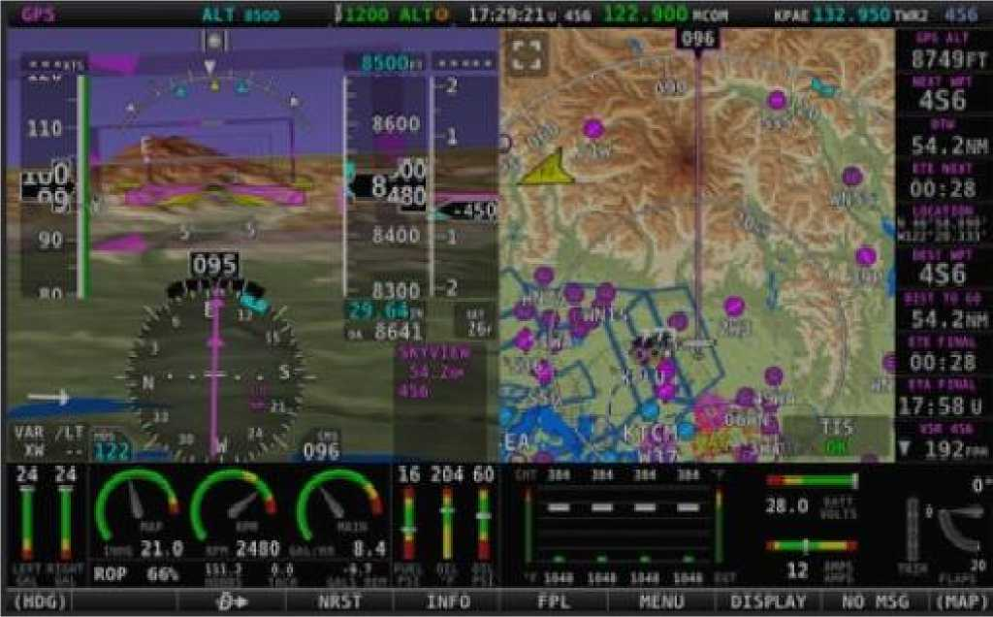

All elements of the *Dynon SV1100* system are protected against electromagnetic interference (including HIRF), mechanical stress, vibration, humidity, water (drop protection), dust and sand, and mold. The operational limitations of the system in terms of these parameters, as well as barometric pressure and ambient temperature, exceed the limitations of the aircraft.

A USB connector is provided for writing off and analyzing this information.



* + 1. Backup pilot equipment

In addition to the main *Dynon SkyVieW SV1100* system, the following backup flight instruments are installed on the aircraft (see Section 2.10.7 for locations):

* Airspeed indicator *FALCON ASI316KN-3*
* Barometric altitude indicator *FALCON ALTN10MBF-3*
* Vertical speed indicator *FALCON VSI10MEF-3*
* Magnetic compass *FALCON CM13L*
* Sliding indicator *FALCON SI-2Q*

The pointers are connected to the Pitot tube in parallel with the ADAHRS sensors of the main system, while the compass and slip indicator operate autonomously.

Signs with scales in the metric system. It is possible to place other signs with scales in the Anglo-Saxon system, which are the same in size and mounting.

The airspeed indicator is accompanied by an instrument correction chart (located on the cockpit light frame).

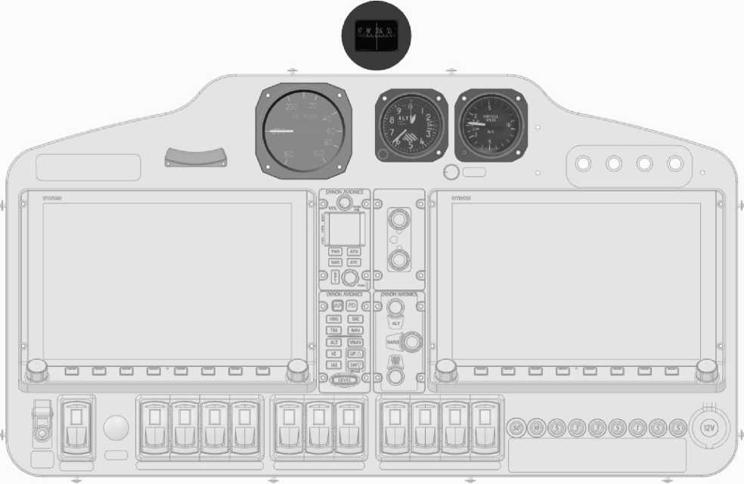The airspeed indicator shows the sectors of the minimum speed limit (red), the maximum operating speed with flaps released (white), and the radial line of the maximum operating speed

General view and location of backup devices:



* + 1. Radio communication equipment

External radio communication is provided by the *Dynon Skyview Com Radio SV-COM-425* shortwave radio station*.* The antenna feeder of the radio is built into the vertical tailplane (the radio is transparent, made of fiberglass). The radio remote control is located on the instrument panel (see Section 2.10.7 for location):

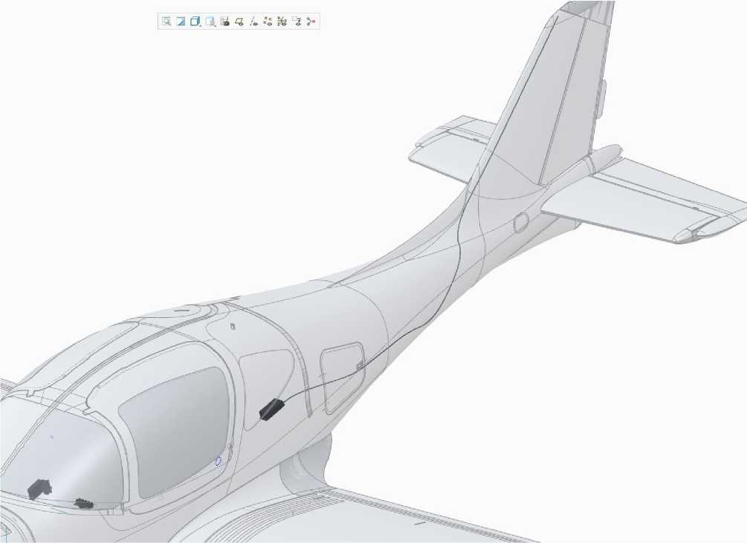

Internal radio communication is provided by a 5-person subscriber node with headset plugs, including an intercom (see section 2.10.7 for location).

*David Clark* headsets are recommended (noise-canceling). Any certified aviation headset is allowed.



* + 1. Lighting equipment

**DESCRIPTION  
CONSTRUCTIONS**

The aircraft is equipped with airborne navigation lights (ANL), flashing lights (STROBE) and LED headlights.

There is no interior lighting for the cockpit, luggage compartment, or instrumentation (the aircraft is designed for daytime flights).

The right and left wing cantilever tips under the transparent fairings have green and red ANLs, respectively, and the fuselage tip (in the tail fairing) has a white ANL.

The STROBE is located on the ends of the right and left wing consoles (in conjunction with ANL), as well as on the top of the directional rudder (separately).

Switching on is performed by separate toggle switches in the cab (see section 2.10.7 for location), and control of the combustion mode is performed by a separate electronic device.

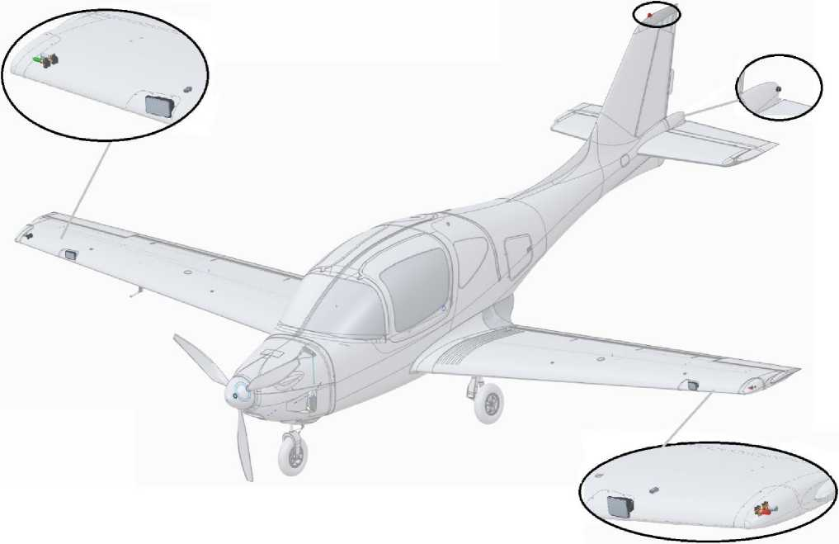

Placement of lighting equipment:



* + 1. Lighting and signaling equipment

There are warning lamps on the instrument panel (see section 2.10.7 for location):

* Circuit A of the ignition system ("CH A" of the "ENG WARN" group);
* Circuit B of the ignition system ("CH B" of the "ENG WARN" group);
* Operation of the engine monitoring system ("WARN EMS");
* Operation of the Pitot tube heating ("PITOT HEAT").

All lamps are equipped with stencils with typical abbreviations that unambiguously interpret their purpose (indicated in parentheses).

Normal operation of the respective systems is indicated by green lights, and fault conditions are indicated by red lights. Failure status is duplicated by audio notifications to the intercom.

Light and sound alarms are generated in the *Dynon SkyVieW SV1100* system.

2.10.6 Toggle switches and CBs

The instrument panel contains toggle switches and CB (see section 2.10.7):

* Toggle switch for the mass switch (under the green cap);
* Battery switch ("Master SW");
* The starter button ("START");
* Switch of the engine ignition system circuit A ("A");
* Switch of the B circuit of the engine ignition system ("B");
* Switch for the main fuel pump ("MAIN PUMP");
* Switch for the auxiliary fuel pump ("AUX PUMP");
* Avionics toggle switch ("AVIONIC");
* The autopilot toggle switch ("AP");
* Switch for heating the pitot tube ("PITOT HIT");
* ANL and headlight toggle switch ("LAND LT");
* The flashing light toggle switch ("STROBE");
* HYDR PUMP automatic fuse, 50A rating;
* Automatic Pitot heating fuse ("PITOT HIT"), 10A rating;
* Automatic flap fuse (FLAPS), 5A rating;
* Automatic control fuse VPP ("PROP CONT"), rated 3A;
* Automatic fuse of the radio station ("INTERCOM"), rated 1A;
* Dynon mainframe display ("MFD") fuse, 1A rating;
* Dynon auxiliary display ("PFD") fuse, 1A rating.

All toggle switches and circuit breakers are equipped with stencils with typical abbreviations that unambiguously interpret their functional purpose.

2.10.7 The layout of the instrument panel:

**DESCRIPTION  
CONSTRUCTIONS**

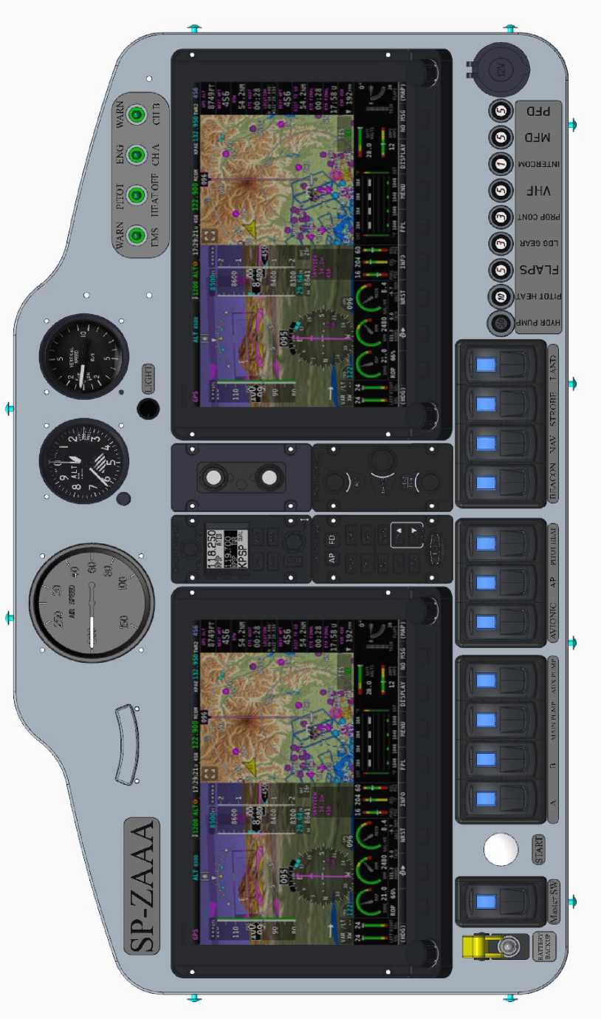



* 1. **Power tools and rescue equipment**
     1. Seats and belts, cab interior

Pilots are seated in individual seats in the front area of the central compartment, which are separately adjustable longitudinally for comfort and reach of the controls (depending on height).

The pilots' seat movement control (individual for left and right pilots) is performed by electric actuators under the seats, which receive control signals from the buttons on the central armrest.

Passengers on the aircraft are seated on a one-piece three-seat sofa in the rear cabin area, with no separate seat adjustment.

In front of the passengers, within their reach, on the central armrest, there is a subscriber node for internal and external communication. Only pilots have external communication.

The pilots' seats, passenger sofa, floor, and interior lining of the cockpit are made of carbon fiber composite materials of the "sandwich" type.

All pilots and passengers are secured in a seated position with individual 4-point belts with individual adjustment. Reliable fastening of the harness fittings to the aircraft structure is ensured in case of loads during an emergency landing.

The interior of the cab is made of non-combustible and easy-to-clean materials.

There are nets for small items in the passenger area.

* + 1. Ventilation and heating of the cabin

**DESCRIPTION  
CONSTRUCTIONS**

The cabin is ventilated with ambient air through automotive-type deflectors located to the left and right of the dashboard. A separate air intake is located in the upper hood of the engine compartment, which is connected to a flange on the frame No. 1 by a flexible pipeline. Behind the flange, there are airflow control dampers and fiberglass piping to the deflectors.

The flaps are controlled by a pull-out handle on the central armrest. Air distribution is controlled by turning the deflectors.

The cab is heated by removing excess heat from the engine's liquid cooling radiator, thanks to a special casing with a separate intake for the outside air in the lower hood of the engine compartment.

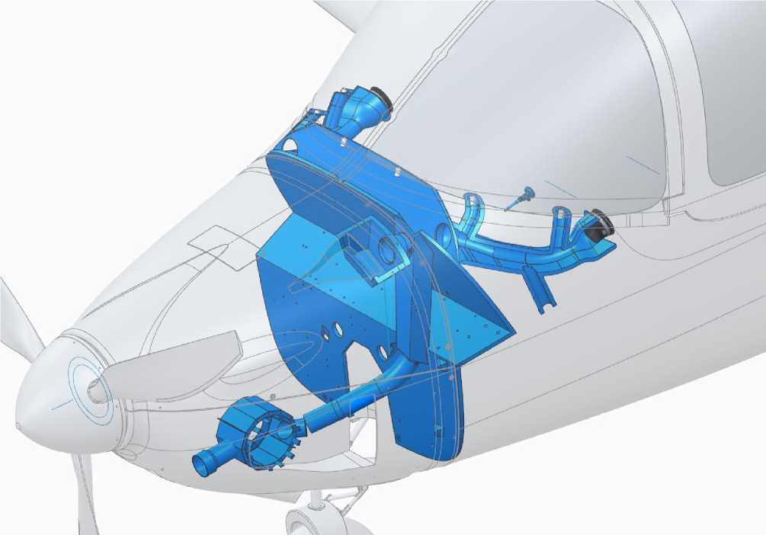

The casing is connected to the flange on the frame No. 1 by a flexible heat-protected pipeline. Behind the flange, there is an air supply control valve and pipelines to the deflectors:



* + 1. Luggage compartments

The aircraft is equipped with a separate luggage compartment, a small luggage compartment on the dashboard torpedo, and an armrest compartment.

The luggage compartment is designed to accommodate pilots' and passengers' luggage: hand luggage such as bags or suitcases of medium size, and other items. The maximum total weight is not more than 60 kg. To secure the luggage, a mooring net is provided, which is fixed to special mooring nodes on the power floor of the compartment.

**WARNING:** maximum baggage weight exceeded or not present

baggage mooring can cause a critical change in alignment and, as a result, deterioration of the aircraft's handling, and on the ground, the aircraft can tip over.

The small trunk (glove compartment) is designed to accommodate operational documentation: AMM, aircraft and engine logbooks, as well as small items and crew documents.

The compartment in the armrest is used to access the landing gear emergency release valve (see section 28.3) .and to place the AFM (must be within easy reach of both pilots).

The luggage compartment is located in the rear area of the central compartment, between the back of the passenger sofa (behind the consumable fuel tanks) and the No. 2 frame.

Access to the luggage compartment is possible only on the ground, from the outside, through a separate hatch on the port side, which is countercurrent to prevent opening in flight. The hatch is equipped with a lock with a key, and canopies fix it in the open position (maximum opening angle of 90° relative to the fuselage). The luggage compartment also provides access to the fuel tanks, fittings and drainage of the fuel system, as well as through the floor and end service hatches in the luggage compartment to the control system rockers and rods, radio feeder connectors and electrical harnesses.

The luggage compartment and small trunk are lined with fleecy, non-combustible and easy-to-clean materials.

Lighting and ventilation of the luggage compartment is provided.

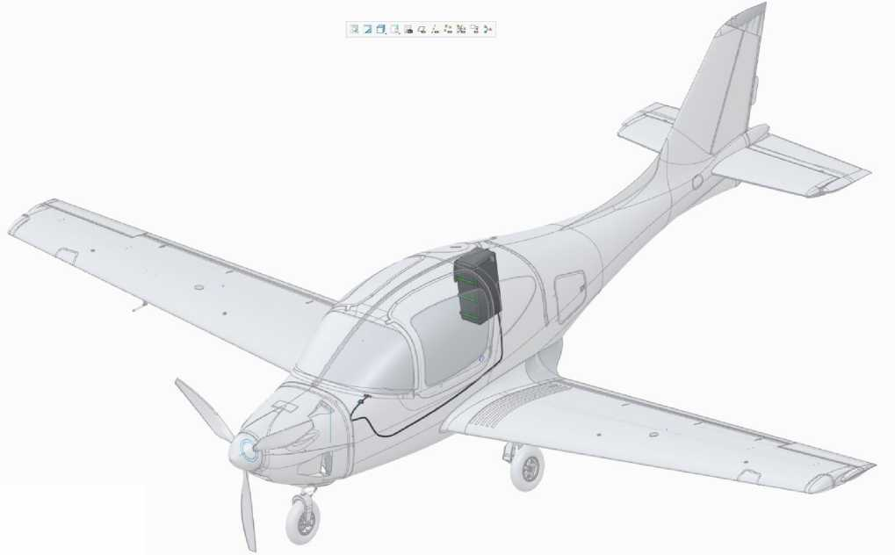

**DESCRIPTION  
CONSTRUCTIONS**

The system is installed in a common compartment in the rear area of the fuselage compartment on the right. The system area is covered by a separate cover on top.

* + 1. Rescue system

The airplane is equipped with a rescue system that provides an emergency parachute landing with a maximum mass at speeds of 60...320 km/h from a minimum height of 80 meters.

The system *model GRS 6/800-990* SDS/FF developed and manufactured by *Galaxy GRS s.r.o. (Czech Republic)* is a single container with a packed parachute and a parachute release device.

The halyards of the rescue system are laid in the longitudinal and lumbar chutes in the upper part of the fuselage, under the protective hatches. The ends of the halyards are securely fastened to the parachute and fuselage power elements.

The rescue system is activated by a handle (with a check), which is mechanically connected to the parachute release device. This activates the powder device to pierce the fuselage cover and open the parachute.

**WARNING:** Activation of the rescue system on the ground, including during maintenance, can lead to death. Do not disassemble the system under any circumstances.

The system should be treated as a pyrotechnic device or weapon.



* 1. **Ground equipment**
     1. Aircraft transportation equipment

The following ground equipment is intended to ensure that the aircraft is transported in accordance with the restrictions of Section 3.5 and the procedures of Section 4.1:

* Transportation tray under the bow support (1 pc.);
* Transporting cradles for the main supports (2 pcs.);
* Wing transport cantilevers (2 pcs.);
* Cover for fuselage windows (1 pc.);
* Propeller blade covers (3 pcs.);
* Plugs for engine compartment intakes (4 pcs.);
* ASC lock (1 pc.).

Layout of aircraft components during transportation, maximum dimensions in the transport position:

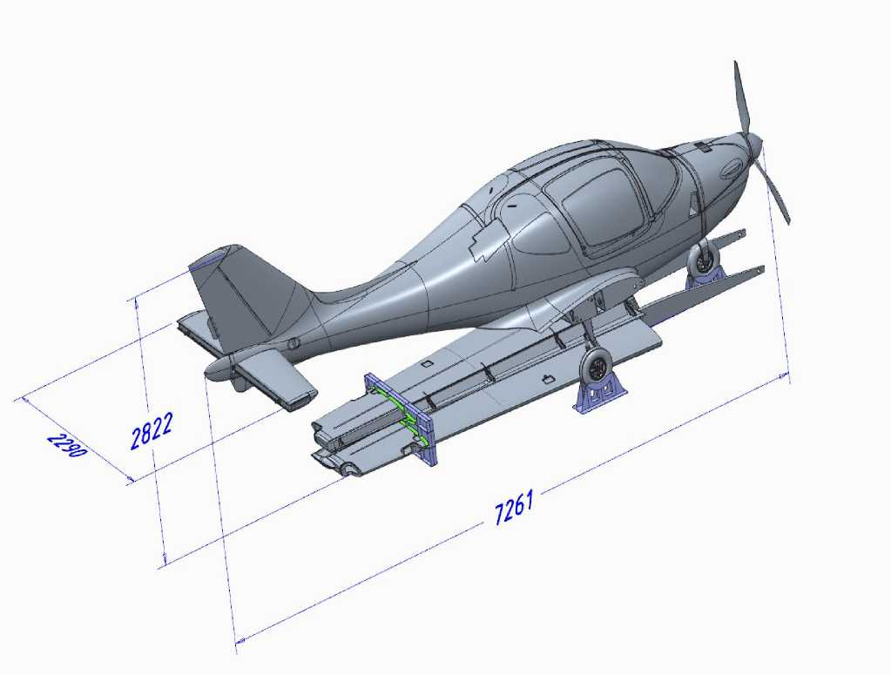

The total weight of the equipment for transportation is 25 kg.



* + 1. Aircraft storage equipment

**DESCRIPTION  
CONSTRUCTIONS**

The following ground equipment is intended to provide storage and parking of the aircraft in accordance with the restrictions of Section 3.4 and the procedures of Section 4.5:

* Parking pad for the main supports (2 pcs.);
* Pitot tube cover (1 pc.);
* Towing steering wheel (1 pc.);
* Mooring rope with fittings (3 pcs.).

The following ground transportation equipment is also used to store aircraft at the parking lot (see Section 212.1).:

* ASC lock (1 pc.);
* Cover for fuselage windows (1 pc.);
* Propeller blade covers (3 pcs.);
* Plugs for engine compartment intakes (4 pcs.).

When performing route flights that involve parking outside the base airfield, the available equipment is transported in the aircraft, in the baggage compartment.

The total weight of the aircraft storage equipment is 5 kg.



* 1. **Stencils, signs**

The external and internal surfaces of the airplane are marked with operational and emergency inscriptions and plates containing the information required by the Airworthiness Standards.

The layout of the stencils on the outer surface of the airplane:

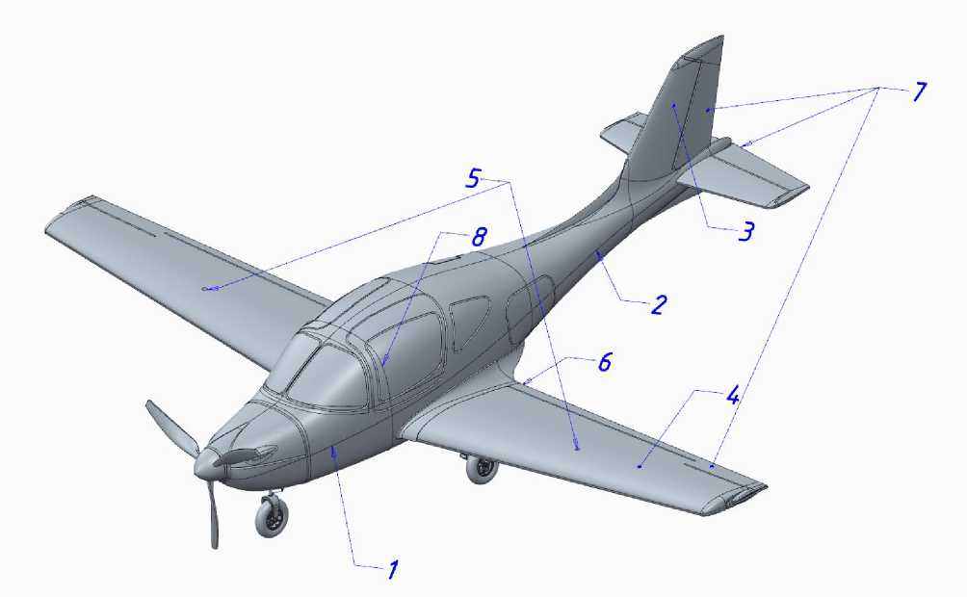

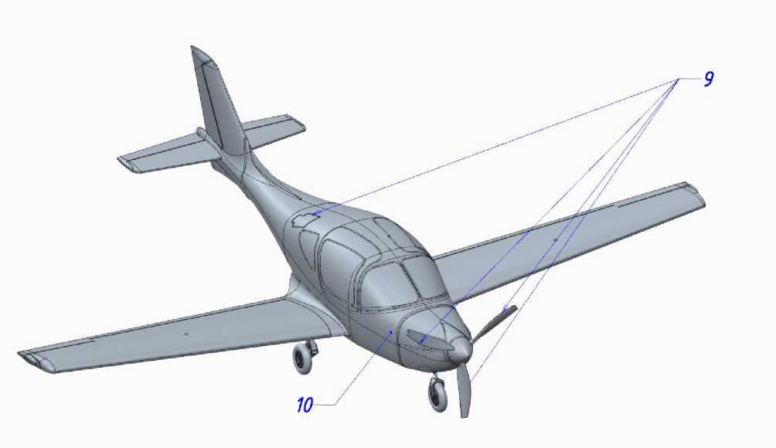

The following stencils are located on the corresponding positions of these drawings:



1. "ANG-01" (name of the aircraft, in black, Arial 35 font);

**DESCRIPTION  
CONSTRUCTIONS**

1. Aircraft registration number (size according to the rules of the country of registration);
2. Flag of the country of registration;
3. "NO STEP" (on the flaps);
4. "DON'T STEP" (on consoles);
5. "92 OCTANE, UNLEADED AUTO GAS, CAPACITY 110 LITERS"

(around the necks of the cantilevered fuel tanks);

1. "NO PUSH" (on the trimmer plate of the directional rudder, ailerons, elevator sections, and elevator trimmer);
2. "OPEN" and "EMERGENCY EXIT" on the door;
3. "DANGER!" on the rescue system cover and all propeller blades;
4. "12V 24 Ah" on the battery compartment door;
5. "HEATING" on the pyto tube bracket.

In addition, on the outer surface of the aircraft there are closed position marks on the JUS .

Stencils of pos. 4...11 are made in red, Arial 25 font, on a transparent background. If the airplane is painted with red paint in the locations of these stencils, the font color changes to white.



The following stencils and signs are located in the cockpit and baggage compartment:

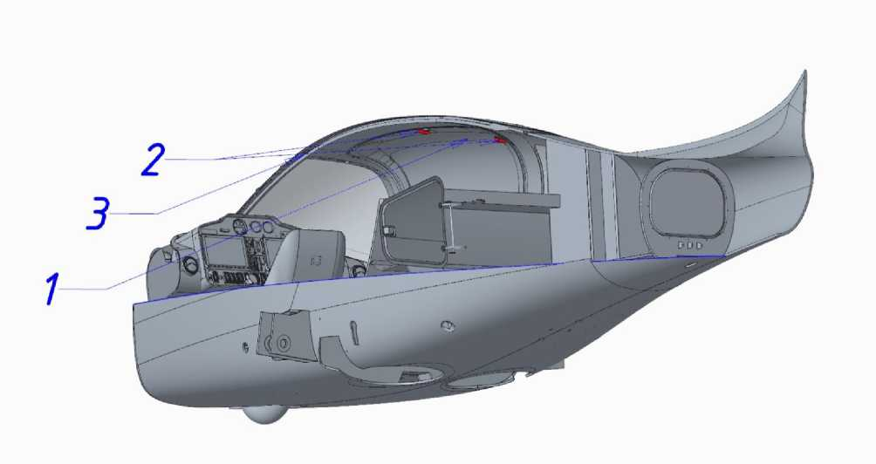

The following stencils are located at the corresponding positions in the figure:

1. "CAPACITY 600L, 60 KG, LUGGAGE MOORING IS MANDATORY" (on the inside of the luggage compartment hatch);
2. "MTOW 950 KG, VA=200 km/h, VNO=340 km/h, NORMAL-CATEGORY LEVEL 2, LOW SPEED, NO AEROBATICS AEROPLANE" (on the dashboard);
3. "OPEN" (on the door);
4. "EMERGENCY EXIT" (on doors and emergency door release checks);
5. "TORN" on the door locks;
6. "NO SMOKING" (top center, behind the frontal wrap);
7. "ANG-01, S/N 000, registration number": steel plate,

riveted at the corners (on the center armrest on the left pilot's side).



**SECTION 3. OPERATIONAL LIMITATIONS**

TABLE OF CONTENTS

* 1. Weight and

54

55

56

57

57

58

**EXPL.  
LIMITATIONS**

* 1. control system and mechanization
  2. Power plant
  3. Conditions of the
  5. Resources and service life

**Introduction**

The section defines all the necessary operational limitations of the ANG-01 aircraft, which guarantee its trouble-free operation and maintenance.

A complete list of aircraft operational restrictions necessary for safe flight operations is provided in the Aircraft Flight Operations Manual ANG.01.AFM.01.

**WARNING:** Failure to comply with these restrictions may result in damage to the aircraft's structural components or create conditions for serious accidents.



* 1. **Mass and center of ization**

The maximum operational weight of the aircraft is 950 kg, the empty weight of the aircraft is 375...385 kg (depending the configuration).

The Aircraft Form shall contain the mass and centering data of an empty equipped aircraft in actual configuration.

**NOTE: The** weight of an empty equipped airplane is determined without crew, baggage, fuel (excluding the unloaded balance), and ground equipment. The aircraft is filled with hydraulic system oil, lubricating oil, and engine coolant.

Determination of the mass and centering of an empty equipped airplane shall be performed in accordance with the methodology of Section 4.4, in the cases specified in Section 4.4. Section 4.4 also describes the procedure for calculating the flight weight and centering of the aircraft.

**WARNING:** Centering an empty, loaded airplane using ballast is PROHIBITED.

When performing maintenance and routine maintenance, it is not recommended that more than 2 people be on the passenger sofa at the same time, if no one is in the pilot's seat. This may cause the aircraft to tip over and damage the tail section.



* 1. **Wing control system and mechanization**
     1. Control system

|  |  |  |  |
| --- | --- | --- | --- |
| **Steering surface** | **Direction.** | **Angle** | **Tolerance/elevation** |
| Height control (left, right sections) | Up to the bottom | 30°  15° | ±1° |
| The steering wheel of direction | Left.  Right. | 25°  25° | ±1° |
| Aileron (left, right) | Up to the bottom | 14°  17° | ±1° |
| Height trimmer | Up to the bottom | 15°  15° | ±1° |

Maximum deviations of the steering surfaces when deviating from the standard controls (ACK and pedals, all the way to the stop):

The speed of the ELV trimmer from one position to another is limited to 10 seconds.

**EXPL. LIMITATIONS**

**WARNING:** application to control system components

a load of more than 50 kgf (in the longitudinal and lumbar canals) and more than 100 kgf (in the track canal) can damage these elements.

In the neutral position of the ACK and pedals, the rudder surfaces must fit into the contours of the stabilizer, keel and wing, respectively, with a tolerance of ±1° for all surfaces.

The trimmer plate of the directional rudder can be tilted by an angle of up to ±10° to compensate for gyroscopic torque and oblique airflow from the propeller (see AFM for angle selection).

* + 1. Wing mechanization

Limit positions of the flaps: "0" and "30", intermediate "10" and "20".

In the "0" position, the flaps are inscribed in the wing contour.

In all positions, the difference between the left and right flap sections must not exceed ±2°.

**WARNING:** applying to the flaps of the vertical

a load of more than 70 kgf can damage them. Therefore, stepping on them is FORBIDDEN, and a corresponding stencil is applied to warn you.



* 1. **Power plant**
     1. Engine.

The main operational limitations set by BRP-Rotax:

|  |  |
| --- | --- |
| **Limitations Value.** | **Note** |
| Shaft speed 1800 rpm  5500 rpm  5800 rpm | low gas mode nominal mode max. up to 5 min. |
| Maximum altitude 7000 м  4570 м | in the ISA  at Th=+50°C |
| The temperature of the environment -20°C  50°С | Minimal  Maximum |
| Lubricant consumption 0.06 l/g | Maximum |
| Lubricating oil pressure 0.8 bar  2.0 bar  5.0 bar | minimum, <3500 rpm minimum, <3500 rpm maximum |
| Fuel pressure 2.9 bar  3.1 bar | minimal exp.  maximum utilization. |
| Lubricating oil temperature* -20°С  90°С | minimal  maximum utilization. |
| Coolant temperature -20°C* is the temperature of the coolant 90°С | minimal  maximum |
| Exhaust temperature 200°С  gases (EGT) 950°С | minimal  maximum |

* - during ground testing, start-up and warm-up

Operational restrictions on the use of engine fluids as specified by *BRP-Rotax* (for more information, see Service Manual SI-915 i-001):

**Lubricant**: according to RON 424 classification.

**Coolant**: *Shell Dex-Cool* is recommended.

**Fuel**: A92, AKI 91, MOGAS EN 228 super (plus), AVGAS 100 LL.

* + 1. Air screw

Operational Restrictions ("*ANG*"):

|  |  |
| --- | --- |
| **Limitations Value.** | **Note** |
| Shaft speed 2700 rpm | Maximum |
| Ambient temperature -25°C  45°С | Minimal  Maximum |
| Blade insertion angle 13°  (translation speed 2°/s) 33° | Minimum maximum |
| Blade runout ≤1.5 mm  ≤7.0 mm | Radial  Axial |



* 1. **Conditions of the base**

Mandatory hangar storage in places of permanent deployment of the aircraft and during periodic and special maintenance (according to sections 5.7, 0 respectively). The hangar must provide artificial

lighting, ventilation. Storage temperature -25°C...+35⁰С, humidity 35...75%, which is determined by the conditions of long-term storage of the rescue system.

**EXPL.  
LIMITATIONS**

At the same time, some of the work for these types of maintenance lasting up to 2 hours is allowed outside the hangar (for example, engine testing) or no closer than 50 meters from significant metal magnetic structures (for example, calibration of GNSS and compass sensors).

It is possible to store outside the hangar in places of temporary dislocation of the aircraft for up to 2 days, and during its operational and periodic maintenance (according to sections 5.6, 5.7, respectively).

During periodic maintenance, it is mandatory to use all standard covers and plugs (see section 212.2 .for a list), to prevent the effects of high winds, it is necessary to moor the aircraft in accordance with section 4.5.2.

Only the brake pads and the Pitot tube cover should be used for routine maintenance.

**WARNING:** prolonged exposure to direct sunlight

radiation, precipitation, and erosion by sand and dust will lead to damage to the composite skin, paintwork, glazing opacification and deformation, corrosion of metal elements, and damage to interior elements.

Parking, storage and all types of MT are allowed when the aircraft is based on a flat, clean surface, preferably with a hard artificial surface. The dimensions of the base area: at least 10x10x4 m (LxWxH).

Restrictions and towing of the aircraft are given in the AFM.

* 1. **Transportation**

Transportation by road, water or rail is allowed.

**WARNING:** Use of transportation equipment other than that specified in section 2.12.1 is prohibited.

Transportation procedures are described in Section 4.1.



* 1. **Resources and service life**

The airframe of the ANG-01 aircraft is authorized for operation according to its technical condition, without limitation of the assigned service life and service life, subject to the conditions:

* Compliance with the operating procedures defined in the existing AMM;
* Compliance with the regulations of units with a limited lifespan;
* Correct and timely maintenance of the Aircraft and Engine Forms.

**WARNING:** claims by the aircraft operator without correct

of the completed Aircraft Form will NOT be accepted.

List of units with a limited service life:

|  |  |  |
| --- | --- | --- |
| **Unit** | **Overhaul life** | **Assigned resource** |
| Engine. | 2000. | 15 years |
| Air screw | 500 hours. | 1000 hours/6 years |
| Rescue system | 6 years | 30 years |
| Engine muffler | - | 5 years |
| Fuel tank pumps | - | 5 years |
| Hydroelectric power station | - | 5 years |
| Fuel hoses | - | 5 years |
| Oil system hoses | - | 5 years |
| Cooling system hoses | - | 5 years |
| Chassis brake hoses | - | 5 years |
| Motor frame shock absorbers | - | 5 years |
| Battery | - | 2 years |
| Spark plugs for the engine | - | 100 hours. |
| Engine oil filter | - | 100 hours. |
| Engine air filter | - | 100 hours. |
| Engine fuel filter | - | 100 hours. |



**SECTION 4. OPERATION OF THE AIRPLANE**

TABLE OF CONTENTS

* 1. Transportation 60
  2. Assembling the aircraft 63
  3. Aircraft leveling 65
  4. Determining mass and centering 69
  5. Parking and mooring 70
  6. Refueling with fuel and operating fluids 72

**AIRPLANE**

* 1. Loading crew and baggage compartments compartments 73
  2. Taxiing and taxiing the aircraft 74
  3. Testing the engine 75
  4. Aircraft cleaning and washing 76
  5. Minor repair of the aircraft skin 77
  6. Setting up instrumentation 79

**Introduction**

The section defines all the necessary operating procedures for the ANG-01 aircraft, which guarantee its trouble-free operation.

**WARNING:** Failure to follow these procedures could result in damage to the aircraft structure or create conditions for serious accidents.



* 1. **Transportation**

To transport the aircraft, a flat horizontal platform of any solid material (wood, plywood, metal) with a total load capacity of 450 kgf or more and a point load of 100 kgf/m(2) at the points where the transport lugs are installed is required.

**WARNING:** It is strictly forbidden to transport the airplane by towing a vehicle by the front landing gear support.

Overall dimensions for placing the aircraft on the vehicle are 7.5x2.5x3.0m (LxWxH), the layout of the aircraft units is given in section 2.12.1. Mounting dimensions of the pads and cradles when placed on the vehicle:

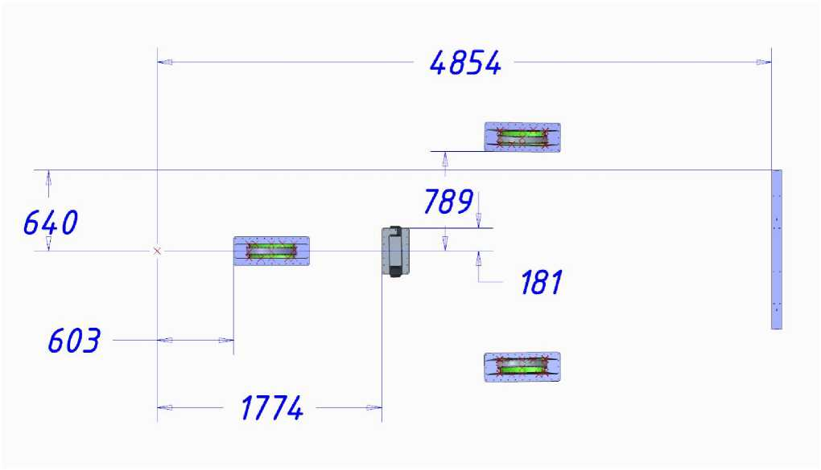

The transportation cradles must be bolted securely to the vehicle platform, making it impossible to move them and the platform. The bolts are included in the ground equipment kit.

When transported by road or rail for up to 2 days, it is allowed to be placed on a platform open from the top and sides.

In case of longer transportation or transportation by water, the platform with the aircraft units must be covered from the top and sides with any light and water impermeable materials on a rigid frame (such as a truck tarp) or a container of certain dimensions and carrying capacity. The frame, materials, and container are not included in the ground equipment set.



**WARNING:** Long-term transportation without protection of the aircraft components from solar radiation, precipitation, and sea water can lead to damage to the paint and varnish coating, delamination, and critical loss of strength of the consoles, fuselage, and propeller (made of composite materials), corrosion of the engine and landing gear (made of metals).

Typically, transportation is performed by road, with the floor of the truck body serving as the platform.

< і- <

**AIRPLANE**

It is possible to install the platform on the floor of a separate trailer or use the trailer floor as a platform (provided that the cradles are installed on the same level).

**o her s**

Preparation for transportation is carried out by at least 2 people and includes actions in the sequence provided:

* Determine the method, route, and duration of transportation and, depending on this, the need for tilting the platform or using a container;
* Determine the compliance of the platform (container) with the overall and mounting dimensions, and carrying capacity;
* Install and secure the transport lugs on the platform according to the diagram;
* Drain fuel from the aircraft (according to 4.6);
* If necessary, to reduce the keel size, bleed the gas from the shock absorbers and pneumatics of the main landing gear supports;
* Set the ACK lock;
* Dismantle the Pitot tube and plug the hoses;
* Unhook the wing consoles;
* Put the AFM, AMM, Form and Logbook, and supporting documents in the small trunk;
* Put the parking pads and Pitot tube in the luggage compartment;
* Seal the doors and luggage compartment (if necessary);
* Place the fuselage on the transportation cradles on the platform;

**NOTES:** equipment - crane with a lifting capacity of 300 kg or more with

the required boom outreach. The lifting points on the fuselage are shown in the diagram in section 2.12.1. To sling the engine, remove the upper engine compartment hood, and after installing the fuselage on the platform, replace the hood in its original place.

**WARNING:** Install the fuselage on the platform at wind speeds of no more than 5 m/s to prevent mechanical damage to the fuselage and the propeller, uncontrolled rotation or swaying in the suspended state, and thus prevent injury to people and animals.

* Secure the chassis wheels in the chassis cradles;
* Determine the transport dimension by the height of the aircraft or container standing on the vehicle;
* Install all plugs and covers (see diagram in section 2.12.1);
* Install and secure the wing consoles on the transport cradles on the platform, check the tightness of the fuel tank necks (seal if necessary).

When planning the route and during transportation, ensure that there is at least 0.2 m of clearance from the top of the aircraft or container on the vehicle to power lines, bridges, etc.)

* 1. **Assembling the aircraft**

After transportation, the aircraft shall be assembled on a site of at least 10x10 meters, with a flat, dry, hard surface, ventilation and artificial lighting. A table for documentation and tools should be located on the site.

The site should be protected from direct sunlight, wind and precipitation. At ambient temperatures below 10⁰C, it is advisable to equip the site with heating.

The aircraft must be assembled by at least 2 persons in sequence:

< і- <

* Check the integrity of all seals, if any;

**AIRPLANE**

* Check the availability of the AFM, AMM, Form and Logbook, and supporting documents;

**o her s**

* Unlock and remove the wing console brackets from the wing brackets;
* Unfasten and remove the fuselage from the cradles to a flat surface. Equipment and safety measures according to section 4.1;
* Tow the fuselage according to the methodology of Section 4.8 to the aircraft assembly site and place it on the parking blocks, move the consoles to the same place (the weight of one allows you to carry a breather);
* Dismantle the pads and cradles (if necessary) from the platform;

Z Inspect the condition of the aircraft, TC 025.01, 051.01, 052.01, 061.01 (according to 5.6);

* Remove all plugs and covers, the ACK lock;
* Charge the chassis support shock absorbers, TC 032.03 (according to 0);
* Inflate the pneumatics of the wheels;
* Install the wing consoles. To do this, connect:
* aileron control system thrusters;
* flap shaft;
* pneumatic piping of the pitot tube between the right console and the fuselage;
* pipelines and drainage of the fuel system of cantilevered fuel tanks;
* ANL and STROBA electrical wires from the wing consoles to the fuselage;
* Install the Pitot tube, TC 031.01 (according to 0);
* Clean and wash the airplane (according to 4.10);
* Check the integrity of the paintwork, stencils, and plates (according to 2.13);
* Level the aircraft (according to 4.3);
* Fill with operating fluids (according to 4.6);
* Inspect the engine compartment units, TC 029.01, 072.01 (according to 5.6);
* Inspect the condition of the rescue system, TC 101.01 (according to 5.6);
* Check the control system and flaps, TC 027.01 (according to 5.6);
* Check the electrical system, TC 024.01 (according to 5.6);
* Check onboard equipment, TC 024.01, 031.01 (according to 5.6);
* Check the lighting equipment, TC 024.02 (according to 5.7);
* Check the landing gear, TC 032.02 (according to 5.7), except for replacing the landing gear pads;
* Perform a ground test of the engine (according to section 4.9);
* Make an entry in the Form.



* 1. **Aircraft leveling**

Leveling of the aircraft in operation! perform in cases after:

* transportation and assembly of the aircraft;
* Excessive operating loads and speeds;
* rough landing with a vertical speed of more than 2 m/s;
* Tail section touching the fuselage during takeoff or landing;
* collision in flight with a bird, drone, or other object;
* landings with the landing gear removed or incompletely released;
* landing with the use of a rescue system;
* according to the pilot's requirements.

< і- <

**AIRPLANE**

Perform in a hangar or on an open area with a flat hard surface (in calm and without precipitation).

**o her s**

**NOTE:** During leveling, do not perform any other work on the aircraft, do not change the pressure in the pneumatics and landing gear shock absorbers, and do not apply any load to the aircraft surface.

Use any authorized level, a 10 m tape measure, a building plumb line, a marker, a template for the end rocker of the elevation control axis (Ш1, included in 8Т0М), a car jack with a shank up to 0.5 m (everything except the template is not included).

Follow these steps:

* Determine the level of the site with a level (it should be horizontal);
* Dismantle the tail fairing and install the template Ш1 on the elevator end rocker axis;

^ Align the airplane in the longitudinal horizontal by installing the jack and raising its shank until the mark from the level, which is set horizontally from the propeller nose, coincides with the mark on the template. If the stroke of the jack shank is not enough for the leveling, adjust the angle with the pressure in the shock absorber and/or gas pressure in the front support pneumatics. The setting is shown in the figure

^ Set the airplane to the lumbar horizontal, ensuring that the shock absorber and/or gas pressure is released or pumped into the pneumatics of the corresponding main wing support to the ground from the root nose of the left and right wing consoles. A schematic representation of the exhibition is shown in the figure above:

* Make measurements at all reference points (black circles with a diameter of 5 mm are marked on the outer surface of the aircraft) according to the following scheme:
* Enter the measurement results into the Aircraft Form;

^ Calculate the angles using any calculator, enter the results into the Aircraft Form, and compare them with the reference angles.



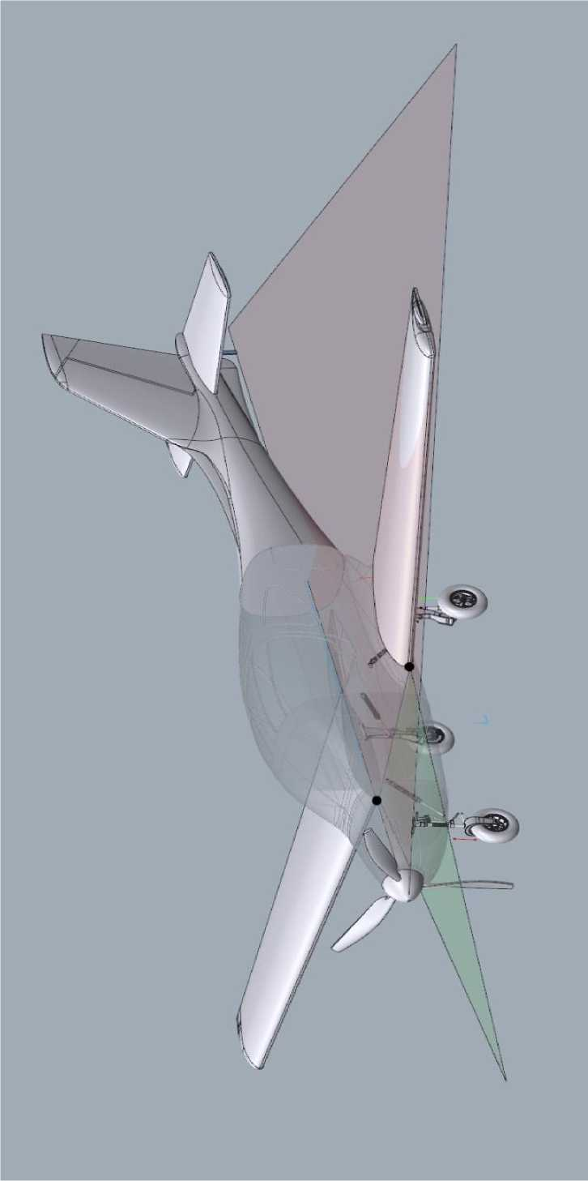

**< I- <**

**o s**

**AIRPLANE**

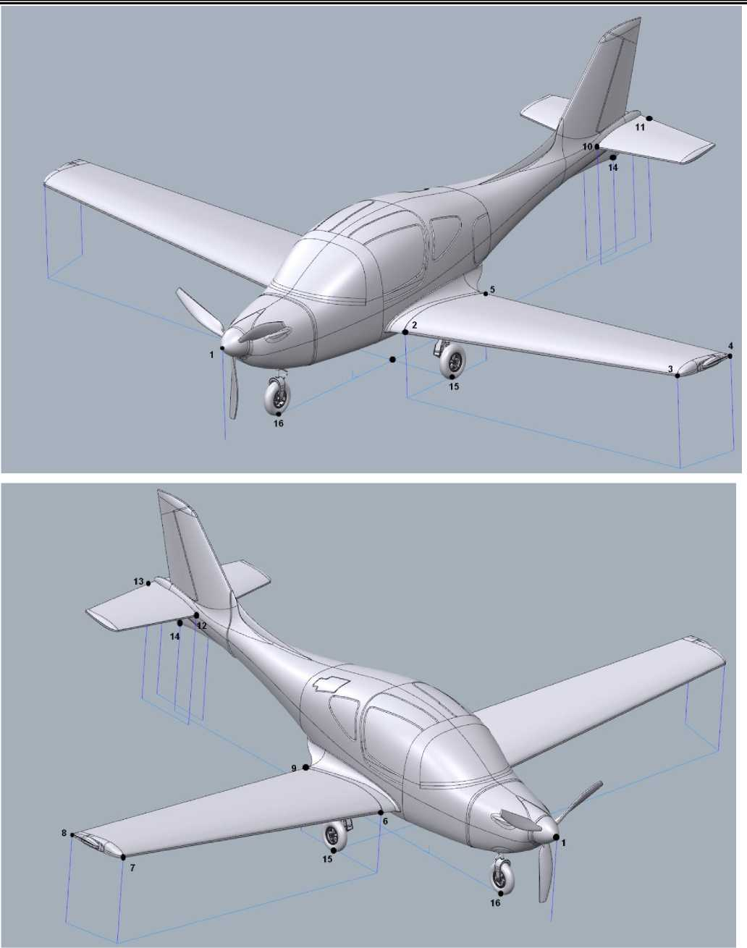

***SECTION 4***

***Aircraft operation***

*June. 23/2020*

*Pp. 67 Page. 124*

The "Leveling" section of the Aircraft Form contains the following measurements (height H and horizontal distance D with an accuracy of 0.01 m):

|  |  |
| --- | --- |
| **Parameter H D** | **Formula Size Reference** |
| Lumbar V angle of the left console ___m ___m ___m  Lumbar V angle of the right console ___m ___m ___m | atan[(H2-H3)/D2-3] ⁰  atan[(H6-H7)/D6-7] ⁰ 5.0±0.1 |
| Angle of insertion of the left console arm ___m ___m ___m  Angle of insertion of the right console arm ___m ___m ___m | atan[(H3-H4)/D3-4] ⁰  atan[(H6-H8)/D6-8] ⁰ . . |
| Angle of insertion of the root of the left console ___m ___m ___m  The angle of the root insertion of the right console ___m ___m ___m | atan[(H2-H5)/D2-5] ⁰ 00±01⁰  atan[(H7-H9)/D7-9] ⁰ . . |
| Root insertion angle of the left STB section __m ___m ___m Root insertion angle of the right STB section __m ___m ___m | atan[(H10-H11)/D10-11] ⁰  atan[(H12-H13)/D12-13] ⁰ 5.5±0.1⁰ |
| Tail clearance ___m n/a ___м | atan[H14/D14-15] ⁰ 17.0±0.5⁰ |
| Aircraft length n/a n/a ___m  STB arm n/a n/a ___m | D1-14 m 7.31±0.02 m  D2-10 m 3.95±0.01 m |
| Chassis track n/a n/a ___m  Chassis base n/a n/a ___m | D15-15 (left/right) m 1.94±0.02 m  D15-16 m 1.98±0.02 m |

**WARNING:** if the results do not match the reference results, contact the Developer to make a decision on further operation of the aircraft.

* 1. **Determining mass and centering**

Determine the mass and center of gravity of the airplane in cases after:

* installation/disassembly of equipment weighing more than 5 kg;
* airplane painting;
* special maintenance;
* according to the pilot's requirements.

Perform in a hangar or on an open area with a flat hard surface (in calm and without precipitation).

**NOTE:** Do not perform any weight or centering **measurements** during the

other work on the airplane, do not apply loads on the airplane surface. This will lead to incorrect results.

Use any verified scales with a range of up to 150 kgf (3 pcs.), a level or a level with a base of 3 m (to determine the level of the site), a 10 m tape measure, a building plumb line, a marker (not included).

Follow these steps:

* Determine the level of the site (it should be horizontal);
* Drain the fuel from the aircraft to the undrained balance;
* Remove all foreign objects, ground and transportation equipment from the cab, luggage compartment, small trunk, close the doors and trunk;
* Enter the list of installed units and the amount of operating fluids (lubricating oil, coolant, and hydraulic fluid) in the Aircraft Form;
* Clean and wash the airplane (according to 4.10);
* Install the scales on the platform, set the unit of measurement "kg" to zero;
* Place the airplane on the scale and enter the weight per landing gear support in the Form;
* Determine the horizontal distance from the propeller nose to the axis of the nose wheel and main landing gear supports according to the diagram at the actual weight of the airplane and enter this data in the Aircraft Form;

**NOTE: it** is necessary to measure these distances at each weighing, as

They depend on the weight and alignment of the aircraft, the charge and condition of the shock absorber stem. The use of statistical or preliminary data can lead to an error in the centering calculation of up to 3% GVW.

* Calculate the mass and centering by the method of moments relative to the rotor blade using any calculator, enter the results in the Aircraft Form and compare them with the reference.

The "Determination of Mass and EE" section of the Aircraft Form contains the following measurements (mass with an accuracy of 0.1 kg, distance with an accuracy of 0.01 m):



|  |  |  |  |
| --- | --- | --- | --- |
| **Parameter (measurement designation, formula for calculation)** | **Measurement** | **Cf.** | **Reference** |
| Weight on the chassis nose weight (mN) | ___kg | n/a | n/a |
| Weight per left main chassis support (mL) | kg  ^^^^^^^^^^^^^ш | n/a | n/a |
| Weight per right main chassis support (mR) | kg  ^^^^^^^^^^^^^ш | n/a | n/a |
| The mass of the airplane: mPL= mN+mL+mR | n/a | kg  ^^^^^^^^^^^^^ш | 380±10* kg |
| Distance from the rudder to the axle of the chassis nose support (DN) | ___м | n/a | n/a |
| Distance from the wheel well to the axle of the left main chassis support (DL) | ___м | n/a | n/a |
| Distance from the wheel well to the axle of the right main chassis support (DR) | ___м | n/a | - |
| *.. .. ((tc+tk)* ь_ ^t^Oy* ) /ц7\  Centering: Х,-{ "^ (2) -24}/(100) | n/a | ___% | 17.6±1 % |
| * - depending on the interior decor |  |  |  |

**WARNING:** if the results do not match the reference results, contact the Developer to decide on corrective actions (relocation of equipment, installation of additional ballast, etc.).

In the Mass and CG Determination section of the Aircraft Form, you also need to define the configuration of the aircraft during weighing:

|  |  |  |  |
| --- | --- | --- | --- |
| **Unit, equipment** | **Mass,** | **Distance.** | **sail on Fact** |
| **kg** | **to CG, m** | **CG,% set.** |
| Air screw (set according to 2.7.2) | 6.0 | 0.20 | -3.0 |
| Engine (set according to 2.7.1) | 35.0 | 0.65 | -12.8 |
| Hydroelectric power station | 4.0 | 0.85 | -1.4 |
| Engine lubrication | 3.0 | 0.65 | -1.2 |
| Engine coolant | 5.0 | 0.80 | -1.8 |
| Working fluid of a hydroelectric power plant | 2.0 | 1.00 | -0.6 |
| Non-draining fuel residue | 5.0 | 3.34 | +1.3 |
| Battery | 1.5 | 0.95 | -0.5 |
| Interior of the cab | 20.0 | 2.30 | 0.0 |
| Inner trunk lining | 2.0 | 3.96 | +0.8 |
| Rescue system | 25.0 | 3.73 | +8.2 |
| Fire extinguisher | 2.0 | 2.30 | 0.0 |
| First aid kit | 1.0 | 3.00 | +0.1 |
| Transponder | 1.0 | 3.42 | +0.3 |
| Ballast in the fuselage keel | 16.0 | 6.60 | +16.2 |
| Parking pad (2 pcs.) | 2.0 | 4.00 | +0.6 |
| Towing wheel (1 pc.) | 2.0 | 4.00 | +0.6 |
| Mooring rope | 2.0 | 4.00 | +0.6 |
| ACK lock (1 pc.) | 1.0 | 4.00 | +0.3 |
| Cover for glazing (1 pc.) | 2.0 | 4.00 | +0.6 |
| Cover for propeller blades | 1.0 | 4.00 | +0.3 |
| Intake plugs | 0.5 | 4.00 | +0.1 |

* 1. **Parking and mooring**

Short-term (up to 4 hours) and long-term (up to 2 days) aircraft parking is allowed. For longer periods, mandatory hangar storage is required in accordance with Section 3.4.

* + 1. Short-term parking

It is allowed without mooring the aircraft if the forecast does not indicate a probability of significant precipitation and wind speeds of more than 5 m/s.

**NOTE:** Do not leave the door open to prevent damage if it is suddenly closed by a gust of wind.

Minimal action is required:

**AIRPLANE**

* Insert the parking brackets under the main chassis support;
* Replace the Pitot tube cover.
  + 1. Long-term parking

Anchoring and covering of the aircraft is required, the minimum overall dimensions are shown in the figure in section 2.12.2.

**NOTE:** Consider the prevailing wind direction at the anchorage.

The airplane must be set nose downwind to prevent damage in high winds.

Necessary actions:

* Inspect the site (it should be a dry, horizontal area with securely fastened mooring nodes);
* Select the parking direction (nose to the wind) and place the aircraft on the pad;
* Insert the parking brackets under the main chassis support;
* Replace the Pitot tube cover;
* Moor the airplane with the ropes provided;
* Set the ASC lock;
* Install the engine compartment intake covers.
* Put on the glazing cover;
* Put on the propeller blade covers;
* Install seals on the hood, doors and luggage compartment and

battery compartment (if necessary) .



* 1. **Refueling with fuel and operating fluids**

Use only fuel, lubricants and operating fluids from the list in section 3.3.

**ATTENTION:** ensure that when refueling both fuel and operating fluids: no open flames, smoking, heating devices within 20 meters of the aircraft, and ventilation of the site. It is strictly forbidden to refuel with fuel and liquids while the engine is running and the aircraft power supply is on.

* + 1. Filling with operating fluids
* Filling the engine with oil, TC 072.03 (according to 5.7);
* Coolant filling, TC 072.06 (according to 0);
* Refueling the hydraulic system, TC 029.02 (according to 0);
* Refueling the wheel brake system, TC 032.03 (according to 0);
* Charging of chassis support shock absorbers, TC 032.03 (according to 0).
  + 1. Refueling

Perform manually, exclusively through the necks of the cantilever tanks, using 20-liter containers and funnels with a coarse filter and water (not included in the aircraft ground equipment).

After refueling, tightly close the fuel filler necks until the red marks on the neck and the console coincide, check the condition of the drainage in the neck (the hole must be clean).

In case of fuel leakage through the console, wipe it with a dry cloth.

Fuel quantity control: by the number of tanks and after switching on the fuel gauge.

The amount of fuel is determined by the pilot based on the route, duration of the flight, forecasted meteorological conditions, and the crew and baggage.

**ATTENTION:** the amount of fuel on board must correspond to the amount of fuel calculated by the pilot, with an error of up to ±5 liters.

After 5...10 minutes after refueling, drain the sludge. Drain through the drainage hole under the fuselage into a clean, transparent container (not included in the ground equipment).

**ATTENTION:** Do not allow the presence of hard mechanical parts, water, ice crystals in the sludge.



* 1. **Loading crew and luggage compartments**

Load the baggage compartment only through the trunk hatch. If the flight plan provides for basing at another airfield, load all ground equipment for storing the aircraft into the trunk (according to the section [2.12.2)](#bookmark63" \o "Current Document) .

**ATTENTION:** All baggage must be secured to prevent its movement during the flight. Unlatched baggage can cause critical misalignment and loss of control of the aircraft, and damage to fuel system components. J

**AIRPLANE**

Check the small luggage compartment in the cab and the armrest compartment for >

no flammable items. The small trunk must contain O

AMM, Forms, airplane documents, and other small items are located in the armrest, while the armrest only AFM and spare landing gear backup cylinders.

**ATTENTION!!!** crew and luggage should be accommodated exclusively by

options authorized by the AFM.

The pilot on the left is the first to board, followed by the rest of the crew. Everyone enters the cockpit from the left and right behind the wing, stepping on special footrests and anti-slip tapes on the iron of the center section.

**WARNING:** Never place your foot on the flap and wing consoles to prevent damage. For this reason, they are marked with special stencils (see section 213.).

Leave the aircraft and unload the baggage compartment after the flight in the reverse order.



* 1. **Taxiing and taxiing the aircraft**

Aircraft **towing** is permitted with any aircraft weight, on any surface condition, with any wind speed (within the operational limits of the airfield conditions, see AFM).

Towing should be performed at speeds up to 5 km/h, manually, by two people, hooking the towing wheel axle of the nose landing gear with the towing wheel from the ground equipment set.

Before starting towing, make sure that the parking blocks are removed and that any objects on the surface do not interfere with the movement of the wheels in the direction of travel.

When the airplane passes through a hangar opening or other obstacles, the person controlling the pilot should carefully watch the passage of the wing, fin (width), and keel (height) consoles.

The course of the aircraft is controlled by turning the nose gear by the pilot.

**WARNING:** When towing, do not apply force to the propeller blades, steering surfaces, flaps, hatches, and doors to prevent damage.

If it is necessary to make a sharp turn with a radius of less than 10 m or to pass an overhead obstacle that threatens to damage the keel, press down on the tail until the nose support is raised and perform the maneuver.

Movement of the aircraft over a distance of more than 200 meters should preferably be performed by taxiing, with the engine running.

**Taxiing** with the engine running is permitted with any aircraft weight, on any surface condition, at any wind speed (within the operational limits of the airfield conditions, see AFM).

Steer at speeds up to 20 km/h.

**NOTES: 1.** Turning radius of 180° when steering: 15 m and 10 m respectively without and with asymmetric wheel braking.

1. If the wind speed is more than 5 m/s, take into account the increase in radius by 2 m when turning into the wind.
2. When taxiing on a surface covered with precipitation, take into account the increase in radius by 1 m.



* 1. **Testing the engine**

Start and stop the engine according to the procedures in section 4.2 of the AFM.

During the test, monitor the motor parameters in accordance with the operating limits in section 3.3.

**ATTENTION:** it is strictly forbidden to run the engine at high EOM (more than 50% of ECK and VPP setpoint more than 2900 rpm) during ground testing in any condition of the pad surface, unless the aircraft is fixed to a solid, stationary support. This can к

cause an aircraft to move that cannot be stopped by the brakes or <

**AIRPLANE**

jumping over parking blocks. г

Fix the airplane to a sturdy fixed support during ground testing at engine operating conditions exceeding 50% ECK by the main landing gear supports with mooring ropes from the ground equipment kit.

* 1. **Aircraft cleaning and washing**

Dirt, insects, and ice on the propeller, wing cantilevers, and stabilizer can significantly increase fuel consumption, impair aircraft handling, and reduce the stall margin of the aircraft, or even cause a sudden asymmetrical stall at operating speeds.

Contamination of the Pitot tube can cause unreliable readings of the main pilot parameters: airspeed, barometric altitude and angle of attack.

Contamination of the glazing can cause a deterioration in the outward view and thus make it difficult for the pilot to perform the flight.

Contamination of landing gear props can make it impossible to clean them or release them in flight (especially if liquid dirt freezes at ambient temperatures below 0⁰C and makes it impossible to release the props in flight from both the main and backup systems).

Contamination of the air intakes can cause the engine to overheat and run erratically, as well as introduce contaminated air into the cab.

All of these factors directly or indirectly affect the safety of flying an aircraft, so it is important to keep the aircraft clean.

Remove dirt, dust, insects, ice and traces of fuel and oil leaks with a soft lime cloth with warm water, and any household detergent may be added.

**WARNING:** Aircraft exterior surfaces that are almost completely folded

painted composite materials, as well as polycarbonate glazing, must not be cleaned with gasoline, acetone or similar aggressive liquids. This can cause glazing to become cloudy and damage the paint and varnish coating. Do not wipe the glazing with a dry cloth, as abrasive wear may occur. Do not allow direct contact with water on the Pitot.

Dirt in the cab and trunk is best removed with a vacuum cleaner.

We do not recommend using paper, wool or silk cloths, as they cause electrostatic discharge and attract dust to the already cleaned surface.

Remove corrosion from metal parts in the engine compartment, on wheel rims, brakes, shock absorbers, and chassis cleaning cylinders by cleaning with fine sandpaper and polishing with a lime swab dipped in gasoline. It is permissible to tint the motorized frame.



* 1. **Minor repair of the aircraft skin**

Minor repairs of the aircraft skin are allowed if the damage is no more than 5 cm2in area or the damage is not closer than 2 cm to the power and particularly critical elements (wing and stabilizer console spar, spar box and all fuselage spars, landing gear supports, landing gear support hinge assemblies, flaps and steering surfaces, control system rods and rockers).

Use an adhesive of the following composition: epoxy resin ED-20 GOST 10578-84 or equivalent, plasticized with 10% plasticizer mixed with PEPA hardener or equivalent in a ratio of 8:1.

< I- <

**AIRPLANE**

Tools and materials required (not included in the scope of delivery): mounting knife, fine sandpaper, 100 g/m(2) fiberglasscloth, 80 g/m(2) foam, 3 mm thick, putty, paint of a suitable color.

**o s**

* + 1. Repair of the "sanwich" type cladding

Actions in case of non-through damage:

* round the edges of the damage with sandpaper;
* cut and remove the foam from the damaged area with a knife;
* stick the foam liner as shown in the diagram below;
* glue the outer skin as shown in the diagram below;
* Clean the edges of the trim with fine sandpaper;
* putty and paint the damage area.

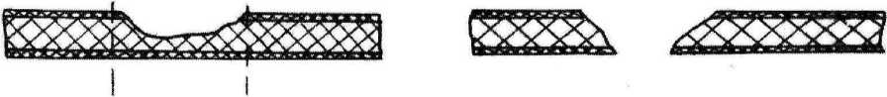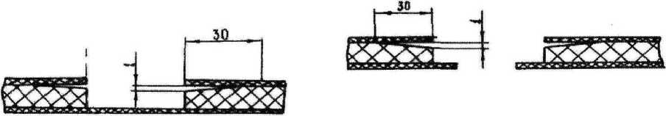

**Superficial damage**

**Through damage**

In case of through damage, the repair is similar,

but before

seal the damage area from the inside with an additional layer of foam liner as shown in the diagram above.

* + 1. Repair of a single-layer skin

Actions in case of damage:

round the edges of the damage with sandpaper;

/  
г

chamfer with sandpaper 20...30 thicknesses of the cladding, as shown in the diagram below;

seal the lining with 3 layers of fiberglass;

Clean the edges of the trim with fine sandpaper;

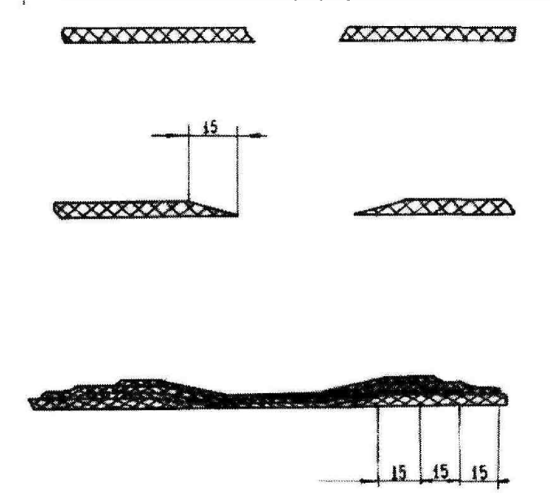putty and paint the damage area.

/ g g



* 1. **Setting up instrumentation**
     1. Registration of *the Dynon SW1100* system user

After installing *the Dynon SW1100* system, each individual user needs to register on the official *Dynon Avionics* portal <http://register.dynonavionics.com>to confirm ownership of the equipment, receive current system updates and service bulletins.

* + 1. Update *the Dynon SW1100* system software

**AIRPLANE**

*The Dynon SW1100* system comes with a factory default software configuration, but you must update the software at [http://downloads.dynonavionics.com](http://downloads.dynonavionics.com/) after the system is first installed or when system components are replaced (see 2.10.1).

Software updates must be performed on each display separately.

Updates are downloaded to the system via a standard FAT32 USB drive that has been scanned for viruses. This drive is first used to download updates from any personal computer connected to the Internet using the link above, and then connected to the *Dynon SW1100* onboard system via the USB connector in the small trunk of the cockpit (see 2.10.1).

To enter the main menu, press simultaneously for 2...3 seconds buttons 7,8 under the system display. Enter the aircraft registration number ANG-01 (without dashes and spaces) or the factory number if the registration has not yet been performed.

To reset the display, press buttons 1, 2, 5 simultaneously for 2...3 seconds under the system display.



* + 1. Setting up *the Dynon SW1100* system

To manage the SkyView in-vehicle network, one display is automatically selected as "Master" and the other as "Standby". If the "Master" display fails, the "Standby" display automatically becomes the "Master" display.

The displays have built-in brightness control, but manual adjustment is possible with the cremplier in the lower left part of each display separately. Setting the units of measurement: "SYSTEM SETUP> UNIT".

Actions in the SYSTEM SETUP menu are shown on the display and are intuitively understandable to any PC user with a basic understanding of English and do not require additional explanations:

The recommended layout of the flight, navigation, engine, and fuel system information scales (screen layout) on the two system displays is given in Section 2.10.1.

To the user's taste, a different screen layout is possible, which can be changed in the "SYSTEM SETUP> PDF PAGE" and "SYSTEM SETUP> ENGINE PAGE" and "SYSTEM SETUP> MAP PAGE" settings menus, respectively.



* + 1. Calibrating the ADAHRS speed and the backup device

**AIRPLANE**

Calibration of speed sensors is the calculation of the indicated airspeed (CAS) by subtracting the instrumental (dVi) and aerodynamic (dVa) errors from the instrument speed (AS), since all operational limits in the AFM are given in CAS=AS-dVa-dVi.

The instrumental error depends on the type of sensors (primary and backup ADAHRS and backup mechanical device).

The aerodynamic error depends on the type of Pitot tube, its location on the aircraft (local aerodynamics) and angle of attack, it does not depend on the type of sensors. The aerodynamic error was determined by the Developer in the flight tests of the ANG-01 aircraft and is as follows:

| **AS, km/h** | 40 | 80 | 120 | 150 | 200 | 250 | 300 | 350 |
| --- | --- | --- | --- | --- | --- | --- | --- | --- |
| **dVa, km/h** | 15 | 10 | 2 | 0 | 0 | -2 | -5 | -10 |

Perform calibration according to the methodology:

* Place the aircraft in a hangar or in an open area (if it is calm);

**NOTE:** If the temperature difference between the environment outside and inside the hangar is more than 15°C (if the process takes place in a hangar), calibration should be performed at least 30 minutes later, because ADAHRS sensors are thermally compensated. Otherwise, there may be an error of up to 5 km/h.

* Connect a reference speed setter directly to the Pitot tube (KPU-3 device with a verified speed setter or any other verified speed setter with a range of up to 350 km/h), close the static pressure holes with a setter nozzle or with a noticeable color of electrical tape so that you do not forget to remove it after calibration;
* Turn on the *Dynon SW1100* system from a ground source;

^ Set the reference speed in the forward and reverse directions according to the table above, holding the "pad" at each speed for at least 30 seconds. Record the readings simultaneously on the main and backup displays of the Dynon system (speed readings from the main and backup ADAHRS, respectively) and the backup mechanical device.

**WARNING:** If the speed reading on the standard drops on the "pad", the system is leaking. It is necessary to find the leak and recheck it. Flying with a leaky system is PROHIBITED.

* Perform CAS calculations for the primary and backup ADAHRS and the backup mechanical device using the formula above;

*S* Enter the CAS graph depending on the AS and the total dVi, dVa for the backup device. Place it on the stencil according to 2.13.

* Enter the graph of CAS depending on AS and total dVi, dVa for the main ADAHRS on the main display, following the recommendations of the menu "SETUP>CALIBRATION>AirSPEED";
* Enter the CAS graph depending on the AS and the total dVi, dVa for the backup ADAHRS on the main display, following the recommendations of the "SETUP>CALIBRATION>AirSPEED" menu;
* Re-set the speed reference in the forward and reverse directions according to the table above.

The criterion for a successful calibration will be when the speed readings on the main and backup displays, as well as the backup mechanical device, differ only by the value of the aerodynamic correction.

* + 1. Calibration of ADAHRS gyroscopes and accelerometers

Perform calibration according to the methodology:

* Set the airplane in the flight line according to the recommendations of section 4.3;

**WARNING:** place the aircraft either in a hangar or in the open

place (if the weather conditions are calm), excluding wind fluctuations. During the calibration period, do not change the position of the aircraft, stay in the cockpit, or apply significant physical force to the aircraft. All this can cause a calibration error.

It is advisable to combine the calibration with the aircraft leveling.

* Turn on the *Dynon SW1100* system from a ground source;
* Follow the recommendations menu "SETUP>HARDWARE>

AHRS>CALIBRATIO" by pressing the corresponding symbols on the display.

The criterion for a successful data update will be when the aircraft is in the flight line and the roll and pitch values on the display are ±1⁰, vertical overload 1.0g ±0.05g, and the horizon line is aligned.

**ATTENTION:** If the ADHRS unit is installed upside down, the blue sector of the air horizon will be at the bottom and the brown sector at the top. It is necessary to turn the ADAHRS upside down, otherwise, when you turn it on

If the autopilot is in flight, it will try to tip the aircraft through roll control, and this maneuver can be extremely dangerous without timely pilot intervention. This applies to both the main and backup ADAHRS units.



* + 1. Calibration of ADAHRS magnetometers of *the Dynon SW1100* system

Perform calibration according to the methodology:

* Place the aircraft in an open area with the nose to the NORTH (oriented by the backup onboard compass);

**WARNING:** The aircraft must be located at least 20 meters away from heavy and large metal structures to prevent magnetic interference.

* Turn on the *Dynon SW1100* system normally;

**< I- <**

**AIRPLANE**

* Turn on the engine normally, keep the computer at low throttle;

**WARNING:** Calibration should be performed with the engine running to take into account its electromagnetic effects on the compass readings.

**o s**

* Turn the airplane on the spot (by the wing) to the EAST, SOUTH, WEST and in the opposite direction, orienting by the backup onboard compass. In each direction, follow the recommendations of the "SETUP>HARDWARE> COMPASS>CALIBRATIO" menu by pressing the corresponding virtual buttons on the display.

The criterion for a successful data update will be the coincidence of the magnetic heading on the display and the backup onboard compass with an accuracy of at least ±2⁰.

* + 1. GNSS calibration

The "GPS FIX STATUS" tab defines the navigation information from the GNSS of the warehouse complex, which the system uses to determine the current position, move the map on the display, synthetic vision system and calculate the wear, wind direction and speed.

For correct operation, it is necessary to regularly update this status (calibrate GNSS), as well as install Jeppesen airfield databases.

Perform the calibration according to the methodology:

* Place the aircraft motionless in an open area;
* Turn on the *Dynon SW1000* system from a ground source;
* Update the current data in the "GPS FIX STATUS" menu.

The criterion for successful data update will be the correct position of the aircraft on the map, zero GS value, and no "GPS NO FIX" notification.

* + 1. Calibration of servo drives *of the Dynon SW1100* autopilot system

Perform the calibration according to the methodology:

* Position the airplane stationary;
* Turn on the *Dynon SW1000* system from a ground source;
* Follow the recommendations menu "SETUP>HARDWARE>

APSERVO>CALIBRATIO", performing sequential ACK pitch and roll deviations to the extreme positions and fixing the position of the servos in each position by pressing the corresponding virtual buttons on the display.

The autopilot status on the display will be the criterion for successful calibration.

4.12.9 Calibration of the fuel gauge

Perform the calibration according to the methodology:

* Turn on the *Dynon SW1000* system from a ground source;
* Set the airplane approximately in the flight line according to ADAHRS (pitch and roll deviations of ±2⁰ are allowed);
* Fully fill the fuel system with gasoline through the necks of the left and right console tanks. Fill with a 20 liter measuring container, counting the number of these containers;
* Enter the calculated maximum amount of gasoline into the system, following the recommendations of the menu "SETUP>

HARDWARE>FUEL_MAX>CALIBRATIO" by pressing the virtual buttons on the display;

* Enter the value of 20 liters into the system, which should correspond to 0 liters on the display in the *Dynon SW1100* system, following the recommendations of the menu "SETUP> HARDWARE>FUEL_MIN>CALIBRATIO" by pressing the virtual buttons on the display.

**NOTE:** 20 liters is the minimum amount of fuel that can be used in the

horizontal flight at the required EOM, the first signs of unstable engine operation begin.

The criterion for a successful calibration will be correct readings of the fuel gauge that correspond to the minimum and maximum fuel amounts.



**SECTION 5. SERVICE REGULATIONS**

TABLE OF CONTENTS

* 1. Frequency of maintenance 86
  2. General requirements for the organization of work 87
  3. Work codes and their content 87
  4. The list of works after which the control flight is performed flight 88
  5. Safety precautions for maintenance work 89
  6. Pre-flight maintenance 90
  7. Line maintenance (A-Check, B-Check) 92
  8. Basic maintenance (C-Check) 95

**Introduction**

**REGULATIONS  
SERVICES.**

The existing maintenance schedule is the main operational document that specifies the ANG-01 aircraft systems that require maintenance, the scope and frequency of maintenance.

The Maintenance Regulations have been developed to maintain the airworthiness of the ANG-01 aircraft during the performance of work. The Regulations define the responsibility and procedure for ensuring that the aircraft owner performs the work, as well as the types, frequency and scope of work, the timely performance of which ensures the required operational level of reliability and readiness of the aircraft for flight.

The Regulation does not include the implementation of additional Airworthiness Directives (ADs) issued by the Competent Authority of the country of registration of the aircraft ANG-01.

The Regulation does not include the implementation of additional Service Bulletins (SB) issued by the Developers of the engine, propeller, Dunon SW1100 system, rescue system (these SBs must be independently monitored on the Developers' websites):

* Engine developer [http://www.flyrotax.com;](http://www.flyrotax.com/)
* Developer of the propeller http://www.s-prop.com.ua;
* Developer of the Dynon SW1100 system [http://www.dynonavionics.com;](http://www.dynonavionics.com/)
* Rescue system developer <http://www.galaxysky.cz>

The technology of the work is set out in the form of technological maps.



* 1. **Frequency of maintenance**
     1. Frequency of pre-flight maintenance:

^ ensuring the first and last flight of the day.

* + 1. The frequency of line maintenance:
* A-Check: once after **20±1** hours of flight time, or after 20±1 flights, or after 1 month of the aircraft's calendar life (whichever comes first).
* B-Check: once after **100±10** hours of flight time, or after 100±10 flights, or after six months of the aircraft's calendar life (whichever comes first).
  + 1. Frequency of basic maintenance:

^ C-Check: once after **500±10** hours of flight time, or after 500±10 flights, or after 2 years of the aircraft's calendar life (whichever comes first)

* after the occurrence of special situations in flight (section 5 of the AFM);
* after visible damage to the aircraft;
* in cases specified in the table in Section 0.
  + 1. Counting the frequency of work:

Hours and calendar resources are recorded in the aircraft's logbook.

Instead of every 5th A-Check, perform a B-Check (overlapping the scope of work).

Instead of every 5th B-check, perform a C-check (overlapping the scope of work).

At the pilot's discretion, individual TC A-Check or B-Check may be performed before difficult flights. In this case, the flight time countdown does not change.



* 1. **General requirements for the organization of work**

Perform all work using the tools, materials and equipment recommended in SECTION 6.

Responsibility for the performance of work rests directly with the contractor.

It is advisable to perform all forms of maintenance in a warm room, in any case, in the absence of direct precipitation.

After completing the A-Check, B-Check, and C-Check, you must make the appropriate entries in the Aircraft Form.

The flow chart number, if present, begins with the system code. Standardized system numbers are used.

The "Work Codes" column indicates the minimum labor intensity of each type of work (in fractions).

**REGULATIONS  
SERVICES.**

Perform the work in sequence indicated below.

* 1. **Work codes and their content**

The flow chart number begins with the system code.

Standardized numbers are used:

008. - Leveling and weighing;

010. - Parking and mooring;

011. - Stencils and signs;

012. - Operational documentation;

020. - Standard technological processes;

024. - Power supply system;

025. - Bit equipment;

027. - Aircraft control system;

028. - Fuel system;

029. - Hydraulic system;

031. - Instrumentation equipment;

032. - Landing gear;

034. - Piloting and navigation equipment;

051. - Airframe (fuselage, feathers, wing);

052. - Doors, hatches;

061. - The propeller;

072. - Piston engine;

101. - Rescue system.



All works are divided into three types:

^ Technical condition monitoring;

^ Technological maintenance;

^ Maintaining and restoring performance.

Each type of work is divided into groups based on similar methods of execution. Standardized job codes are used:

**Technical condition monitoring**

1. - Visual inspection without the use of tools;
2. - Thorough inspection. It is carried out to ensure that there is no evidence of a fraud:

damage, dents, deformation or other mechanical damage, bolted connections, peeling of the lining, corrosion and contamination, damage to electrical insulation, electrical connections;

1. - Special inspection of the aircraft control system. It is performed in order to

Make sure that the steering surfaces can move freely to their maximum positions, that the controls are in the correct position, and that they are not damaged;

1. - Checking the functioning of systems and equipment with on-board means;
2. - Measurement of of electromagnetic characteristics;
3. - Measurement of mechanical forces, backlash, geometric dimensions;
4. - Measurement of liquid level measurement;

198 - Weight (centering) control;

**Technological maintenance**

220 - Cleaning;

228 - Purging;

231 - Removing plugs, covers, stoppers, pads, etc;

234 - Bringing systems and equipment back into working order;

235 - Installation and dismantling of units;

236 - Opening and closing hatches;

237 - Preparation of documentation;

243 - Removing batteries and equipment;

**Maintaining and restoring performance**

301 - Tightening fastening joints that do not have a locking device;

304 - Adjustment of mechanical forces, backlash, clearances, and relative position;

311 - Replacement of units for resource depletion;

312 - Change the fluid;

321 - Restoration of the protective coating at the point of damage;

341 - Minor repair of structural elements without dismantling;

343 - Medium repair by restoration or replacement

* 1. **List of works to be performed after the control flight**

^ Replacing the engine

^ Replacing engine components

^ Replacing the propeller

^ Replacement of instrumentation (list according to 2.10.1 and 2.10.3)



* 1. **Safety precautions for maintenance work**
     1. Before carrying out work, take all measures to protect against electric shock, unintentional engine start-up, mechanical damage to technical personnel directly involved in the work, as well as people and animals nearby.
     2. It is FORBIDDEN to perform work with the engine running.
     3. It is FORBIDDEN to perform work on the aircraft, to switch on the equipment with visually noticeable mechanical, thermal, electrical or chemical damage.
     4. Smoking, open flames, placement of heating devices and combustibles within 20 meters of the work site is prohibited.

**REGULATIONS  
SERVICES.**

* + 1. In the event of a fire due to a short circuit or any other cause, it is FORBIDDEN to extinguish with water. If possible, knock down the flame by any mechanical means, turn off the power supply and use a fire extinguisher.
    2. The engine is allowed to start only when the crew member performing the startup receives confirmation of the "FROM THE ROTARY" command.
    3. When the engine is started, it is FORBIDDEN to place crew members, other people and animals in the plane of rotation of the propeller at a distance closer than 10 m.
    4. When starting the engine, take into account the wind direction and speed, and the likelihood of wind gusts.
    5. Work in the presence of active atmospheric thunderstorm activity is PROHIBITED.



* 1. **Pre-flight maintenance**

The total time for one person to complete the work does not exceed 30 minutes.

|  |  |  |  |  |
| --- | --- | --- | --- | --- |
| Technical map | **Name of the object. *Type of work*** | **Code/labor (min.)** | **Tool.** | **Compliance criteria** (if not compliant, enter in Section 9 of the Form) |
| 010.01 | Covers and plugs, parking . *Dismantling* | 231/1.0 | - | All covers and plugs are removed. Pads for one support are installed |
| 061.01 | The propeller. *Careful inspection Backlash (hand force)* | 112/0.1  164/0.2 | - | Damage and backlash not more than 3.3.2.  There are no oil leaks. The coke is fixed. Gaps between washer, packer and each blade are at least 5 mm |
| 072.01 | The engine and its components:  injector, intercooler, turbine, fuel frame, gearbox, starter,  fuel/oil/air filters,  intercooler damper,  oil and water radiators, cables  throttle and dampers.  *Dismantling the upper hood*  *A thorough review*  *Backlash (hand force)*  *Measuring the amount of liquid (oil, water)* | 236/0.5  112/2.0  164/0.2  165/2.0 | Screwdriver | There are no leaks of fuel, oil, or coolant.  The air filter and radiators are clean.  No sagging or snagging.  Hoods without noticeable thermal effects. The units are fixed.  The rubber bushings of the motor mount are one-piece.  There is no smell of burnt wiring. The terminals of the VPP contactor are in contact with the tracks of the coil screw washer |
| 029.01 | Hydraulic system and its components:  Chassis hydraulic and brake fluid levels  *A thorough review*  *Backlash (hand force)*  *Measuring the amount of liquid*  *Mounting the upper hood* | 112/2.0  164/0.2  165/2.0  236/0.5 | Screwdriver | There are no leaks of hydraulic fluid or landing gear brake fluid. Fluid levels are normal (in the tanks). The units are secured. No smell of burnt wiring |
| 024.01 | Battery.  *Careful inspection of backlash (hand force)* | 112/0.5  164/0.5 | - | The battery is present, intact, and connected. There is no backlash.  The compartment hatch is closed. Dynon voltage ≥11 V |
| 027.01 | Steering surfaces, flaps, trimmer, trimmer plate.  *Special review*  *Backlash (hand force)*  *Deviation to extreme positions* | 113/2.0  164/0.5  140/0.5 | - | All steering surfaces are present and intact.  The backlash does not exceed that specified in 3.2.1, 3.2.2.  There is no rubbing |
| 052.01 | Doors and hatches, hoods. *Overview*  *Backlash (hand force)* | 110/0.1  164/0.5 | - | Everything is present, holistic.  There are no backlashes. The door glazing is undamaged.  Hatches and hoods closed |
| 051.01 | Wing consoles, stabilizer, fuselage. *Thorough inspection*  *Backlash (hand force) Tapping (hand)* | 112/5.0  164/0.5  113/1.0 | - | Everything is present, complete. There are no backlashes.  There is no damage to the paintwork and glazing.  There is no lining delamination (no dull sound when pushed by hand) ANL, STROE and headlights are fixed and not damaged |



|  |  |  |  |  |
| --- | --- | --- | --- | --- |
| Technical map | **Name of the object. *Type of work*** | **Code/labor (min.)** | **Tool.** | **Compliance criteria** (if not compliant, enter in Section 9 of the Form) |
| 032.01 | Chassis, supports, brakes:  Chassis supports, shock absorbers, chassis retraction/release cylinders, wheel rims and pneumatics, hoses and brake pads. *Thorough inspection*  *Backlash (hand force)* | 112/1.0  164/0.1 | - | Supports are intact, there is no dirt or corrosion of brakes, shock absorbers, cylinder rods. There is no backlash in the supports or cylinders.  Shock absorbers without Clearance between the struts and pneumatics ≥3 mm. Wheel rotation marks are the same.  The pneumatics are inflated, there are no hernias, no rubbing against the cord. |
| 034.01 | Instrumentation equipment:  Dynon system, backup flight instruments, radio, intercom, propeller control, flaps, toggle switches, CB. *Thorough inspection*  *Checking the functioning*  *Wiping displays with alcohol wipes* | 112/2.0  140/2.0  220/1.0 | Dynon display, standard headset, napkin | Integral, available. No dirt, no backlash.  All CBs are on.  Turning on the equipment according to the AFM procedures and sequence.  After switching on, there is no sparking, no smell of burnt wiring.  Warning lights are standard. Dynon displays show information from all standard sensors, no errors are displayed. Internal and external communication is checked (at least 4 points) |
| 031.01 | Pitot tube:  *Overview.*  *Backlash (hand force)* | 110/0.1  164/0.1 | - | Solid, no dirt, water, insects. The holes are clean. There is no backlash |
| 028.01 | Fuel system: cantilevered and consumable tanks, drainage.  *Overview.*  *Measuring the amount of liquid*  *Shutting down the Dynon system* | 110/0.5  165/1.0  140/0.1 | On the standard Dynon display | Fueling according to the calculated flight duration (Dynon control), according to 4.6.2.  No dirt, corrosion and fuel leakage through drainage |
| 101.01 | Rescue system. *A thorough inspection* | 112/0.5 | - | The hatch and sling straps are closed.  The activation knob is unlocked |
| 025.01 | The cabin and luggage compartment. *Thorough inspection* | 112/1.0 | - | There are no foreign objects or unusual odors.  There are harnesses and headsets for the entire crew.  Baggage (if any) is moored.  AFM is available and located at designated locations |
| 072.02 | Engine.  Control of lubricant consumption (ruler in the tank) | 165/1.0 | - | Lubricant consumption does not exceed that specified in the  3.3.1 |
| 012.01 | Aircraft logbook.  *Preparation of documentation* | 237/2.0 | Ballpoint pen | Make a record of the aircraft's readiness for flight (flight series) |

**SERVICE REGULATIONS.**



* 1. **Line maintenance (A-Check, B-Check)**
     1. A-Check

The total time of work performed by one person does not exceed 2 hours.

|  |  |  |  |  |
| --- | --- | --- | --- | --- |
| Technical map | **Name of the object. *Type of work*** | **Code/labor (min.)** | **Tool.** | **Compliance criteria** (in case of non-compliance, execute a C-Check) |
| 051.02 | Fuselage cladding, wing consoles, stabilizer, cowls.  *A thorough review* | 112/15 | - | There are no cracks, damages, or snores. The paintwork is intact |
| 051.03 | Glazing, fairings ANL, STROBA. *Thorough inspection* | 112/ 5 | - | There are no cracks, turbidity larger than the size specified in the  Annex 3 |
| 061.02 | Propeller: coke, VPP mechanism, blades, bushing, washer.  *Dismantling the coil screw*  *A thorough review*  *Determination of backlash*  *Measurement of blade angles*  *Measurement of the blade turning speed*  *Measurement of blade fastening torques Installation of the coil screw* | 235/ 5 112/ 5  164/ 5  140/ 5 140 /5 164/ 5  235/ 5 | Angle , stopwatch, torque wrench | Damage and radial/axial runout of the blades no more than 3.3.2. There are no lubricant leaks. The coke, bushing, VPP motor, washer are intact, without corrosion. Contact tracks (on the washer) are free of wear and corrosion Blade setup angles according to 3.3.2. Tightening torques of the blades 10 kg/m. |
| 072.03 | The engine and its components:  injector, intercooler, turbine, gearbox, starter, oil/air filters, intercooler damper, oil and water radiators, throttle and throttle cables, muffler, thermostats, oil and water radiators, piping, clamps, engine frame.  *Dismantling of hoods*  *A thorough review*  *Backlash (hand force)*  *Measurement of tightening torques with motors Installation of hoods* | 235/ 5 112/10 164/ 5 164/ 5 235/ 5 | Screwdriver, torque wrench | All units and pipelines, engine clamps are free of corrosion, cracks, paintwork, mechanical, thermal, electrical damage. Throttle and intercooler damper cables without kinks or sagging. Tightening torques of the fasteners to the engine frame are 50 kg/m, and the ECK fastening bolt is 10 kg/m. Clamps are securely fastened Coolant expansion tank without leaks, securely fastened |
| 031.02 | Pitot tube.  *Purging*  *Checking the heating controller* | 228/ 5 140/1 | Screwdriver, pressure setter | The system is hermetically sealed.  The instrumental amendments correspond to those specified in section 4.12.4 |
| 012.02 | Aircraft form.  *Preparation of documentation* | 237/ 5 | Ballpoint pen | Make a record of A-Check execution |



* + 1. B-Check

The total time of work performed by two persons does not exceed 8 hours.

|  |  |  |  |  |
| --- | --- | --- | --- | --- |
|  | **Name of the object. *Type of work*** | **Code/labor (min.)** | **Tool.** | **Compliance criteria** (in case of non-compliance, execute a C-Check) |
| Technical map |
|  |
| 020.01 | Airframe of an airplane  *Cleaning the outer surface according to* *4.10*  *Cleaning the interior according to* *4.10* | 220/30  220/15 | Rag water, detergent | The outer surface of the airplane, propeller, landing gear, and Pitot tube are clean. Displays are clean, without cracks |
| 051.04 | Strength elements of wing and fuselage consoles: spars, frames, fuselage box of spars.  *Dismantling trunk hatches and consoles*  *A thorough review*  *Tapping the trim*  *Mounting hatches in the trunk and consoles* | 235/10  112/30  112/30  235/10 | Flashlight, screwdriver, rubber hammer | There are no cracks, damage, or snores in the lining near the power elements. The sound when tapping the lining is deaf |
| 027.02 | Aircraft control system and wing mechanization: ACK, pedals, thrusters, rockers, rudder and trimmer attachments, flaps.  *Dismantling of hatches in the cab and trunk*  *Dismantling hatches in consoles*  *Dismantling of hoods*  *Dismantling of ELV, RDR, ailerons (TC 027.03)*  *Dismantling of flaps (TC 027.03) Special inspection*  *Determination of backlash*  *Lubrication of bearings*  *Installation of hoods*  *Mounting hatches in consoles*  *Installation of ELV, RDR, ailerons (TC 027.03)*  *Installation of flaps (TC 027.03)*  *Installation of hatches in the cab and trunk* | 235/ 5 235/ 5  235/ 5 235/20 235/20 113/30 164/ 5 165/30 235/ 5 235/ 5 235/20 235/20 235/ 5 | Flashlight, screwdriver, torque wrench | Movement of all rudders without rubbing. All rods, rockers, ELV, RDR, aileron, nose gear, ELV trimmer and their counterweight assemblies are intact, without deformation, no backlash of the lugs.  All bearings are lubricated. Backlash of all rudders is within tolerances according to 3.2.1 Backlash of all rods, rockers and their fasteners is absent. ACK and pedals of the left and right pilots are intact. Limit positions of rudders from ACK and pedals according to 3.2.1. Spring tightening torque in the ELV channel of the left and right pilots 5 kg/m |
| 072.04 | The engine and its components:  oil/air filters, ignition system, lubrication system.  *Dismantling of hoods*  *Replacing the air filter*  *Replacing the oil filter*  *Changing the lubricant*  *Replacing candles*  *Inspection of motors and cushions*  *Installation of hoods* | 235/ 5 311/10 311/15 312/15 311/20 235/ 5  235/ 5 | Screwdriver, engine oil, air and oil filters, spark plugs | The air and oil filters have been replaced. Spark plugs are replaced. The oil has been changed |
| 028.02 | Fuel system: fuel tanks, pipelines, connectors in the consoles and under the hatch in the passenger sofa, drainage, fuel pumps, fuel filter.  *Dismantling panels in the trunk*  *Dismantling of consumable tanks*  *Dismantling of fuel pumps*  *Dismantling the hatch in the passenger sofa Thorough inspection*  *Installation of the sunroof in the passenger sofa*  *Blowing out the drainage*  *Flushing of fuel pumps*  *Checking the tightness of the consumption tanks Installation of fuel pumps*  *Installation of consumption tanks* | 235/ 5 235/10 235/10 236/ 5 112/20 236/ 5 228/10 220/10 228/15 235/10 235/10 | Screwdriver, fuel filter, 500 cm**3**syringe, 0.5 liter sprit, car pump, pressure gauge | All pipelines and connectors are intact, without chemical or mechanical damage. The fuel filter has been replaced. Drainage is cleaned (with a syringe). Fuel pumps have been cleaned (with alcohol). Consumable fuel tanks checked for integrity and leaks (pump, pressure gauge) |

**SERVICE REGULATIONS.**



|  |  |  |  |  |
| --- | --- | --- | --- | --- |
|  | **Name of the object. *Type of work*** | **Code/labor (min.)** | **Tool.** | **Compliance criteria** (in case of non-compliance, execute a C-Check) |
| Technical map |
|  |
|  | *Installation of panels in the trunk*  *Dismantling of hoods*  *Replacing the fuel filter*  *Installation of hoods*  *Ground testing according to* *4.9* | 235/10  235/ 5  311/15  235/ 5 140/30 |  |  |
| 101.02 | Emergency equipment: rescue system hatch, emergency reset mechanisms and door locks, tether belts.  *Dismantling the hatch of the rescue system*  *Dismantling of hoods*  *A thorough review*  *Installation of hoods*  *Installation of the rescue system hatch* | 236/10 235/ 5 112/15  235/ 5 236/20 | Screwdriver, flashlight, silicone | All elements are undamaged, belts are free of fraying, seams and fittings are intact. The emergency door release pins can be pulled out effortlessly. The straps and their fittings provide a firm hold when pulled with a strong, sharp jerk of the hand. The rescue system is securely fastened, the cable from the handle in the cab and the slings are connected. The hatch of the rescue system is sealed with silicone |
| 032.02 | Chassis supports, shock absorbers, chassis retraction/release cylinders, wheel rims and pneumatics, footrests, hoses and brake pads  *Setting the airplane on jacks*  *Chassis removal and release (basic system)*  *Dismantling the wheels of the main supports*  *Mounting the wheels of the main supports*  *Removing an airplane from jacks* | 120/10  140/10  235/15  235/15  120/10 | Jack, torque wrench, pressure gauge, brake pads, 12V ground power supply | Supports and disks are intact, there is no corrosion of cylinder rods, brakes, shock absorbers. Tightening torques for fastening supports, shock absorbers, cylinders are 10 kg/m. The chassis position alarm is correct. The footrests are removed and released in synchronization with the supports. Pressure in cylinders and shock absorbers. 3...5 atm. |
| 024.02 | Power supply system: battery, alternator and starter relays, wires, contacts, connectors.  *Dismantling of hoods*  *Dismantling the dashboard*  *Dismantling the central control panel*  *Dismantling the trunk hatches*  *A thorough review*  *Check the lamps of the light-signaling equipment.*  *Performance testing, ANL, STROBA*  *Checking the performance of the headlights*  *Installation of sunroofs in the trunk*  *Installation of the central control panel*  *Mounting the dashboard*  *Installation of hoods*  *Dismantling the battery*  *Charging the battery (full cycle)*  *Mounting the battery* | 235/ 5 243/15 243/10 236/10 112/30 163/ 5 163/ 5 163/ 5 236/10 243/ 5 243/15 235/ 5 243/ 5 243/30 243/ 5 | Flashlight, screwdrivers, spirt (0.2 liters), multimeter, 12V ground source | All elements and wires are intact, without chemical, electrical or mechanical damage. The wires are fixed with clamps, there are kinks. All contacts and connectors are free of corrosion and have been washed (with alcohol). The cable lines have been tested (with a multimeter). The full battery charging cycle is 30 minutes, the voltage after charging is not less than 11 V. The feeder and radio unit (under the trunk lid) are intact, without damage or corrosion |
| 012.03 | Aircraft form.  *Preparation of documentation* | 237/10 | Ballpoint pen | Make a record of the execution of the V-Check |



* 1. **Basic maintenance (C-Check)**

The total time of work performed by two persons does not exceed 16 hours.

|  |  |  |  |  |
| --- | --- | --- | --- | --- |
| Technical map | **Name of the object to be serviced. *Type of maintenance work*** | **Code/labor (min.)** | **Tool, material, device** | **The basis for the execution of the C-Check** |
| 051.05 | Wing consoles.  Installation (disassembly in reverse order). *Installing the consoles in the fuselage box*  *Fixing consoles (according to* *2.5.2)*  *Connecting rods and flap shafts*  *Pipeline connections (pneumatic, fuel)*  *Connecting electrical wires* | 235/ 2 301/10 301/ 5  301/ 5 301/ 1 | Screwdrivers, torque wrenches, socket wrenches | Assembly of the aircraft according to 4.2 and preparation for transportation |
| 051.06 | Airframe skin of an airplane.  *Minor repairs (according to the guidelines [4.11)](#bookmark129" \o "Current Document)* | 341/90 | Glue, foam, carbon fiber according to 4.11, mounting knife, brush | Presence of damage to the lining (dimensions not exceeding those given in 4.11) |
| 051.07 | Strength elements of wing and fuselage consoles: spars, frames, fuselage box of spars.  *Dismantling the wing consoles*  *Dismantling the trunk and console hatches*  *A thorough review*  *Tapping the trim and spars Installation of wing consoles (TC 051.05) Dismantling trunk hatches and consoles* | 235/15  235/10  112/30  112/60  235/15  235/10 | Flashlight, screwdriver, torque wrench, socket wrench, rubber tires and hammer | Periodicity by 5.1.3 There are no cracks, damages, or snores in the skin near the power elements. Console assemblies, bushings, and areas around them are intact. Bolts, nuts, and threaded washers are undamaged. The sound when tapping the trim is deaf |
| 027.03 | Steering surfaces, flaps, trimmer.  Installation (disassembly in reverse order).  *Mounting on brackets*  *Locking and counterbalancing*  *A thorough review*  *Deviations to the limit positions* | 235/ 5 301/10 112/90 140/ 1 | Screwdrivers, angle gauge | Frequency of 5.1.3 Implementation of TC 027.02 |
| 031.02 | Pitot tube.  Dismantling (reverse the order of installation).  *A thorough review*  *Mounting on a bracket*  *Fixation*  *Purging*  *Checking the heating controller* | 112/ 5 235/ 1  301/ 2 228/10 140/ 1 | Screwdrivers, adhesive tape, 12V power supply | Periodicity according to 5.1.3 Aircraft assembly according to 4.2 and preparation for transportation.  Damage does not allow to perform functions according to 2.10 |
| 061.03 | Air screw.  *Dismantling of hoods*  *Dismantling the screw*  *A thorough review*  *Replacing the screw (by resource) or*  *Repair at the Manufacturer's premises*  *Mounting the screw*  *Implementation of TC 061.02*  *Ground testing according to* *4.9* | 235/ 5 235/60 112/30 311/- - 343/- - 235/30 140/20 140/30 | Screwdrivers, protractor, stopwatch, torque wrench | Periodicity according to 5.1.3 Exhausted life according to 3.6. Damage and backlash more than 3.3.2.  Non-compliance with TC 061.02 |
| 072.05 | Engine.  *Dismantling of hoods and pipelines*  *Dismantling the engine*  *A thorough review*  *Engine replacement (by resource)*  *Replacing rubber cushions with motors*  *Ground testing according to* *4.9* | 235/15 235/60 112/30  311/- - 311/30 140/60 | Screwdrivers, crane - load capacity ≥80 kg | Periodicity according to 5.1.3 Exhausted resource according to 3.6. Damage does not allow to withstand restrictions according to 3.3.1 Rubber cushions replaced |

**SERVICE REGULATIONS.**



|  |  |  |  |  |
| --- | --- | --- | --- | --- |
| Technical map | **Name of the object to be serviced. *Type of maintenance work*** | **Code/labor (min.)** | **Tool, material, device** | **The basis for the execution of the C-Check** |
| 072.06 | Engine components (work involving engine dismantling): turbine, gearbox, starter, muffler, engine frame shock absorbers. *Dismantling of hoods and pipelines Dismantling of the engine*  *Dismantling the respective unit Thorough inspection*  *Replacement or repair at the Manufacturer Ground testing according to* *4.9* | 235/15  235/60  235/90  112/30  343/- - 140/30 | Screwdrivers, crane - load capacity≥80 kg | Periodicity for 5.1.3 The service life of 3.6 (muffler, motor frame shock absorbers) has been exhausted.  Damage does not allow to withstand the restrictions of 3.3.1 |
| 072.07 | Engine components (work without dismantling the engine): injector, intercooler, intercooler damper, oil and water radiators, throttle and throttle cables, rubber hoses for the lubrication and cooling systems.  *A thorough review*  *Dismantling of hoods and pipelines Dismantling of the respective unit Replacement or repair by the manufacturer Ground testing according to* *4.9* | 112/30  235/15  235/90 343/- - 140/30 | Screwdrivers | Periodicity according to 5.1.3 Damage does not allow to withstand the restrictions according to 3.3.1 |
| 028.03 | Fuel system: pumps, pipelines. *Fuel drainage*  *Dismantling panels in the trunk*  *Dismantling of pipelines*  *Dismantling of consumable tanks*  *A thorough review*  *Replacement of pumps and pipelines (by service life)*  *Calibration of the fuel gauge according to* *4.12.9* | 230/10  235/10  235/30  235/30  112/30  311/- - 140/60 | Screwdrivers | Periodicity according to 5.1.3 The resource according to 3.6. Damage does not allow to withstand the restrictions of 3.3.1 |
| 029.02 | Hydraulic system: hydraulic power plant, pipelines, backup landing gear release crane, landing gear release/retract cylinders.  *Dismantling of hoods*  *Changing the hydraulic fluid*  *Replacement of the hydraulic station, hoses (by resource)*  *A thorough review*  *Repair of cylinders and crane*  *Chassis removal and release (basic system) Chassis release once (reset system)* | 235/ 1 312/15 311/30 112/30 343/- - 140/30 140/10 | Screwdriver jack, hydraulic fluid (2 liters), reserve cylinder | Periodicity according to 5.1.3 Exhausted resource according to 3.6. Damage does not allow to perform functions according to 2.8.3 |
| 032.03 | Chassis: supports, brakes, shock absorbers, wheel rims and pneumatics, hoses and brake pads. *Thorough inspection*  *Replacement of pneumatic valves, hoses (by resource)*  *Charging shock absorbers with nitrogen*  *Changing the hydraulic fluid*  *Charging the shock absorbers with liquid (syringe)*  *Charging pneumatic systems with nitrogen Adjusting the brake pedals* | 112/30  312/15  311/30  312/15  312/10  312/ 5  304/15 | Jack, wrench, pressure gauge, syringe, pump, screwdrivers, nitrogen (5 l), hydral fluid (1 l) | Periodicity according to 5.1.3 Exhausted service life according to 3.6 (rubber hoses, pneumatics).  Implementation of TC 032.02.  Non-compliance with TC 032.01. Shock absorber stem in the parking position of the aircraft stroke less than 45 mm |
| 024.03 | Power supply system: battery, alternator and starter relays, wires, contacts, connectors, switches, toggle switches and CBs.  *Dismantling the hoods and battery compartment hatch*  *Replacing the battery (by resource)*  *A thorough review*  *Cleaning the contacts*  *Replacement of toggle switches, CB (type according to* *2.10.6)* | 235/ 1 311/10 112/60 234/30 337/30 | Screwdrivers, spirt (0.2 l), multimeter, 12V power supply | Periodicity by 5.1.3 Exhausted resource by 3.6 (battery).  Non-compliance with TC 024.02.  Damage does not allow the functions according to 2.9 to be performed. |

|  |  |  |  |  |
| --- | --- | --- | --- | --- |
| Technical map | **Name of the object to be serviced. *Type of maintenance work*** | **Code/labor (min.)** | **Tool, material, device** | **The basis for the execution of the C-Check** |
| 034.02 | Instrumentation equipment: according to 2.10.1, as well as intercom, propeller and flap control panels.  *Dismantling the dashboard*  *Dismantling the central control panel*  *Dismantling of the relevant equipment*  *A thorough review*  *Repair or replacement at the Manufacturer's setup of the equipment (see* *4.12)* | 243/15  243/10  243/15  112/60  343/- - 140/90 | Flashlight, screwdrivers, multimeter, 12V ground power supply | Frequency by 5.1.3 Non-compliance with TC 034.01.  Damage does not allow to perform functions according to 2.10 |
| 101.03 | Emergency equipment: hatch and lifeline, emergency release mechanisms and door locks, tether belts. *Dismantling of the escape hatch Dismantling of the hoods*  *Dismantling the lifeline straps of the rescue system. Thorough inspection*  *Installation of hoods*  *Installation of lifeline straps Installation of lifeline hatch* | 236/10 235/ 5 236/10 112/30  235/ 5 236/20 236/20 | Screwdriver, flashlight, silicone | Periodicity according to 5.1.3 All elements are undamaged, straps are free of fraying, seams and fittings are intact. The emergency release pins of the door can be pulled out without excessive force. The straps and their fittings provide a firm hold when pulled with a strong, sharp jerk of the hand. The rescue system is securely fastened, the cable from the handle in the cab and the slings are connected. Rescue system hatch and lanyard straps are silicone sealed |
| 101.04 | Rescue system (installation/disassembly).  *Dismantling the system hatch*  *System replacement (by resource)*  *Installation of the system hatch* | 235/15  311/90  235/30 | Screwdrivers, silicone (0.2 l) | The resource for 3.6 has been exhausted |
| 020.01 | Painting, stenciling  *According to standard procedures (cleaning, degreasing, puttying, painting, drying)* | 321/90 | Paint, brush, stencils | Damage to the paint and varnish coating, detected during the implementation of TC 051.02, 072.02 |
| 008.01 | Aircraft leveling.  *According to the methodology of section* *4.3* | 304/30 | Level, tape measure, plumb line, marker, template  Ш1, jack | Periodicity according to 5.1.3 In the cases defined in 4.3 |
| 008.02 | Determination of mass and CG *According to the methodology of section* *4.4* | 198/30 | Scales (3 pcs.), level, plumb line | In the cases defined in 4.4.  After painting more than 20% of the outer surface |
| 012.04 | Aircraft form.  *Preparation of documentation* | 237/10 | Ballpoint pen | Make a record of the execution of the C-Check. It is necessary to specify which TCs have been completed |

**SERVICE REGULATIONS.**

The page is intentionally left blank.



**l I - th year CO**

**STDM**

**SECTION 6. STDM'S STATEMENT OF PURPOSE**

TABLE OF CONTENTS

* 1. Nomenclature of of devices 100
  2. Nomenclature of the tool 101
  3. Nomenclature of of consumables 101

**Introduction**

The Tool, Spares, and Materials (STDM) list establishes the nomenclature, purpose, and quantity of STDM required for the operation of the ANG-01 aircraft.



* 1. **Nomenclature of devices**
* .1.1 The ANG-01 airplane is equipped with the following devices:
* Transportation pad under the bow support (1 pc.);
* Transportation pad for main supports (2 pcs.);
* Wing cantilever transportation tray (2 pcs.);
* Cover for glazing (1 pc.);
* Cover for propeller blades (3 pcs.);
* Plugs for engine compartment intakes (4 pcs.);
* Cover for the centerframe iron (2 pcs.);
* Cover for the console root nerve (2 pcs.);
* ASC lock (1 pc.);
* Parking pad for the main supports (2 pcs.);
* Pitot tube cover (1 pc.);
* Towing steering wheel (1 pc.);
* Mooring rope with fittings (3 pcs.).

The total weight of the devices is 45 kg.

* .1.2 The ANG-01 aircraft is NOT equipped with the following devices, which are commercially available and can be used at any airfield:
* KPU-3 with a verified speed device or any other verified setpoint with a range of up to 350 km/h;
* Ground power source 12 V (car battery);
* USB storage device;
* The pen is ballpoint;
* Protractor (protractor);
* Multimeter;
* Pressure gauge (up to 5 atm);
* Automotive pump;
* Calculator;
* Stopwatch;
* Lantern;
* Car jack (load capacity >300 kgf);
* Fuel tanks (standard 20 liter automotive canisters), from 4 pcs;
* Funnel for fueling;
* Crane (lifting capacity from 300 kgf);
* Leveler;
* Construction overhang;
* Tape measure (10 m);
* Floor scales (up to 150 kgf), 3 pcs.



* 1. **Tool nomenclature**

The ANG-01 aircraft is NOT equipped with tools. A commonly used automotive tool kit is sufficient for its maintenance, including:

* Set of flathead screwdrivers;
* A set of curved screwdrivers;
* Torque wrench;
* Socket wrench;
* The knife is an assembly knife.

**6.3 Nomenclature of consumables**

The aircraft is NOT equipped with consumables. Commonly used materials are sufficient for its maintenance:

* A rag;
* Detergent;
* Technical alcohol;

**j i- g s o g CQ**

* Personal protective equipment (respirator, gloves);

**STDM**

* Syringe (500 cm3);
* Silicone;
* Scotch tape;
* Nitrogen (5-liter cylinder);
* Putty, paint, and a brush;
* Adhesive4.11), carbon fiber foam (according to .

The airplane is NOT equipped with engine fuel and lubricants, hydraulic fluid, and engine cooling fluid. Their list and nomenclature are defined in the available AMM.

The airplane is NOT equipped with replaceable air fuel and oil filters, engine spark plugs, and any other spare parts for the engine, propeller, equipment, and brake pads. Their nomenclature is defined in the available AMM.

The page is intentionally left blank.



**APPENDICES**



**APPENDIX 1**

List of permissible damages (Damage List)

|  |  |  |  |
| --- | --- | --- | --- |
| **Airframe assembly** | **Type of damage** | **Max. damage size** | **Elimination period** |
| Fuselage | Scratches, paint chips, stencils | 5x5 mm | C-Check |
| Glazing | Scratches, cracks, silvering | 30 mm | B-Check |
| Wing | Scratches, paint chips, stencils | 5x5 mm | C-Check |
| Flap | Scratches, paint chips, stencils | 5x5 mm | C-Check |
| Stabilizer | Scratches, chipped paint | 5x5 mm | C-Check |
| Steering surfaces | Scratches, chipped paint | 5x5 mm | B-Check |
| Management bodies | Scratches, chipped paint | 5x5 mm | B-Check |
| Motorized frame | Changes in paint finish, scratches, chips | 5x5 mm | C-Check |
| Chassis supports | Scratches, chipped paint | 5x5 mm | A-Check |
| Chassis prefabrication | Cuts, wiping to the cord | 1x5 mm | A-Check |
| Interior | Rubbing, scratches, threads, cuts, discoloration | 15 mm | C-Check |

The page is intentionally left blank





**ANNEX 2**

List of faults with which the aircraft is approved for operation (Master Minimum Equipment List, MMEL).

Correction Interval: Inoperable items or components deferred in accordance with the MMEL shall be corrected at or before the correction intervals established by the following notation in this column.

Category A: items in this category must be corrected within 1 consecutive calendar day. Eliminate the defect at the earliest opportunity.

Category B: items in this category must be corrected within 3 consecutive calendar days, excluding the opening day.

Category C: items in this category must be corrected within 10 consecutive calendar days, excluding the opening day.

Category D: items in this category must be corrected within 120 consecutive calendar days, excluding the opening day.

Inoperable: A unit is considered inoperable if it malfunctions, fails to achieve its intended purpose and/or does not function consistently within its tolerance.

(O): The use of this symbol indicates that the procedure can be performed by the pilot.

**APPENDICES**

(M): the use of this symbol indicates that the procedure can be performed only by technical personnel.

Opening day: the calendar day when the malfunction was recorded in the Logbook. This day is excluded from the calendar days or flight days specified in the MMEL for repair of the inoperative unit. This provision applies to all categories: A, B, C and D.

System: a group of directly related units that together perform the specified functions.

The MMEL applies to all defects that occur before or after the start or completion of the flight.

If the modification of the aircraft affects the admissibility of the records, the serial number of the specific aircraft should be indicated.

It is not advisable to repair or replace the unit before flight.

**NOTE:** The aircraft may not be flown if spare parts are not available, personnel are not available, or there is insufficient time to correct defects. After the flight, the defects must be eliminated.



|  |  |  |  |  |
| --- | --- | --- | --- | --- |
| **ATA code/System** | **Kat. MMEL** | **Number of units** | **Number of units allowed to fly with** | **Notes.** |
| 027/ Control system *Trimmer RV* | С | 1 | 0 | (M) record in ALV, open SI |
| 027/ Steering system *Nose support rotation* | В | 1 | 0 | (M) record in ALV, open SI  (O) side wind up to 2 m/s |
| 072/ Power plant *Muffler* | D | 1 | 0 | (M) record in ALV, open SI |
| 072/ Power plant *Generator* | В | 2 | 1 | (M) recording in ALV, open SI (O) blade duration up to 30 minutes. |
| 072/ Power plant *Heating system cover* | D | 1 | 0 | (M) record in ALV, open SI  (O) flight at a temperature not lower than 10°C |
| 072/ Power plant *Fuel pressure sensor* | А | 1 | 0 | (M) record in ALV, open SI  (O) increased attention to engine parameters |
| 072/ Power plant *Fuel pump* | А | 2 | 1 | (M) record in ALV, open SI  (O) increased attention to engine performance and fuel consumption |
| 032/Chassis  *Shock absorber* | А | 3 | 3 | (M) record in ALV, open SI  (O) stem outreach of at least 20 mm |
| 032/Chassis  *Pneumatic* | А | 3 | 3 | (M) record in ALV, open SI  (O) landing without intensive braking, takeoff weight up to 600 kg |
| 032/Chassis  *Cleaning cylinder* | В | 3 | 3 | (M) record in ALV, open SI  (O) flight without landing gear removal |
| 029/Hydraulic system *Hydraulic power plant* | В | 1 | 0 | (M) record in ALV, open SI  (O) flight without landing gear removal |
| 031/Instrumentation equipment *Pitot heating controller* | D | 1 | 0 | (M) record in ALV, open SI  (O) flight at a temperature not lower than 10°C |
| 031/Instrumentation equipment *ADAHRS backup module* | С | 1 | 0 | (M) record in ALV, open SI  (O) in case of failure of the main ADAHRS, the flight on the backup ADAHRS |
| 031/Instrumentation equipment *SNA module* | С | 1 | 0 | (M) record in ALV, open SI  (O) only non-stop flights |
| 031/ Instrumentation equipment *Autopilot* | С | 1 | 0 | (M) record in ALV, open SI  (O) manual piloting |
| 031/ Instrumentation *Backup speed, altitude, variometer, slip indicator instruments* | В | 1 | 0 | (M) record in ALV, open SI  (O) flight with operational ADAHRS primary and backup modules |
| 031/Instrumentation equipment *Backup magnetic compass* | С | 1 | 0 | (M) record in ALV, open SI  (O) only non-stop flights |
| 031/ Electrical system *Headlights* | С | 2 | 1 | (M) record in ALV, open SI |
| 031/Electrical system  *Tumbler or gas station backup fuel pump* | А | 2 | 1 | (M) record in ALV, open SI  (O) increased attention to engine performance and fuel consumption |
| 031/ Electrical system *Tumbleweed or autopilot gas station* | С | 1 | 0 | (M) record in ALV, open SI  (O) manual piloting |
| 031/Electrical system *Tumler or Pitot heating station* | D | 1 | 0 | (M) record in ALV, open SI  (O) flight at a temperature not lower than 10°C |
| 025/Household equipment *Electrical mechanism for adjusting the pilot's seat position* | D | 2 | 2 | (M) record in ALV, open SI  (O) set and secure the seat in the required position on the ground |



**APPENDIX 3**

Wiring diagrams (Wiring Diagram)

**APPENDICES**

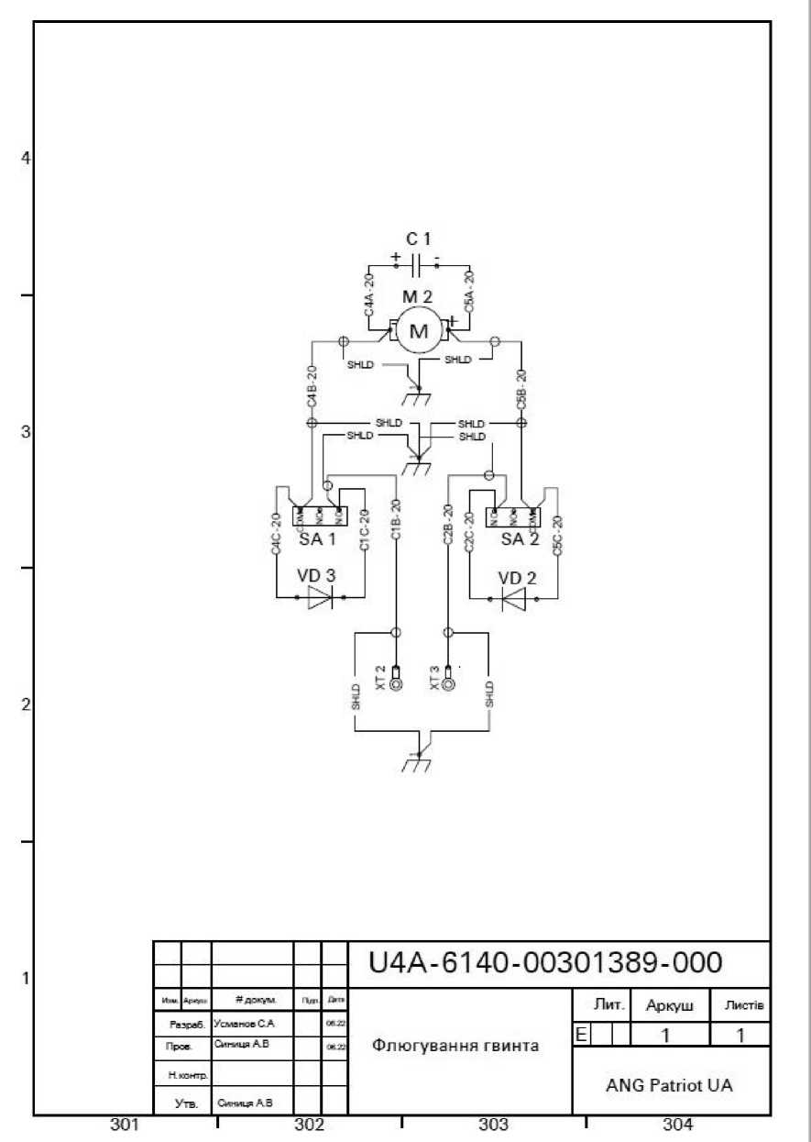



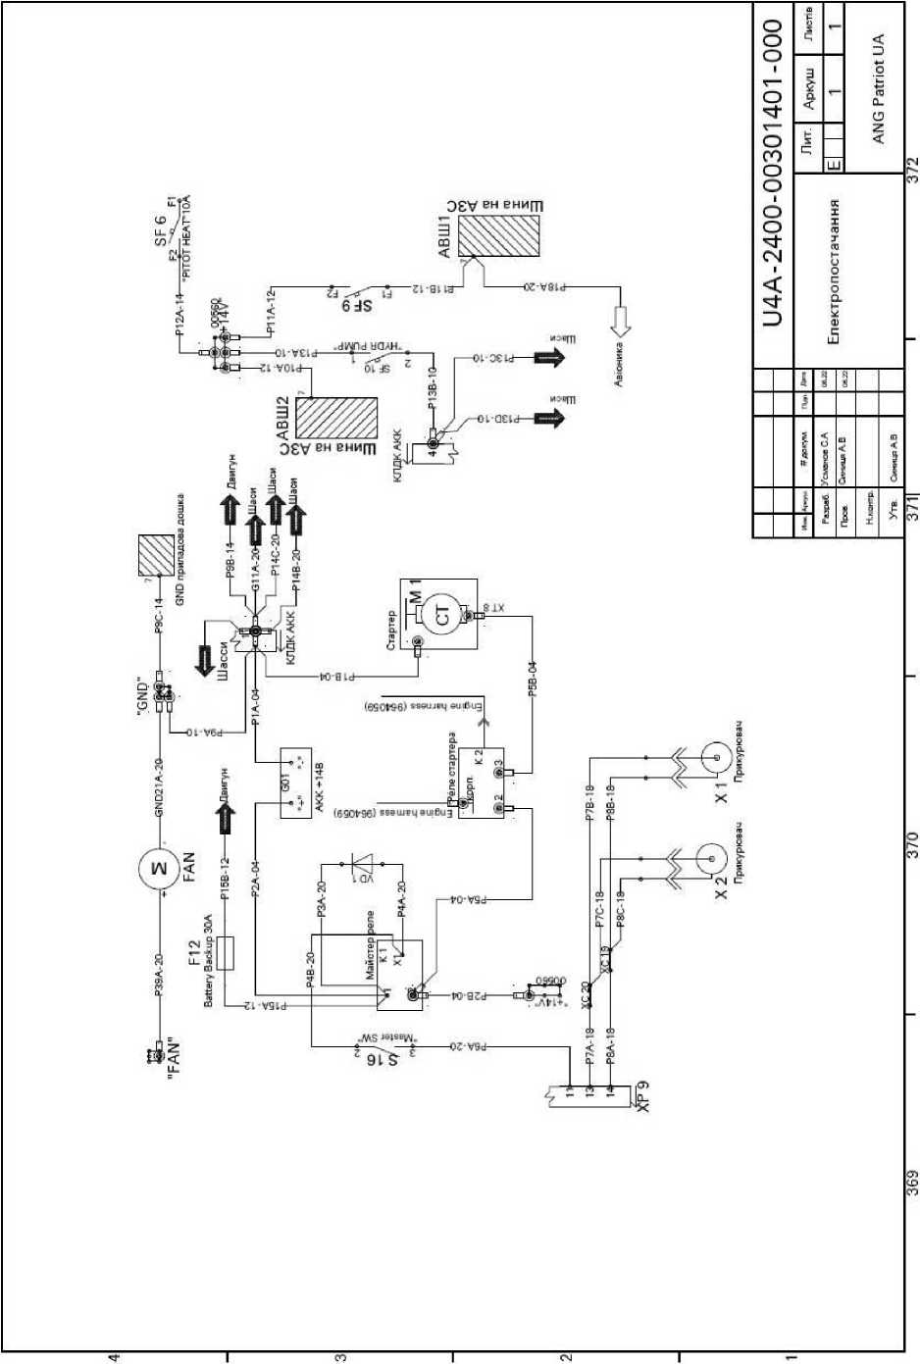

**APPENDICES**

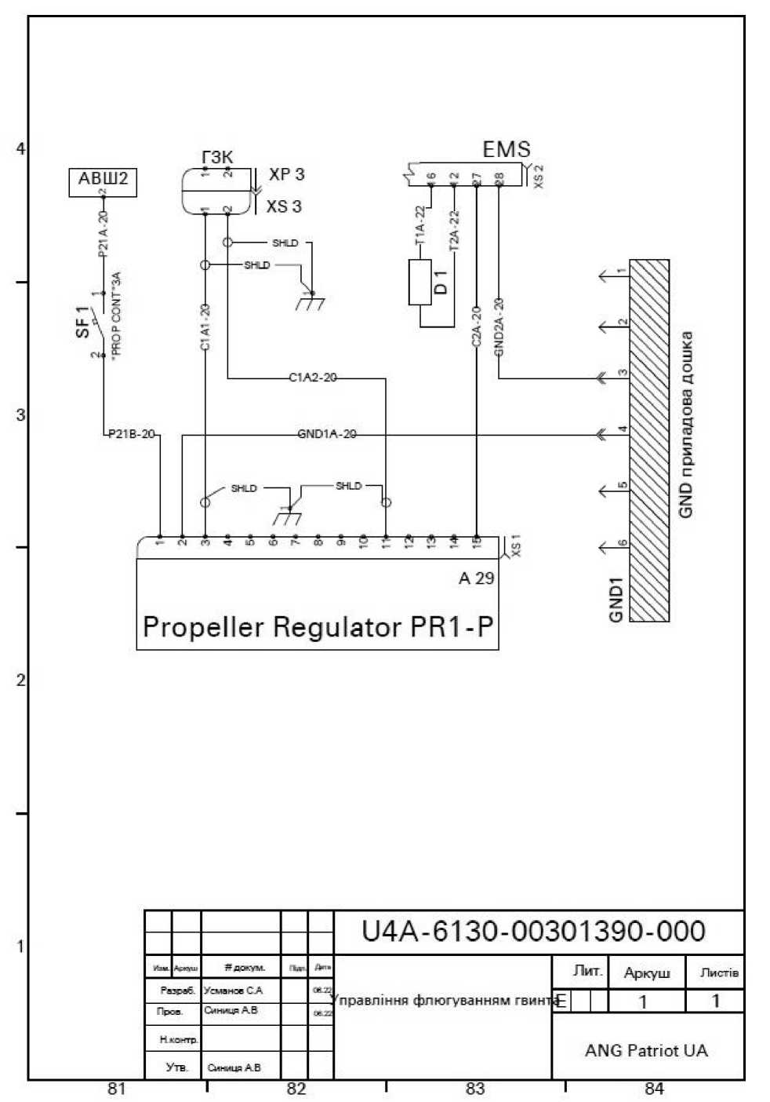



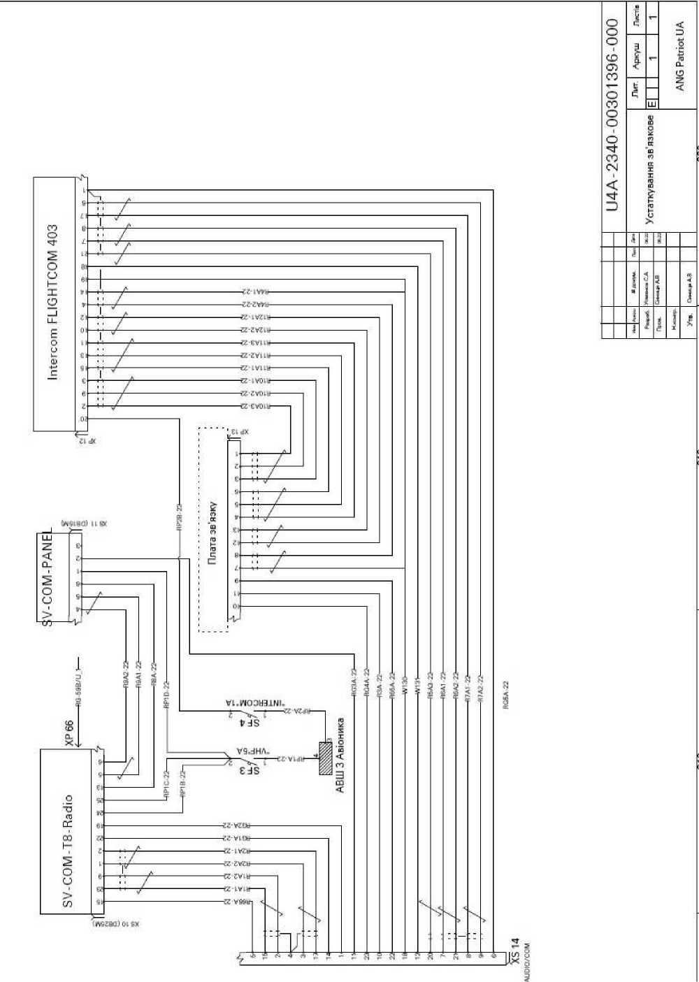

4

З

2

і

325

**Gray-**

**-Whrte-**

**Wirte/Orange- -White/Green-**

**White/Blue.**

M Z

**PACT2-10 gyroid trimmer**

|  |  |  |  |  |
| --- | --- | --- | --- | --- |
|  |  |  |  |  |
|  |  |  |  |  |
|  | -4*7 - і | **"docum** | **TWI** | /Ut* |
| **Developer** | | **UsmvnoeS.A.** |  | ► .. |
| **Prov.** | | CHhmjrA.B |  | T .1 |
| **N. Coitre** | |  |  |  |
| **By the way.** | | **Sym>"^1AB** |  |  |

326

HC 13

XC 14

XÇ 15

XÇ 16

XC 17

U4A-2730-00301394-000

Trimmer drive

327

|  |  |  |  |
| --- | --- | --- | --- |
|  | Lit. | Sheet | **Letters** |
| E |  | 1 | **1** |
|  | ANG Patriot UA | | |

328

**APPENDICES**

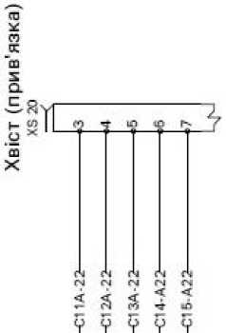



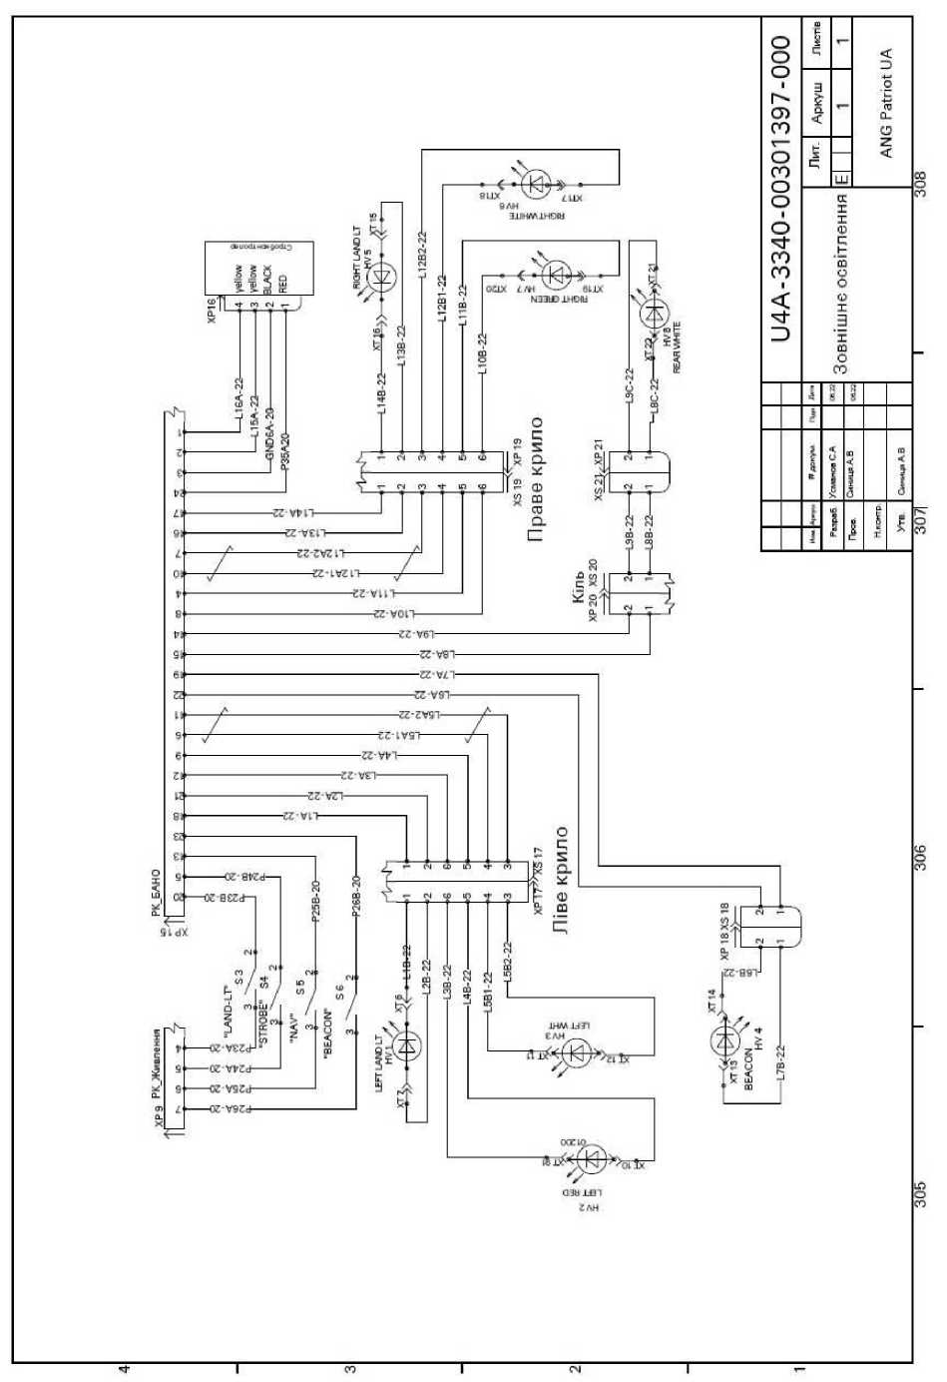

**APPENDICES**

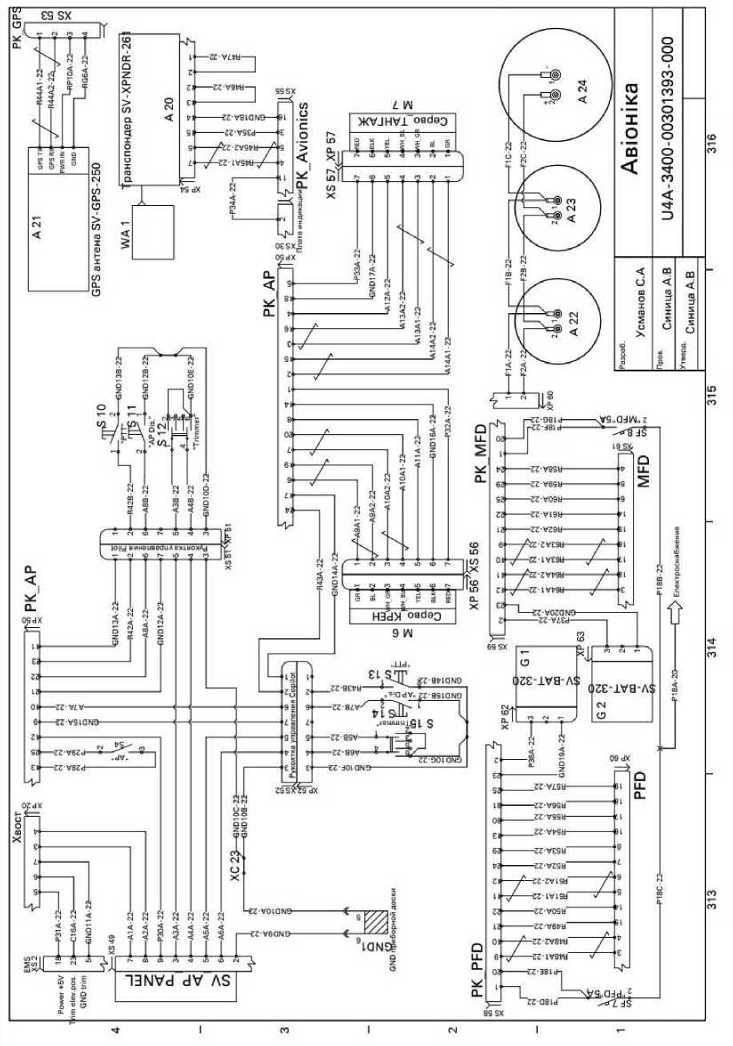

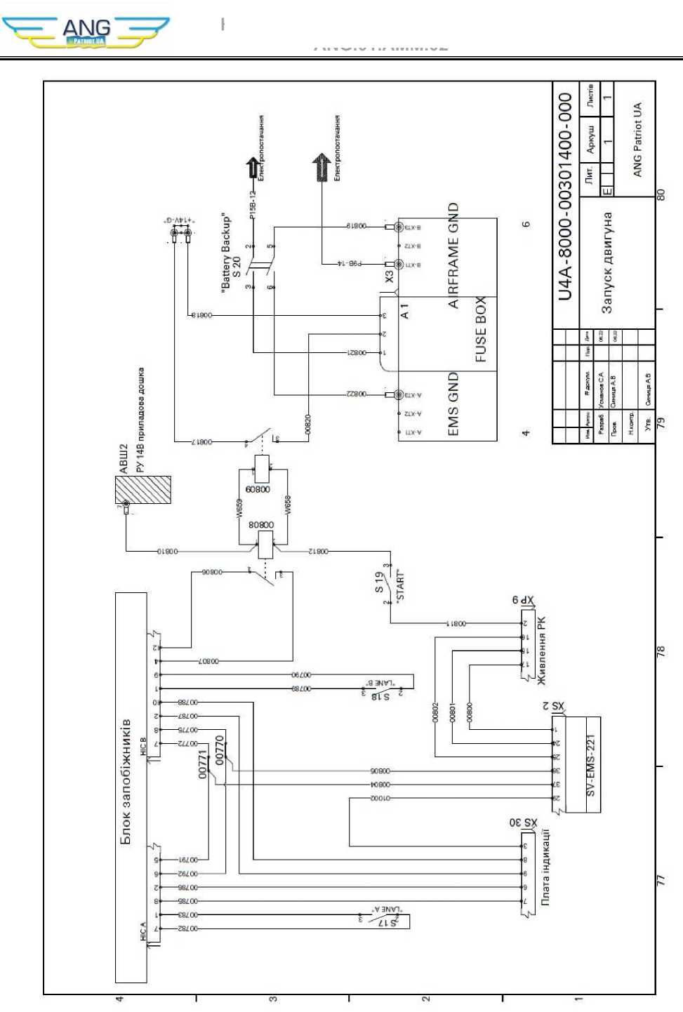

1

**APPENDICES**

|  |  |  |  |  |
| --- | --- | --- | --- | --- |
|  |  |  |  |  |
|  |  |  |  |  |
|  | **A.W*.** | **"®ÄW** | Lt |  |
| **Razrvb.** | | **UsmviavSA** |  |  |
| **Washing.** | | **Synod AB** |  | **L A.** |
| **Nyantra** | |  |  |  |
| **By the way.** | | **Cmhml^ AB** |  |  |

**C7A-2O**

**C8A-2O**

**(MOLI .22**

Flaps

|  |  |  |  |
| --- | --- | --- | --- |
|  | Lit. | Sheet | **Letters** |
| Є |  | **1** | **1** |
|  | ANG Patriot UA | | |

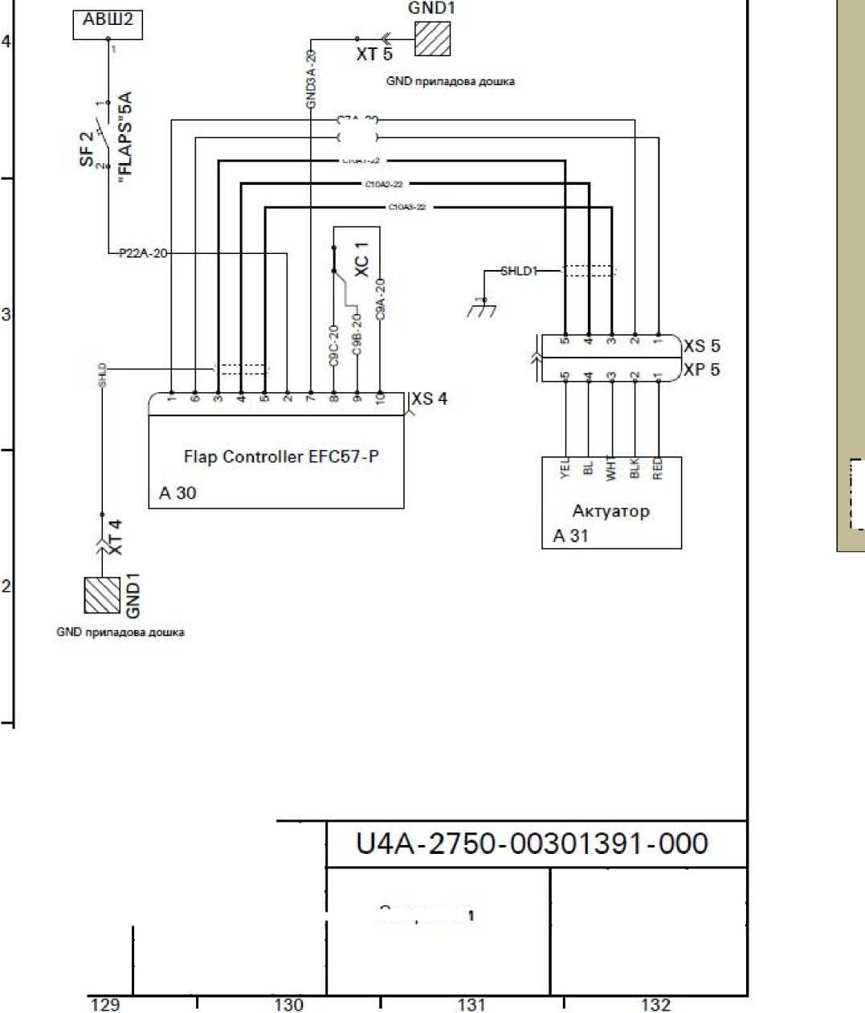

4

**S1B-20**

**S2B-20**

і

121

|  |  |  |  |  |
| --- | --- | --- | --- | --- |
|  |  |  |  |  |
|  |  |  |  |  |
| **Lin** | **Ch "m.** | **^doc.** | **Dust** | **^-** |
| **Developer.** | | **Usmanov SA** |  |  |
| **Proa** | | **SyngentaLV** |  | **і"^** |
| **N poitr** | |  |  |  |
| **By the way.** | | **Sinshea A.V.** |  |  |

Pilots' seats

122

U4A-2500-00301392-000

123

|  |  |  |  |
| --- | --- | --- | --- |
|  | Lit. | Sheet | **Letters** |
| **Е** |  | **1** | **1** |
|  | ANG Patriot UA | | |

124

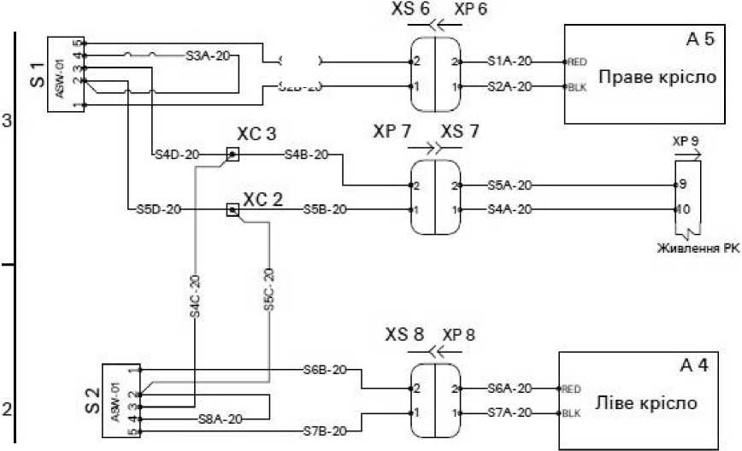

36135.R4

2

і

36135.nl

36135.R3

36135.R2

145

36135.HVIeng warn a

**W1+**

36135.HV2

|  |  |  |  |  |
| --- | --- | --- | --- | --- |
|  |  |  |  |  |
|  |  |  |  |  |
| **Lee** | **Arwi** | **Yadokum** | **d Ue** |  |
| **Developer.** | | **Usmanov S A** |  |  |
| **Preje.** | | **Cwhmur AB** |  | *■г ^* |
| **N coggtr** | |  |  |  |
| **By the way.** | | **Sigma AB** |  |  |

U4A-3150-00301398-000

Indication board

146

147

|  |  |  |  |
| --- | --- | --- | --- |
|  | Lit. | Sheet | Letters |
| **Е** |  | **1** | 1 |
|  | ANG Patriot UA | | |

148

**APPENDICES**

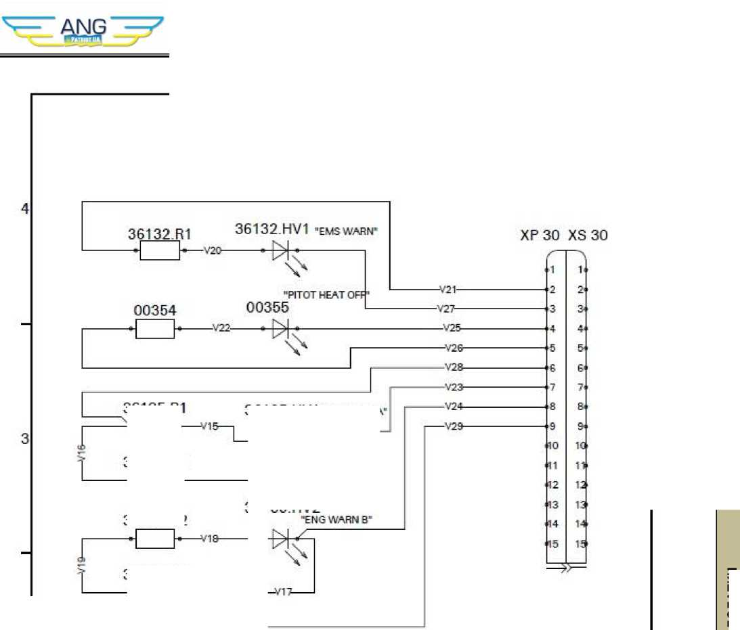

4

Chassis release board

**Indication board**

і

U4A-3100-00301395-000

Apw

**Fa era5**

**?^ to kum /smanse S. A Sinitsa AB**

**-Ь-**

Alarm system

Ute

**Sigmia A.V.**

377

378

379

|  |  |  |  |
| --- | --- | --- | --- |
|  | Lit. | Sheet | Letters |
| **Е** |  | **1** | 1 |
|  | ANG Patriot UA | | |

380

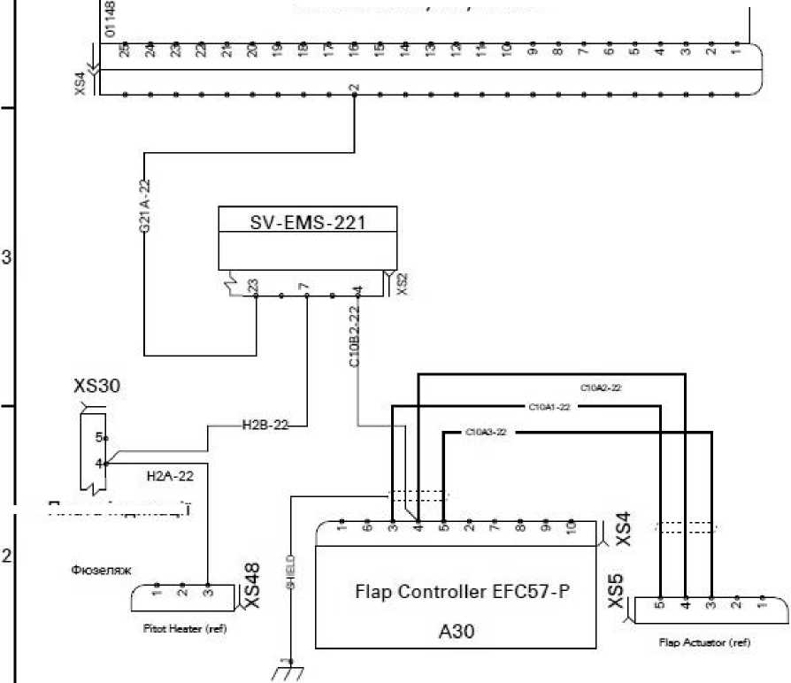

**APPENDICES**

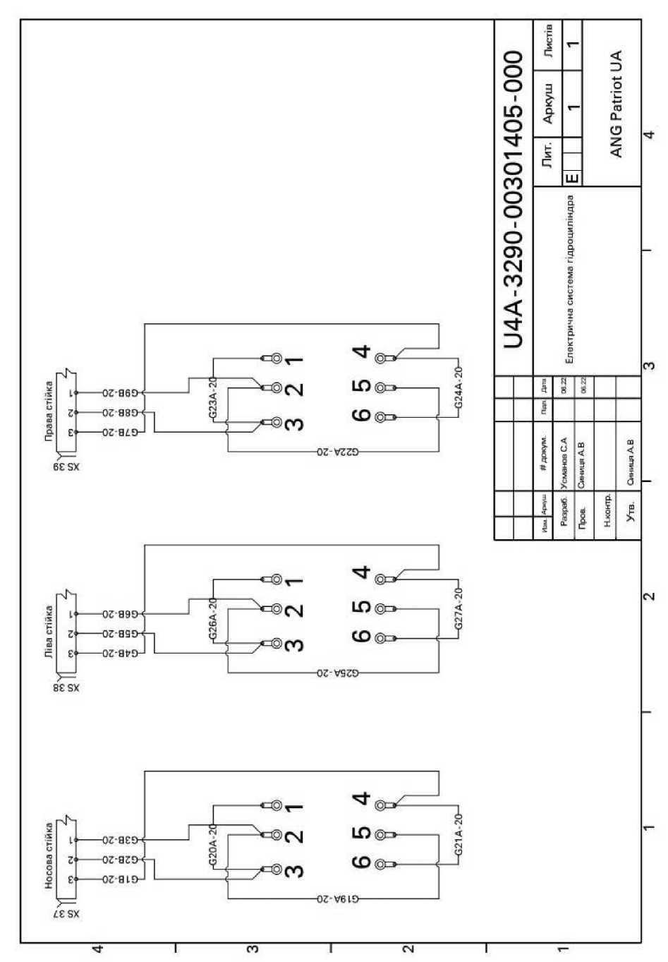

B1 OAT Probe

t

3

**1**

373

SV-ADAHRS-20QA 10

U4A-3450-00290153-000

**"kA deck**

**Pa muffin.**

**Nkemgr**

**Approved by.**

**SyshtsyaAV**

374

**Navigation**

375

|  |  |  |  |  |
| --- | --- | --- | --- | --- |
|  | Lit. | | Sheet | **Letters** |
| **Е** |  |  | **1** | 1 |
|  | ANG Patriot UA | | | |

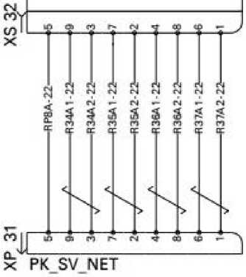

**APPENDICES**

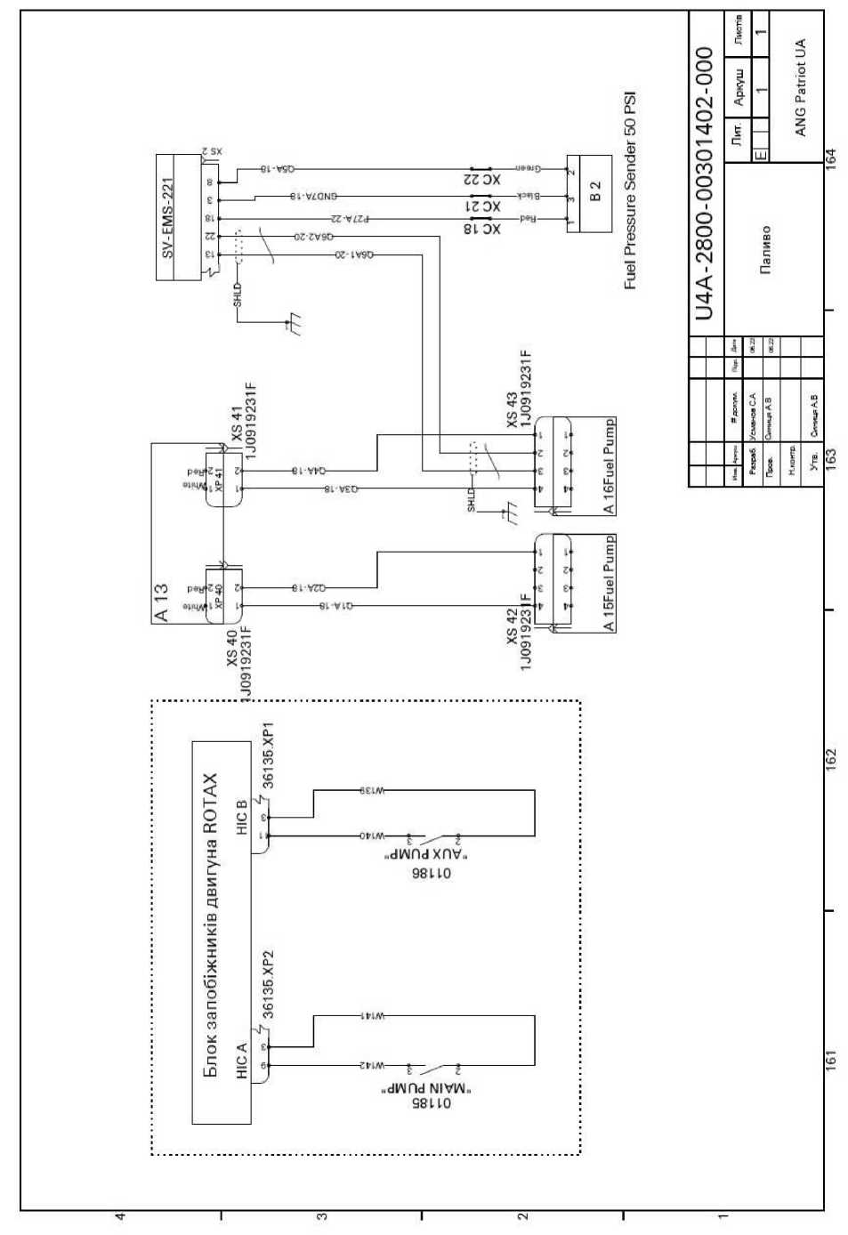

Heater Controller

**APPENDICES**

і

133

|  |  |  |  |  |
| --- | --- | --- | --- | --- |
|  |  |  |  |  |
|  |  |  |  |  |
| **/з\*** |  | **LIE.** | **ft"'** |  |
| **Razovb.** | | **UsmanoSA** |  | **► 7.** |
| **"roar** | | **Synthia AB** |  |  |
| **Nkoitr.** | |  |  |  |
| **Approved by.** | | **Sigma AB** |  |  |

Heating of VAT

U4A - 3030-00301399-000

134

135

|  |  |  |  |
| --- | --- | --- | --- |
|  | **Lit.** | **Sheet** | **Letters** |
| Е |  | 1 | 1 |
|  | ANG Patriot UA | | |

136

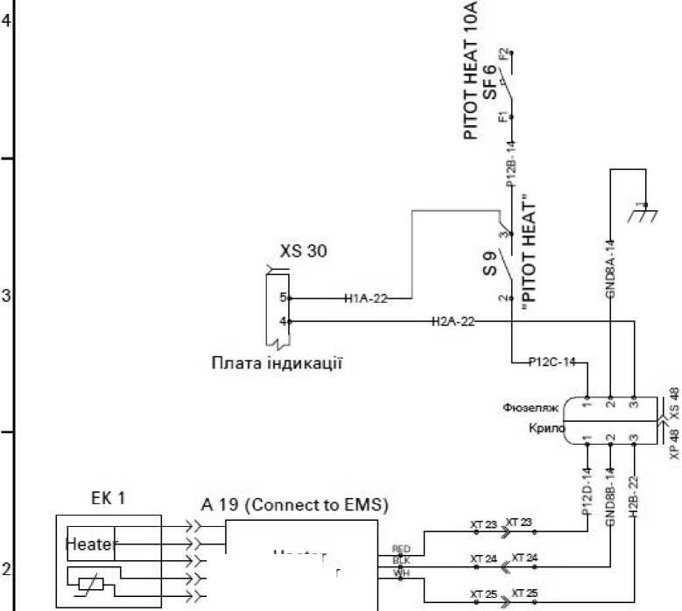

AR Panel

SV-NET harness

373

375

|  |  |  |  |  |
| --- | --- | --- | --- | --- |
|  |  |  |  |  |
|  |  |  |  |  |
|  | A^S | **Yadrsum** | **1 Ur-.** | **4-Й'"** |
| **^ASPVS** | | **UsmanoSA** |  | **- -** |
| **Project.** | | **Son""#: AB** |  | **^Л** |
| **Nxmtr** | |  |  |  |
| **IN TB.** | | **Synthia AB** |  |  |

**R14A2-22**

**R15A1-22**

**R15A2-22**

**R16A1-22**

**R16A2-22**

**RI 7A1-22**

|  |  |  |
| --- | --- | --- |
| **Lit.** | **Sheet** | **Letters** |
|  | 1 | 1 |
| ANG Patriot UA | | |

