FLIGHT MANUAL
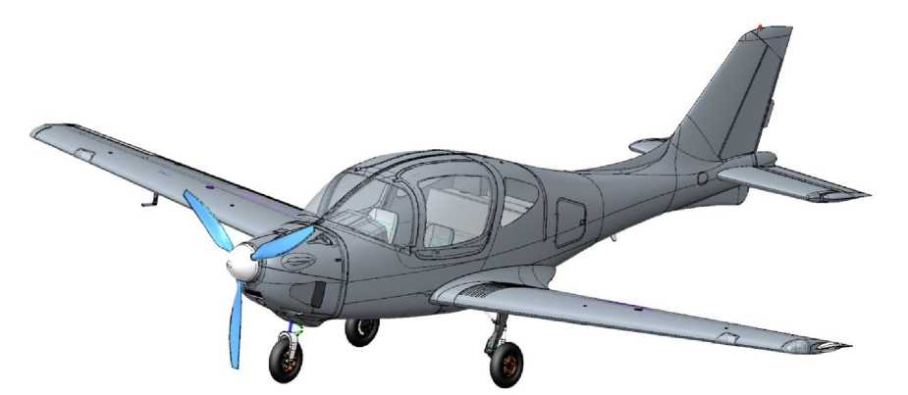
VELOCE-ANG-01

PILOT OPERATING HANDBOOK - POH

VELOCE-ANG.01.POH

INFORMATION ABOUT THIS DOCUMENT
Title: VELOCE-ANG-01 Pilot Operating Handbook
Designation: VELOCE-ANG.01.POH (Revision 01)
Developer: Inna Golovach (Brovary, Ukraine)
Purpose: regulates the specific operating rules for the VELOCE-ANG-01 aircraft.
Applicability: VELOCE-ANG-01 aircraft
Audit registration sheet
№ Audits | Date of issue/date of approval by SASU | Name of the person who made the changes | Date of amendment / date of approval by SASU | Signature
00 | 24.12.2021 | Holovach I. I.
01 |  | J. Fettig | 15.04.2026

INFORMATION ABOUT THIS DOCUMENT 2
SECTION 1. INTRODUCTION 4
SECTION 2. DESIGN DESCRIPTION 7
  - Classification, purpose of the aircraft ...........................................................................................................7
  - General information 8
  - Basic geometric dimensions 10
  - Aircraft Airframe 11
  - Power plant 13
  - Landing gear and hydraulic system 15
  - Electrical system 16
  - Instrumentation equipment 17
  - Cabin features and rescue equipment 20
SECTION 3. OPERATING LIMITATIONS 23
  - MTOW in Weight and Balance Procedure 24
  - Crew capacity 26
  - Speeds 26
  - Flight altitude 27
  - Load Factor 27
  - Maneuvering 27
  - Types of flights 28
  - Airfields 28
  - Powerplant 29
SECTION 4. STANDARD PROCEDURES 31
  - Pre-flight inspection 32
  - Starting and shutting down the engine 34
  - Taxiing 36
  - Takeoff 37
  - Climb 38
  - Horizontal flight 39
  - Aerobatics 40
  - Descent/Best Glide Speed (Engine Failure Procedure) 41
  - Landing 42
  - Go-around 44
  - After flight procedure 44
SECTION 5. EMERGENCY PROCEDURE 46
  - Use of the rescue system 47
  - Engine failure on the ground 48
  - Engine failure at low altitude 48
  - Engine failure at high altitude 48
  - Fire in the engine compartment on the ground 49
  - Fire in the engine compartment in flight 49
  - Fire in the cabin 49
  - Unintentional spin 50
SECTION 6. ACTIONS IN DIFFICULT SITUATIONS 52
  - Forced landing 53
  - Encountering a zone of significant turbulence 54
  - Impaired visibility 54
  - Icing 54
  - Pitot tube malfunction and angle of attack 55
  - Primary flight navigation system malfunction 55
  - Power failure 55
  - Rudder trim tab malfunction 55
  - Flaps malfunction 56
  - Landing gear failure 56
SECTION 7. FLIGHT CHARACTERISTICS 58
  - Introduction 58
  - Takeoff 60
  - Landing 62
  - Climb 63
  - Descent 64
  - Flight range and duration 65
APPENDIX 1 CHECKLISTS 66

SECTION 1. INTRODUCTION
The VELOCE-ANG-01 Pilot Operating Handbook (hereinafter referred to as POH, Pilot Operating Handbook or the Handbook) is issued in Ukrainian, and currently issued in this English version. The POH provides specific rules for flight operation of the VELOCE ANG-01 type light aircraft that are required for its safe operation.
POH contains data on the composition and functioning of systems, components, and assemblies, necessary for the flight operation of the aircraft.
POH lists the malfunctions that can lead to severe accidents and provides recommendations for mitigating or eliminating them.
POH is the only flight document governing the operation of the VELOCE-ANG-01 airplane. Aviation operations not specified in POH are PROHIBITED.
The existing POH is not a substitute for competent theoretical and practical training. Failure to comply with the provisions of the POH may result in the breakdown, loss of the aircraft, or tragic consequences.
The pilot is allowed to operate the VELOCE-ANG-01 aircraft with a PPL or CPL certificate and only after a detailed study of the available POH.
The developer is not obliged to provide the existing Handbook in printed form.
Permission to print the Handbook is granted to third parties. Preferred print format: A5 size.
It is also convenient to have an electronic version of the Handbook on your tablet or smartphone. The electronic version in PDF format (with a ban on making changes) has a structure of sections, subsections and chapters, as well as working cross-references that make it easier to find the information you need.
Checklists for flights are provided in APPENDIX 1.
The list of equipment with which flights are permitted to operate (MMEL, Master Minimum Equipment List) is provided in ANNEX 3 of the Technical Operation Manual ANG.01.АMM.
Changes and additions to the POH are issued instead of or in addition to the existing material in the form of separate standard sheets.
These changes or additions are noted in the Change Registration Sheet, indicated by a vertical line in the fields to the right opposite the changed part.
In the lower left side of the modified page, in the line of the Revision number, the text "Change" is placed with the change number. Also, instead of the revision number and the date of the previous revision/change, a new revision/change number is placed with the new date. In the printed version of the Handbook, the previous version of the changed page is removed and destroyed.
CAUTION! Flight operations of VELOCE-ANG-01 without POH are prohibited.

Definition of terms
Information of critical and particular importance is indicated by CAUTION, WARNING, and NOTE in bold, capitalized font. The importance of the instructions is further emphasized by the color-coding (red, orange, and green, respectively) of the text. Each of these terms is defined below.
CAUTION means that failure to follow the appropriate procedure or condition may cause an aviation accident with serious consequences.

WARNING means that failure to follow the appropriate procedure or conditions may result in damage to the aircraft or crew.

NOTE draws attention to special circumstances that need to be emphasized, provides necessary information and explanatory material.

All numerical values given are in Imperial units of measurement.

Abbreviations
ADAHRS - Air Data and Altitude Heading Reference System
AMM - Technical operation manual (Aircraft Maintenance Manual)
ANL - Airborne navigation light
CAS - Calibrated Airspeed (indicator)
CB - Circuit breaker for on-board power system
CG - Center of gravity of airplane
CS - Control Stick (aircraft control stick)
CS-23 - Airworthiness standards
EASA - European Aerospace Agency/FAA (Federal Aviation Administration)
ECU - Engine control unit
EGT - Engine cylinder head temperature
ELV - Elevator - Elevator control
EMS - Engine monitoring unit
EOM - Engine operating mode
FC - Fabric cover - Paint and varnish coating
GNSS - Satellite Navigation System (global nav satellite system)
IFR - Instrument flight rules
ISA - International Standard Atmosphere
LSA - Light Sport Aircraft
MAC - Medium Aerodynamic Wing Chord
POH - Flight operations manual or Pilot Operating Handbook
RDR - Rudder (Directional Control)
RW - Runway
STROBE - Onboard Flashing Light
THR - Throttle
V₂ - Takeoff safety speed
VA - Maneuvering speed
V_{REF} - Landing reference speed
V_{D} - Maximum design diving speed
V_{NE} - Maximum structural cruising speed
VFR - Visual flight rules
VPP - Variable pitch propellor
V_{S} - Stall speed
V_{Y} - Vertical speed, (best rate of climb speed)

SECTION 2. DESIGN DESCRIPTION
DESIGN DESCRIPTION

2.1 Classification, purpose of the aircraft 7
2.2 General information 8
2.3 Basic geometric dimensions 10
2.4 Airframe 11
2.5 Power plant 13
2.6 Landing gear and hydraulic system 15
2.7 Electrical system 16
2.8 Instrumentation equipment 17
2.9 Cabin features and rescue equipment 20

Introduction
This section describes the classification and purpose of the VELOCE-ANG-01 aircraft, with information about its design and the functional purpose of its main components.
The text and graphic material presented herein are sufficient for the safe flight operation of the VELOCE-ANG-01 aircraft.
2.1 Classification, purpose of the aircraft
The VELOCE-ANG-01 belongs to the LSA1 class (maximum takeoff weight up to 2600 lbs.).
VELOCE-ANG-01 is a normal category, non-aerobatic aircraft. When equipped in accordance with applicable regulations, the aircraft is approved for daytime and nighttime operations, and for flight under Visual Flight Rules (VFR) and Instrument Flight Rules (IFR), in non-icing meteorological conditions and away from zones of thunderstorm activity.
It is FORBIDDEN to perform complex aerobatic maneuvers with the VELOCE-ANG-01, unless it is otherwise and specifically equipped to do so.

DESIGN DESCRIPTION
  - General information
The VELOCE-ANG-01 is of a typical aerodynamic design, strutless low-wing aircraft with fuselage, deck-type tail (empennage) assembly, and trapezoidal (tapered) wing.

General view and main geometric dimensions of the VEL-ANG-01 aircraft:
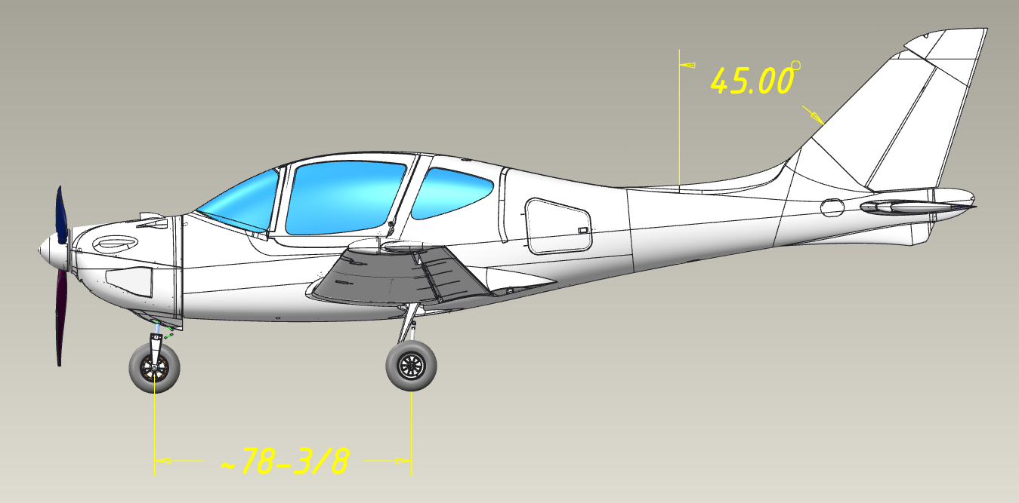
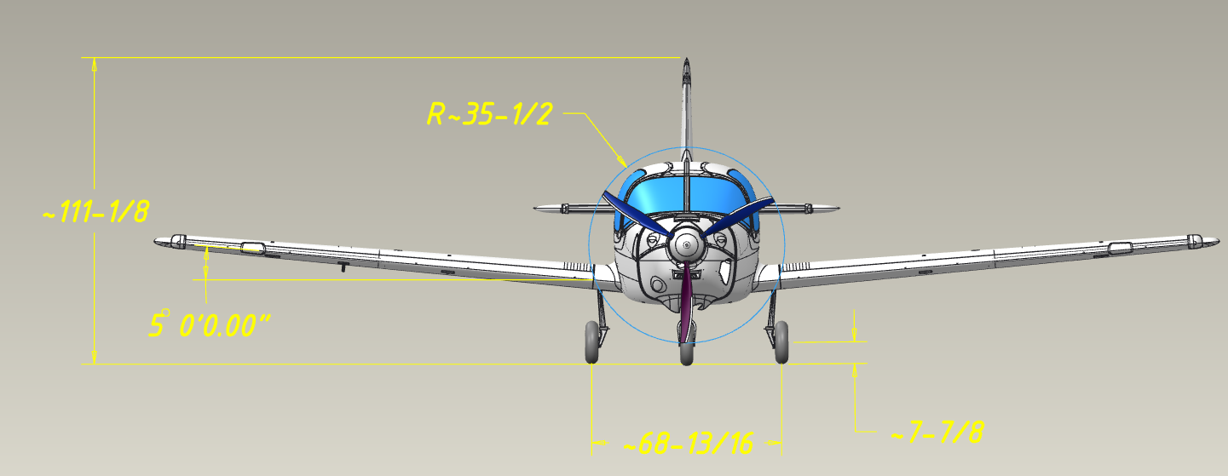
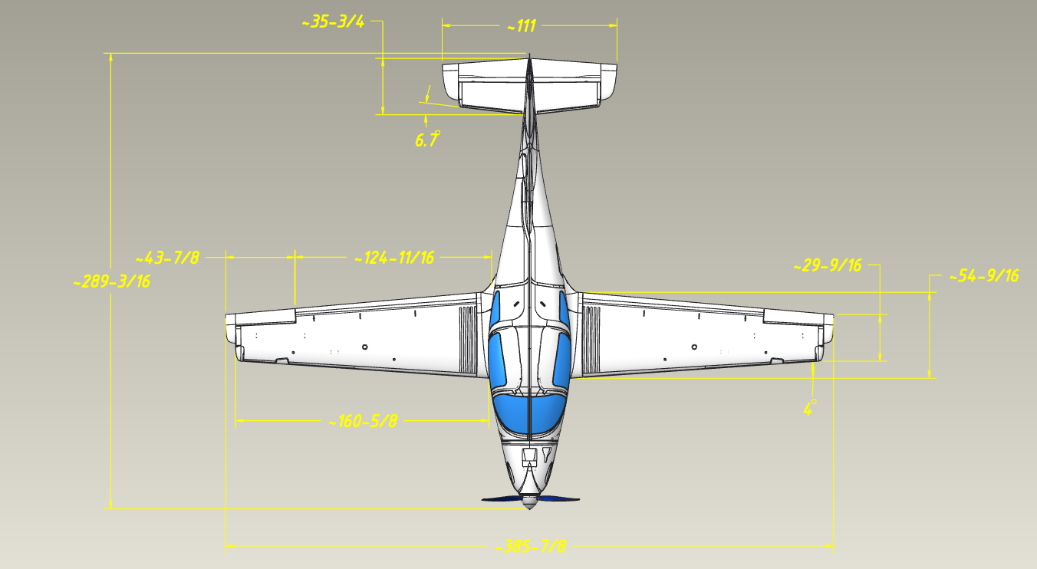
Steering surfaces: two-section elevator (with trim tab on the right section), single-section ailerons, directional rudder (with trim tab plate). All surfaces with an aerodynamic balancing horn. The elevator is equipped with Vortex Generators for greater efficiency.
DESIGN DESCRIPTION
Wing mechanization: two-section slotted flap.
Landing gear: retractable in flight, three-legged (tricycle) with a nose-steerable wheel.
Power plant: one piston engine.
Propeller: a 3-blade, in-flight adjustable variable pitch propeller.
2.3 Basic geometric dimensions
Geometric data (in addition to those defined in the figure in Section 2.2):
 | Component |  | Data type | Value
 | Wing |  | Area | 120.55 sq.ft.
 |  |  | Lengthening ratio | 8.5
 |  |  | Wing taper | 2.0
 |  |  | Leading edge sweep | 4.0°
 |  |  | Lumbar V console angle | 5.0°
 |  |  | Mounting angle on the root rib | 0.0°
 |  |  | Geometric twist | 0.0°
 | Empennage |  | Area | 13.77 sq.ft.
 |  |  | Leading edge sweep | 5.0°
 |  |  | Lumbar V angle | 0.0°
 |  |  | Mounting angle on the root rib | 5.5°
 |  |  | Geometric twist | 0.0°
 | Fuselage |  | Door size* | 3.6x2.6 ft.
 |  |  | Trunk hatch size* | 1x0.66 ft.
 |  |  | Useable luggage compartment volume | 35.3 cu.ft.
 |  |  | Fin mounting angle | 0.0°
 |  |  | Propeller clearance** | 0.66 ft.
 | Landing gear** |  | Track | 6.36 ft.
 |  |  | Base | 6.50 ft.
* Minimum length and width
DESIGN DESCRIPTION
** for static compression of shock absorbers with maximum aircraft weight.

2.4 Aircraft Airframe
DESIGN DESCRIPTION
The general design of the airframe components is described below. For a more detailed description refer to the AMM.
    - Fuselage
The engine compartment is located in the nose (front) of the aircraft. The central part has a non-pressurized cabin (for pilots and passengers), and a luggage compartment. The empennage is in the rear of the aircraft.
The engine compartment houses the engine with its essential operating attachments, as well as pipelines and cabin air intake, cabin heating system, hydraulic power plant, and elements of the landing gear brakes. The lower area of the compartment houses the front landing gear. The battery is located in a separate compartment. The engine is secured on a steel engine mount fitted with shock-absorbing pads, mounted to the power frame No. 1 (with a fireproof coating).
To enter and exit the cabin, there are two doors on the port and starboard sides, which open forward and upward, and also serve as emergency exits (rip pins on the door hinges). Access to the luggage compartment is through the hatch behind the cabin (on the port side).
The cabin is designed for five people, with 1 or 2 (side-by-side) pilots, and 1 to 3 passengers on the rear (bench) seat. The cabin is equipped with ventilation and air heating. In the front area of the cabin there is a recess for equipment, attached to the instrument panel. To the right, there is a small trunk ("glove compartment" for small items and documentation). In the central area of the cockpit are the pilots' seats. In the middle between the pilot's seats is a central armrest/pedestal. It houses an intercom console, landing gear extension/retraction control panel, a handle and a backup landing gear release cylinder (in the armrest). In the rear area of the cabin, is a bench seat (sofa), under which the wing spar box is located. The flight and navigation system sensors are located behind the bench seat, as well as two fuel feed tanks with fittings. At the rear of the central compartment is a luggage compartment and is partially occupied by the parachute rescue system housing.
The tail compartment houses a vertical and horizontal empennage with control (steering) surfaces.
Vertical empennage: swept, symmetrical NACA 65-1-012 profile, composed of a fuselage, made of fiberglass composite materials (to ensure radio-wave transparency, as it houses the radio communication antenna).
Horizontal empennage: arrow-shaped, asymmetrical NACA 6401 profile, one-piece structure, glued into the fuselage, made of carbon fiber and fiberglass composite materials.
    - Wing and mechanization
DESIGN DESCRIPTION
The wing of the aircraft is trapezoidal (tapered) in form, without geometric twist.
Wing profile along the entire span is NLF(1)-215F, with a relative thickness of 16.5%, the average aerodynamic chord is 3.94ft. (at 3.94ft. from the inboard side rib), with 0° wing setting angle.
Structurally, the wing is composed of left- and right-wing panels, made entirely of carbon fiber composite materials, with spars inherently built into them.
The wing panels contain the control system aileron rods and rockers, the mechanization drive shaft, and wiring harnesses. The right console also contains elements of the pitot tube: wiring harnesses (heating controller and pneumatic line).
In the middle part of each console, there is one caisson fuel tank. In the upper part of the consoles is the neck of the corresponding caisson tank.
Mechanization of the trailing edge of the wing: Fowler flap (single-slotted, retractable), with a maximum extension of 16.5% and a corresponding deflection angle of 30°. Intermediate positions are 10° and 20°.
The flap is extended and retracted by a servo drive located in the fuselage in the middle of the corresponding part of the shaft; the extension and retraction are controlled with a separate panel on the central pedestal.
    - Control system
The aircraft control system is traditional, 3-channel: pitch channel (elevator), roll channel (ailerons) and yaw channel (rudder).
The control system is mechanical, consisting of controls (CS; left and right pilot pedals, which are mechanically interconnected), mechanical elements (rods and rockers) and control surfaces.
All control surfaces are slotted, equipped with aerodynamic horn and weight compensation for hinge moments. The elevator is two-sectioned, while ailerons and rudder are single-sectioned.
An electric trim tab is mounted on the right section of the elevator to reduce the force required to deflect the CS (controlled by a button on the CS).
A trimtab is mounted on the rudder for directional (yaw) balancing during flight at cruising speed.
Autopilot servo drives are installed in the pitch and roll channels of the control system.
  - Power plant
DESIGN DESCRIPTION
    - Engine
NOTE: Power ratings and V-speeds for the Rotax 918 iS EP will be confirmed following completion of the test flight program. Refer to the current Aircraft Flight Manual supplement.
The aircraft propeller is driven by means of a step-down gearbox. The fuel-air mixture is formed by means of an injector. In order to enhance power, the engine is equipped with a turbocharger and intercooler.
The engine cooling system is a combination of liquid-cooled cylinder heads, and air-cooled cylinders. The engine is equipped with a closed-loop oil system.
    - Propeller
The propeller type is a three-blade, constant speed, in-flight adjustable variable-pitch propeller, with a diameter of 71.5 inches.
The blades are made of composite materials; the front edge is protected from mechanical damage by a rubber lining. The blades are not heated.
The hub is made of aluminum alloy. The pitch control drive is electric, located on the hub (under the wheel). The pitch control signal is transmitted to the actuator from a separate console (in the cabin, on the central pedestal) via a sliding contact.
    - Monitoring and control
To enable monitoring and control of the power plant, the crew is provided with the following information:
- Engine speed
- Temperature of the cylinder heads (rear)
- Exhaust gas temperature
- Coolant temperature
- Oil temperature
- Oil pressure
- Air pressure in the receiver
- Throttle position
- Fuel consumption (calculated by throttle position
- Fuel pressure in the pipeline
- Remaining fuel in the tanks (total)
- Generator terminals’ voltage (phases A, B)
- Engine operating time (accumulated)

To display this information, the ECU receives it from the engine sensors and additional sensors and transmits it via the CAN bus to the EMS unit for displaying on the Dynon SkyView SV1100 (or Garmin) multifunctional system display.
DESIGN DESCRIPTION
The display also provides warnings of emergency conditions related to the power plant, the Dynon SkyView SV1100 (or Garmin) system generates the appropriate sound alarm and transmits it to the on-board communication system.
Power plant controls in the cockpit:
- Throttle control knob (THR);
- Control panel for the variable pitch propeller (VPP).
The THR (see section 2.8.6 for location) is mechanically connected to the throttle by a cable. The THR is mounted on the center console between the pilots. All other engine control commands are executed by the ECU.
The propeller control panel (see section 2.8.6 for location) operates in manual and automatic modes and is changed over by a toggle switch on the panel. In the manual mode, the pilot sets the required propeller speed with a selector knob (dial). In automatic mode, the speed is set and maintained by the ECU depending on the throttle position. The remote control is equipped with a screen that displays the set engine speed.
    - Fuel system
The fuel is stored in two cantilever caisson tanks and a feed tank in the fuselage, with a maximum total capacity of 68.7 (±2.6) gallons.
The feed tank is located between the rear sofa and the luggage compartment of the central fuselage compartment from below, so that fuel from the cantilever tanks flows into it by gravity.
There are 2 constant-flow pumps installed in the fuel tank, with a built-in fuel gauge. They pump the fuel to the fuel filter located in the engine compartment and then to the engine injector through the discharge pipeline. Excess fuel is returned to the consumption tank from the injector through the drain line.
The drainage in the console and consumption tanks is centralized, with a U-shaped tube (to prevent fuel from spilling into the center compartment) leading to a spigot under the Fuselage. In the cantilever tanks, additional drainage is provided through the filler caps.
  - Landing gear and hydraulic system
DESIGN DESCRIPTION
    - Landing gear
The landing gear is three-pillared (tricycle), three-wheeled, with two single-axle main legs and a single-axle nose support.
All supports are retractable in flight: the nose support retracts backward along the flow, the main ones retract under the fuselage across the flow (towards the aircraft’s plane of symmetry). All gears are equipped with gas-lubricated shock absorbers. The nose gear is telescopic, the main ones are of a lever type.
The nose support with a pivot mechanism is kinematically connected with the direction (yaw) control pedals (±30° angle of rotation of the wheel at full pedal travel). The nose support is centered during cleaning thanks to a special universal joint mechanism.
All wheels are equipped with alloy wheels and chamber pneumatics.
    - Brakes
The main supports are equipped with hydraulically operated disc brakes, without anti-skid automation. Hydraulic brakes are automotive-type: they work without engaging the hydraulic power plant, the tanks are located in the engine compartment.
Braking is performed by pressing the brake pedals located on the directional (yaw) control pedals of both the left and right pilot's seats. (each pilot can apply the brakes independently).
    - Landing gear extension/retraction controls
The position of each landing gear support is indicated by the corresponding green LEDs (they are red in intermediate positions) on the landing gear control panel, located on the central pedestal (see section 2.8.6 for location).
The extended or retracted position of each support is determined by the hydraulic lock built into each cylinder.
When the toggle switch on the landing gear control panel is set to either extension or retraction, the electric driven hydraulic unit is engaged, and the working fluid pressure enters the cylinders on the corresponding side.
In the event of the hydraulic system failure, or a power failure, the landing gear can only be extended by means of the backup system. To do this, set the three-position valve to the LG extension position. This opens the nozzle of the carbon dioxide cylinder (in the cylinder above the valve), the pressure of this gas moves the slide valve, closing the pressure line of the hydraulic power plant and pressurizing the exhaust cavity of each cylinder.
    - Hydraulic system
The pressure source is the electrically driven hydraulic unit in a single assembly with a 0.66-gallon (US) tank and safety valves.
  - Electrical system
DESIGN DESCRIPTION
The power source is generator no.2, built into the engine. Generator no.1 is the power source exclusively for the engine (injector, ignition system, ECU, etc.).
The onboard 12V (24 Ah) lithium-polymer battery is located in a separate compartment in front of frame No. 1. The compartment contains terminals for connecting the onboard power supply and a temperature sensor.
Power supply to the onboard circuit from generator No. 2 is possible only after the engine speed reaches 1800 rpm.
In case of failure of generator No. 1, the engine power supply is automatically switched to generator No. 2. Hence, the generator will be disconnected from the onboard consumer circuit, providing power exclusively to the engine. In this case, the corresponding indicator light on the instrument panel will light up.
The battery supplies power in flight:
- at engine startup: starter and ECU;
- in flight, in case of generator failures: all consumers (15 minutes, in ISA).
  - Instrumentation equipment
DESIGN DESCRIPTION

    - Primary flight and navigation equipment
The primary flight and navigation equipment is the Dynon SkyVieW SV1100 system or, optionally, the Garmin version. System elements:
- Multifunctional display (1 pc.);
- Pitot tube with heating controller;
- ADAHRS primary module;
- Temperature sensor (2 pcs.);
- GNSS module;
- EMS engine communication module;
- Radio station console;
- Autopilot servo drive (2 pcs.);
- Transponder;
- Power supply battery (1 pc.).
All system elements are powered by 12 V DC from the onboard power supply. In the event of a power failure, the system is equipped with an emergency battery that provides power for 30 minutes (in ISA).
The Pitot tube is connected to the ADAHRS module by pneumatic tubing. The tube is heated in case of icing.
The ADAHRS module is a source of data on instrument and vertical speeds, barometric altitude, angle of attack, altitude angles, load factors, and ambient air temperature.
The magnetometer (compass) is the source of magnetic heading data and is also used by the system to calculate the wear angle.
The GNSS module is the source of data for the airspeed, altitude relative to the earth's surface, and the position of the aircraft on the map (in this version of the GNSS module, only GPS NAVSTAR is used).
The EMS module links the power plant data to the system.
The transponder sends the necessary aircraft identification data (current position, altitude, registration number, etc.).
The multifunctional color touch-screen display (see Section 2.8.6 for location) is equipped with processors that compute all current data and generate images of scales and current flight information, navigation, engine, autopilot, transponder information, as well as the aircraft position on the map, flight route, and battery temperature. The display is equipped with brightness adjustment dial and buttons.
Indicated air speed is adjusted according to the instrument correction as calibrated airspeed.
All elements of the Dynon SkyView SV1100 (or Garmin) system are protected against electromagnetic interference, mechanical loads, vibration, humidity, exposure to water, barometric pressure and ambient temperature (exceeding the operational limitations of the aircraft).
DESIGN DESCRIPTION

    - Backup flight equipment
DESIGN DESCRIPTION

In addition to the main Dynon SkyView SV1100 (or Garmin) system, the aircraft is equipped with the following backup flight equipment (see Section 2.8.6 for locations):
- Airspeed indicator
- Vertical speed indicator
- Barometric pressure altitude indicator
- Magnetic compass
- Sideslip indicator.
The instruments are connected to the Pitot tube parallel to the ADAHRS sensors of the main system, and the compass and sideslip indicator operate autonomously.
The airspeed indicator is accompanied by an instrument correction chart (located on the cockpit light frame).
The airspeed indicator has standard color-coded marking to indicate safe operating standards, with minimum speed limit (red), maximum operating speed with flaps extended (white), and maximum operating speed line.
    - Radio communication equipment
External radio communication is provided by the Dynon Skyview Com Radio SV-COM-T8 ultra-shortwave radio station. The antenna feeder of the radio is built into the vertical tail unit (the radio is transparent, made of fiberglass). The radio remote control is located on the instrument panel (see 2.8.6 for location).
Internal radio communication provides a subscriber node for 5 people with headset plugs, including an intercom (see section 2.8.6 for location).
Headsets with noise reduction are recommended.
    - Taxi/Landing Lights
The aircraft is equipped with airborne navigation lights (ANL), flashing lights (STROBE) and taxi/landing lights. The taxi/landing lights are located in the left and right wing tips (one per side) and are controlled by the LAND LIGHT switch on the instrument panel.
The aircraft is equipped with a glass panel avionics suite; display backlighting is controlled through the avionics panel brightness settings. There is no separate cockpit flood or instrument lighting installed.
The right and left wing consoles have green and red ANLs, respectively, and the fuselage has a white ANL on the tip.
The STROBE is located on the ends of the right and left wing consoles (in conjunction with ANL), as well as on the top of the directional rudder (separately).
    - Instrument Warning Lights
DESIGN DESCRIPTION

Warning lights are on the instrument panel (see section 2.8.6 for location):
- Circuit A of the ignition system ("CH A" of the "ENG WARN" group);
- Circuit B of the ignition system ("CH B" of the "ENG WARN" group);
- Operation of the engine monitoring system ("WARN EMS");
- Operation of the Pitot tube heating ("PITOT HEAT").
All lights are equipped with placards, with typical abbreviations that clearly indicate their functional purpose.
Green lights indicate normal operation of the respective systems. Red lights indicate failure or faulty conditions. Failure status is repeated by audio notifications through the intercom.
Light and sound alarms are generated in the Dynon SkyVieW SV1100 system (or Garmin) system.
    - Instrumentation layout
General view of the instrument panel and central control console:
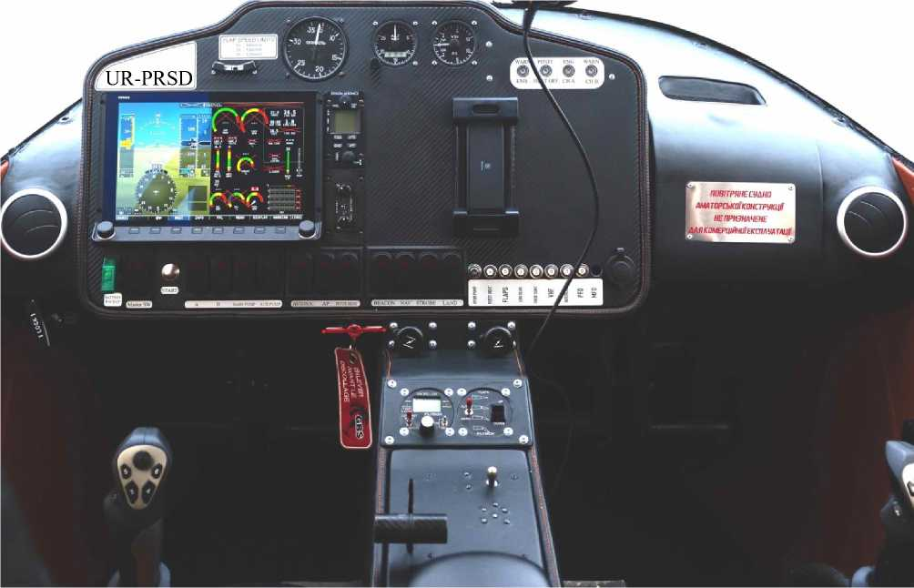
  - Cabin features and rescue equipment
DESIGN DESCRIPTION
    - Seats and safety belts, cabin interior
Pilots have individual seats that are separately adjustable lengthwise, using the buttons on the central armrest, allowing for comfort and reach of the controls (depending on pilot’s height).
The aircraft control system controls (CS and pedals), the instrument panel with flight and navigation equipment, toggle switches, and CB are located in front of the pilot(s) and are reachable while seat belt is secured. The controls for the power plant, landing gear and intercom system are all on the central pedestal between the pilot’s seats.
In addition to the pilot, the aircraft can accommodate up to 4 more people. One person in the front seat, and three people on a solid three-seater sofa in the rear cabin area. The rear seats are not individually adjustable.
The pilot and other occupants are secured in their seated position with individually adjustable 4-point safety seat belts. Reliable fastening of the belt fittings to the aircraft structure is ensured, in case of emergency landing.
The cabin interior is made of non-flammable and easy-to-clean materials.

    - Ventilation and cabin heating
The cabin is ventilated with ambient air through vents, which are located to the left and right of the instrument panel.
The regulating valve is operated by a retractable handle on the central pedestal. Air distribution is controlled by moving the vents.
The cabin is heated by removing excess heat from the liquid-cooled radiator, via to a special casing. The casing is connected to the vents via a flow control valve.

    - Luggage compartments
DESIGN DESCRIPTION
The aircraft is equipped with a separate luggage compartment, a small “glove” compartment on the instrument panel, and a compartment in the armrest.
The luggage compartment is designed to accommodate carry-on luggage, such as medium size bags or suitcases, and other items. The maximum total weight is not more than 133 lbs.
For securing luggage, a mesh net is provided, which is attached to special tie-down fittings on the reinforced floor of the compartment.
CAUTION Exceeding the maximum baggage weight or not securing the baggage properly can cause a critical change in centering and consequently reduce the aircraft's controllability.
The small trunk (glove compartment) is designed to store operational documentation: POH, AMM, Forms and Log Book, of the aircraft and the engine, as well as small items and documents.
The compartment in the armrest is used to access the Landing Gear Emergency Release valve (see section 2.6.3) and for storing the POH (must be kept within Pilot’s easy access).
Access to the luggage compartment is possible only on the ground, from the outside, through a separate hatch on the port side, that opens against the airstream to prevent opening in flight.
Luggage compartment and small trunk are lined with fleecy, non-flammable and easy-to-clean materials.

    - Rescue system
DESIGN DESCRIPTION
The aircraft is equipped with the Galaxy GRS 6/750 SDS Speedy FF Soft B13 rescue system, which provides emergency landing of the aircraft, with a maximum weight, by means of a parachute, in the speed range of 32 to 173 KIAS (all data are within the operational limits of the VELOCE-ANG-01 aircraft), at a minimum altitude of 270 feet.
The system consists of a single container with a packed parachute, and a powder parachute release device (containing powder charge). The system is installed on the aircraft in a special box in the rear area of the central fuselage compartment, on the right side. The compartment is covered with a separate lid.
The straps of the rescue system are enclosed in the longitudinal and intersecting grooves in the top part of the fuselage, under protective covers. The ends of the straps are securely attached to the parachute and fuselage power elements.
The rescue system is activated by a handle (with a security peg), which is mechanically connected to the parachute release device. This activates the powder charge device to pierce the box lid (in the fuselage) and open the parachute.

SECTION 3. OPERATING LIMITATIONS
OPERATING
LIMITATIONS
  - MTOW in Weight and Balance Procedure 24
  - Crew capacity 26
  - Speeds 26
  - Flight altitude 27
  - Load factor 27
  - Maneuvering 27
  - Types of flights 28
  - Airfields 28
3.9 Power plant 29

Introduction
This section outlines all the necessary operating limitations of the VELOCE-ANG-01 aircraft, the compliance of which ensures its safe operation.
For further aircraft operating limitations necessary for its safe operation and maintenance, see the Aircraft Maintenance Manual ANG.01.AMM.
CAUTION 1. The pilot must be familiar with all these limitations.
2. Failure to comply with these limitations may result in damage to the structural elements of the aircraft or create conditions for serious accidents.

  - MTOW in Weight and Balance Procedure
OPERATING
LIMITATIONS
            - 3.1.1 The minimum flight weight of the aircraft is 1212 lbs. and is determined by the sum of:
- Weight of empty equipped aircraft: 1014 lbs. (maximum)
- Weight of the 1st pilot: 170 lbs. (according to CS-23)
- Fuel weight: 29 lbs. (4.5 gallons) for flight duration of 30 minutes.
    - The maximum flight weight of the airplane is 2,100 lbs (SLSA) or 2,600 lbs (EAB):
- Weight of empty, equipped aircraft: 1014 lbs. (maximum);
- Weight of the 1st pilot: 170 lbs. (according to CS-23);
- Weight of 4 people is 170 lbs. each, and 680 lbs. total (according to CS-23), which is the full crew;
- Fuel weight: 507 lbs.
NOTE The weight of an empty equipped aircraft is determined without crew, baggage, fuel (except for non-drainable residue), and ground equipment. The aircraft is filled with hydraulic fluid, oil, and engine coolant.
WARNING Determining the actual weight and balance in a particular combination of the number and weight of persons on board, their luggage, and the amount of fuel, should be performed in accordance with the methodology set out in the AMM without exceeding the applicable MTOW: SLSA-certified aircraft MTOW = 2,100 lbs (load limits +3.8g / -1.8g); EAB-certified aircraft MTOW = 2,600 lbs (load limits +3.0g / -1.5g)
    - Centering range
Weight and balance chart with the area of limitations, all possible combinations of the number of pilots, passengers, luggage, and fuel consumption:
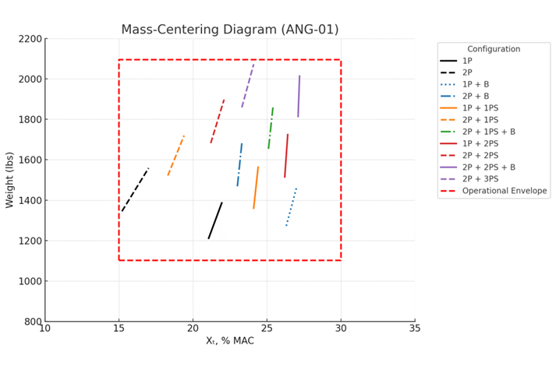
The designation "1P" means an aircraft with one pilot, "2P" - with two
OPERATING
LIMITATIONS
pilots, "1P+B" - with one pilot and 130lbs of luggage in the luggage compartment, "1P+1L" - with one pilot and one person in the back seat, etc.
The center position changes insignificantly with the consumption of fuel, within the limits of 3% MAC, this change may not be taken into account in the calculations (determine the weight and centering in the most extreme case, i.e., by the amount of fuel).
Forward centering limit of 20% MAC is obtained with a minimum amount of refueling in the "2P" combination, rear centering limit of 28% MAC in the "2P+2L+b" combination with refueling of 37 gallons.
CAUTION: When landing with CG at 15–20% MAC (forward limit), maintain approximately 10% throttle on final approach — do not reduce to full idle until main wheels are on the ground.
Up to 300 lbs is allowed structurally in the luggage compartment, but only if it remains within the weight and balance and total gross weight of the plane limits overall. No more than 120 lbs is recommended as a general rule of thumb, but that still must also be within the weight and balance and total gross weight of the airplane.
CAUTION Combinations "1P+3L+b", "2P+3L+b" are PROHIBITED because they are outside the operating range.
NOTE: The front center of gravity with two pilots can be 10% or 7% ONLY after practice. You can begin flights with a 66 lb. load at the end of the luggage compartment, (or enough to move the CG back more than 15%). Fly for 5 to 10 hours so the pilot gets accustomed to it and then remove the weight bit by bit and see the difference. Without weight on landing, the plane will start to lower its nose at a speed 2.6 – 5.2 KIAS more than normal. That is, not at 38 KIAS, but at 42 to 46 KIAS. But for safety purposes, there is no difference. This is countered by adding 10% throttle, the plane will then fly straight. It will be moving slightly faster on landing. The increased speed is not significant because landing can be performed at a speed of 70 KIAS with no bouncing, thanks to the trailing link landing gear system.

  - Crew capacity
Minimum crew: 1 pilot, maximum 2 pilots.
NOTE 1. Aircraft equipment and its characteristics allow one pilot to operate
the aircraft safely, within operating limits, fly, to monitor the environment outside the cockpit, and conduct radio communications and other operations in accordance with the current POH.
2. The extent and duration of mental and physical expenditure does not lead to extreme fatigue of one pilot in normal flight and in emergency situations.
Maximum number of people on board is 5, provided that operating range in terms of weight and centering of the aircraft is observed.

  - Speed
OPERATING
LIMITATIONS
The speeds are determined in accordance with CS-23 airworthiness standards, with maximum forward centering, without taking into account propeller thrust, and taking into account instrument correction (all CAS speeds).

CAUTION Flying at speeds less than the minimum or greater than the maximum speed is PROHIBITED.
Aircraft weight, lbs. | 1200 | 1400 | 1600 | 1800 | 2000
Flaps “0” | 55.9 | 58.6 | 61.3 | 64 | 66.7 | Mph
Flaps "1" (10°) | 52.9 | 55.6 | 58.3 | 61 | 63.7 | Mph
Flaps "2" (20°) | 49.9 | 52.6 | 55.3 | 58 | 60.7 | Mph
Flaps "3" (30°) | 46.9 | 49.6 | 52.3 | 55 | 57.7 | Mph
3.3.1 Stall speed (Vs) is dependent on the weight of the airplane and flaps:
* an increase in flight weight of every 200 lbs. results in stall speed increase of approx. 2.7 mph (2.4 KIAS)

    - Minimum flight speeds
Determined with speed margins normalized to the stall speed and depending on the weight of the aircraft, as follows:
- 49 to 65 KIAS on takeoff with flaps "1" (V2)
- 51 to 67 KIAS on landing with flaps "2" or "3" (VREF)
- 59 to 73 KIAS in climb, descent, and horizontal flight.
NOTE: To determine the minimum speeds for a particular aircraft weight, use the nomograms in SECTION 7.
    - Maximum flight speeds
Determined with normalized margins up to the maximum speed depending on the aircraft configuration (flap and landing gear position) as follows:

Speed | Value | Configuration | Note
V_{D} | 184 KIAS | flaps "0", landing gear retracted | Design Dive Speed — structural design parameter, not a pilot operating limit
VNE | 173 KIAS | flaps "0", landing gear retracted | Maximum Structural Cruising Speed — do not exceed except in smooth air
VA | 108 KIAS | flaps "0", landing gear retracted | Maneuvering Speed — do not make full or abrupt control inputs above this speed
VFE | 70 KIAS | flaps "1", "2", "3" | when extending/retracting flaps*
VLE | 150 KTAS | Landing gear extended | Maximum speed with LG extended. LG may be extended below 80 KTAS. If LG is deployed above 80 KTAS (e.g.as a speed brake) the nose gear may not lock. Retract and re-extend below 80 KTAS. Maximum gear retraction speed:100 KTAS.

  - Flight altitude
OPERATING
LIMITATIONS
The maximum flight altitude is 12,000 ft, limited by the lack of oxygen equipment on the aircraft (cabin is not pressurized). or 23,600 ft. with the Rotax 918 engine and equipped with oxygen option.
  - Load Factor
Vertical load factor limits depend on aircraft certification category (flaps up, at MTOW): SLSA-certified aircraft: +3.8 g / -1.8 g; EAB-certified aircraft: +3.0 g / -1.5 g. These limits apply in smooth air. In turbulent conditions, reduce speed to V_{A} (108 KIAS) and avoid abrupt or full control deflections.
  - Maneuvering
    - Aerobatic maneuvers allowed:
- all maneuvers inherent to a normal flight, including turns, spirals, rolls, glides, dives, and slides;
- flat figure-eights, intense turns with a bank angle not exceeding 60°;
- stalls
WARNING Stall is permitted for training purposes only.
    - The maximum roll angle is 60° to the left and right. During coordinated turns, a roll of up to 90° is allowed.
CAUTION Advanced aerobatics, and inverted flying is PROHIBITED.
  - Types of flights
The VELOCE-ANG-01 is approved for day and night VFR, and IFR operations, when equipped in accordance with applicable regulations. Flight in known or forecast icing conditions is PROHIBITED. Avoid areas of known thunderstorm activity.
CAUTION: Flight in icing conditions is PROHIBITED. The aircraft is not equipped with airframe de-icing; only pitot tube heating is installed.

  - Airfields
OPERATING
LIMITATIONS
    - Permissible to operate at class A, B, C, D, E, F, airfields, unclassified and miscellaneous airfields, permanent and temporary runways or landing sites.
    - Minimum equipment of airfields and sites should be communication and visual surveillance equipment, means of determining meteorological information (pressure, temperature, direction and velocity of wind at ground).
    - RW dimensions: 2300 x 33 ft. in all expected operating conditions.
RW dimensions, depending on aircraft weight, wind speed and ambient temperatures: 590-1600 ft. for takeoff, 980-2100 ft. for aborted takeoff, 1700-2300 ft. for landing (RW slope of 2% to any of its edges).
NOTE: To determine the required RW size for specific actual aircraft weight and environment, use the nomograms SECTION 7.
    - RW types and conditions:
- dry RW (DRY condition);
- wet or damp RW (GOOD condition);
- dry soil RW with a strength of at least 114 psi, with a grass stand of up to 2 inches.
WARNING 1. The ground RW must have a prepared surface without holes and bumps, with unevenness not exceeding 2 inches on a 10-foot base.
2. Landing on an unprepared site is allowed only in an emergency.

3.9 Power plant
The main operational limitations set by BRP-Rotax:
Limitations. | Value | Note
Shaft speed | 1800 rpm  5500 rpm  5800 rpm | low throttle mode nominal mode max. up to 5 min.
Oil consumption | 0.06 l/g | maximum
Oil pressure | 0.8 PSI  2.0 PSI  5.0 PSI | minimum, <3500 rpm minimum, >3500 rpm maximum
Fuel pressure | 2.9 PSI  3.1 PSI | minimal exp maximal exp.
Oil temperature* | 122°F  266°F | minimal  maximum operating
Coolant temperature | 104°F  248°F | minimal  maximum
Exhaust gas temperature | 392°F  1742°F | minimal  maximum

OPERATING
LIMITATIONS

*- in flight

OPERATING LIMITATIONS
The page is intentionally left blank

SECTION 4. STANDARD PROCEDURES
STANDARD PROCEDURES
  - Pre-flight inspection 32
4.2 Starting and shutting down the engine 34
4.3 Taxiing 36
4.4 Takeoff 37
4.5 Climb 38
4.6 Horizontal flight 39
4.7 Aerobatics 40
4.8 Descent /Best Glide Speed (Engine Failure Procedure) 41
4.9 Landing 42
4.10 Go-around 44
4.11 After flight procedure 44

Introduction
This section defines all procedures for the VELOCE-ANG-01 airplane required for safe flight operations with its systems operating normally. Aircraft maintenance procedures not directly related to flight operations (fueling, mooring, etc.) are described in the ANG.01.AMM Aircraft Maintenance Manual.
CAUTION Failure to follow these procedures may result in damage to structural components of the aircraft or create conditions for serious accidents.
  - Pre-flight inspection
STANDARD PROCEDURES
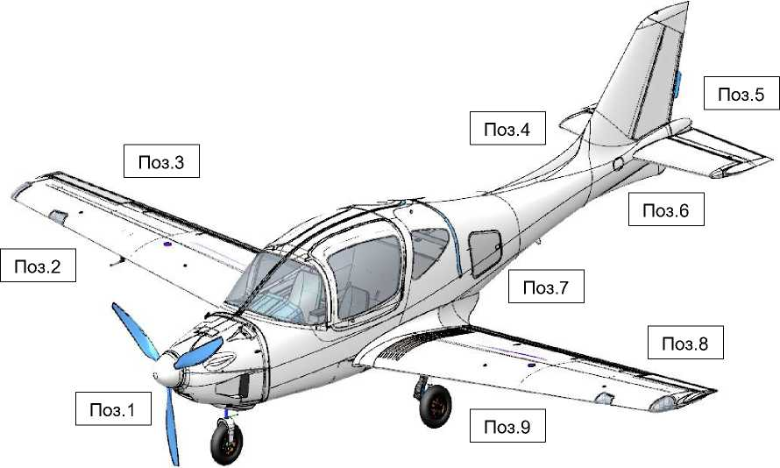
    - External review, Checklist #1
No. 5
No. 7
No. 1
No. 2
No. 6
No. 9
No. 8
No. 3
No. 4

Item Subject of Inspection |  | Pay attention to and ensure....
1 | Propeller  Engine cowling  Front landing gear support  Windshield, frontal glazing | Absence of play, cracking or chipping of blades, rubber peeling at the edge.  Absence of fuel or oil leaks. No paint coating damage. Ensure fuel injection pumps are closed, cowling retainers are locked, plugs removed, and battery properly installed.  Absence of play, no traces of oil leaks, shock strut cylinder is clean, wheel rim free of cracks, tire is inflated, no cuts or abrasions to the tire cord. LG well is clean.  Absence of cracks, "silvering", or turbidity.
2 | Right wing panel  Right fuel tank filler neck | Absence of play, absence of paint coating damage, front edge is clean, headlight, ANLs secured, their glazing free of cracks, absence of play in the Pitot tube, plug removed.  Absence of leaks, cap locked, drainage not contaminated.
3 | Right aileron  Right flap  Right landing gear support | Absence of play, no damage to paint coating.  Absence of play, no damage to paint coating.  Absence of play, no traces of oil leaks, shock strut cylinder is clean, wheel rim free of cracks, tire is inflated, no cuts or abrasions to tire cord, brake hoses connected, LG well is clean, footstep released.  released.
4 | Tail section of the Fuselage (right side) | Absence of paint coating damage, no cracks, delamination, or chips in the lining; stencils and serial number are applied, surface is clean, and control hatch is locked.
5 | Stabilizer  Altitude control (elevator)  Rudder | Absence of paint coating damage, cracks, delamination, or chips in the lining.  Absence of cracks at the joints with the fuselage, the surface is clean.  Absence of play between the left and right sections and the trim tab, the sections tilt synchronously without significant effort, and the trim tab is connected to the drive.  The play should not exceed 2/5”, the trim tab plate is set.
6 | Tail section of the Fuselage (left side) | Absence of paint coating damage, no cracks, delamination, or chips in the lining, placards and registration number applied, surface is clean, and control hatch secured.
7 | Luggage compartment | Absence of fuel odor, luggage secured, hatch closed.
8 | Left aileron  Left flap  Left landing gear support | Absence of play, no damage to paint coating.  Absence of play, no damage to paint coating.  Absence of play, no traces of oil leaks, shock strut cylinder is clean, wheel rim free of cracks, tire is inflated, no cuts or abrasions to the tire cord, brake hoses connected, LG well is clean, footstep released, wheel chocked (at least on one strut).
9 | Left wing panel  Left fuel tank filler neck | Absence of play, no paint coating damage, front edge is clean, headlight and ANLs attached securely, their glazing free of cracks.  Absence of leaks, cap is locked, and the drainage is not contaminated.

4.1.2 | Cabin Inspection | Checklist #2:
Item | Area | Note:
1 | General overview and inspection | The pilot should take the left seat.  Ensure there are no foreign objects on the seats, floor, canopy, rear shelf behind the sofa, wires hanging under the dashboard, no fuel odor, or burning wiring.  Ensure that the safety belts for all crew are in place and properly secured. Ensure that fire extinguishers and first aid kits are installed in their proper places.  Make sure that all instrumentation is installed and properly secured. Make sure the doors are securely locked in the open position and that the emergency checks are in place.
2 | Documentation | Ensure that the POH is available and in its proper place.  The necessary flight documentation is located in the small luggage compartment as required (AMM, Aircraft and Engine Forms are optional for flight).
3 | Power supply, remote controls | Ensure that all toggle switches are turned off and all Circuit breakers are turned on.  Turn on the "MASTER SWITCH" and "AVIONIC" switches.  Ensure that the VPP control panel is switched on as prescribed: VPP display shows 5800 rpm. Ensure that the flap control board is functioning properly: the LEDs are green, without flickering, and that actual flap position corresponds to the display.  Ensure that the LG control panel is functioning properly (LEDs of the extended position are green, without flickering; LEDs of the retracted position are not lit).  Ensure that the on-board radio remote control is functioning properly.
4 | Instrumentation equipment | Ensure that the Dynon SkyVieW SV1100 (or Garmin) system is running normally.  Check the system's recognition of all sensors (according to 2.8.1) and the accuracy of system readings.  Check the onboard power supply voltage of 12±0.5 V.  Check the compliance of geolocation with the actual location of the aircraft.  Check the proper operation of the warning lights (red before the engine starts).  Set the backup altimeter and speed indicators to "0": the barometric (atmospheric) pressure must correspond to the actual instruments of the airfield meteorological system.  Enter the flight route into the system (if necessary).
5 | Controls | Check for proper operation of the aircraft control system by moving the CS in the longitudinal (pitch) and transversal (roll) channels to its limit positions: CS "toward itself" deflects the ELV upward and vice versa, CS to the left deflects the left aileron upward and the right aileron downward and vice versa. CS movement should be smooth, without jerkiness, and in sync with the left and right control positions.  Check that the ELV trim tab is functioning properly: its position corresponds to the set position.  Check the THR lever for proper functioning: its movement to the limit positions must be smooth.
6 | Crew accommodation | Crew members should take their seats according to the weight and centering calculation.  For everyone, fasten and adjust their seat belts.  For pilots, set the seats to a comfortable position, ensuring that the CS and pedals are within the pilots’ reach.
7 | Radio communication | The crew should use their headsets to connect to the subscriber intercom system.  Everyone should check the availability and quality of internal communication.  Pilots should set the frequency of the radio node (if available at the airfield).  Pilots should check the availability and quality of external communication.
CAUTION 1. If at least one check according to the available Checklists No. 1 and No. 2 (see Appendix 1) has not been conducted, or the result of the check does not meet the checklist requirement, do not perform the flight until the specified problems or inconsistencies are eliminated or rectified.
2. Performing a flight without successfully and fully completing the required Checklists can lead to serious aviation accidents.
STANDARD PROCEDURES
  - Starting and shutting down the engine
STANDARD PROCEDURES
    - Turn the engine shaft three times by the blades (lubrication of engine components after parking for more than 1 hour).
    - Set the THR to the "idle" position (pulling lever back completely).
    - Request clearance to launch, from ground services (if available at the airfield/site)
    - Ensure that there are no people, animals, or obstacles in the plane of rotation of the propeller and in front of the aircraft at a distance of at least 16 ft.
    - Turn on the "MASTER SWITCH" switch.
4.2.6 Turn on the "AVIONIC" switch. Wait until the DYNON displays show the information.
4.2.7 Turn the "MAIN BATTERY" switch to the up position. It should be within 12+1.5 V
4.2.8 Check that the actual fueling corresponds to the data of the Dynon SkyVieW SV1100 or Garmin system.
NOTE A difference of up to 1.32 gallons is allowed
4.2.9 Set the VPP to 1800 rpm on the remote control. Make sure that the pitch control switch is set to "CONSTANT SPEED".
4.2.10 Turn on the "FUEL PUMP" switch of the feed tank (main, backup) pump. Make sure that the fuel pressure shown on the DYNON display is at least 0.3 PSI
4.2.11 Turn on the ignition switches "IGN A" and "IGN B".
4.2.12 Press the brake pedals, give the command to stay "CLEAR OF PROPELLER", press and hold the "START" button in ONE MOTION until the engine starts steadily, then release the button.
WARNING If the engine does not start after 10 seconds, abort the process. Restart after at least 2 minutes.
4.2.13 Make sure that the circuit warning lights are green and that both ignition circuits are functioning properly.
4.2.14 Increase the speed to 2900 rpm by moving the THR.
Warm up for at least 1 minute.
4.2.15 Turn the "MAIN BATTERY" switch to the down position.
It should be within 12 + 2.5 V.
4.2.16 Check the readings displayed on the DYNON displays.
The temperature of the lubricating oil not more than 230°F.
Coolant temperature no more than 230°F. Fuel pressure not less than 0.3 PSI. Oil pressure not less than 2.0 PSI. Check fuel levels do not drop.

STANDARD PROCEDURES
CAUTION If the oil pressure does not reach 2 PSI or higher, or a burning smell is detected, or the parameters of other indicators do not reach or exceed the specified values, immediately shut down the engine by turning off all switches. Restarting is possible only after all the deficiencies that led to the emergency shutdown have been eliminated.

4.2.17 Set the THR to the position at which the speed of 2500 rpm is reached and continue warming up until the temperature of the lubricating oil reaches 158°F and the coolant reaches 104°F
4.2.18 Upon reaching the temperatures specified above, at 2500 rpm, alternately turn off and on the "IGN A" and "IGN B" toggle switches. When switched off, the engine speed should not decrease to less than 300 rpm.
4.2.19 Evaluate the engine's response by setting the propeller to 5500 rpm on the VPP control board and smoothly moving the THR to 50% "away from you" and then pulling it back. If necessary, repeat at a higher rate.
CAUTION At THR 50% on unpaved RW or precipitation-covered RW, a yaw may occur. With THR position greater than 70%, yaw or wheel spin is possible even on dry RW. Ensure that the airplane is parked on the pads and that there are no obstacles 65ft. in front of the airplane.

4.2.20 Engine shutdown on the ground
Shut down the engine, at the pilot's discretion, by repeatedly pressing the "FUEL PUMP" toggle switch, ignition circuits "IGN A" and "IGN B".
    - Emergency engine shutdown on the ground
Perform immediately in the following cases:
- engine fire;
- significant engine and aircraft vibration.
- danger to people or animals.
- risk of collision with obstacles.
- smell of fuel or burnt wiring in the cabin.
- inoperability of VPP management.
- drop in fuel pressure.
- oil or EGT temperature outside of the operating limits.
- inability to switch the power supply from the engine generator.
- other external reasons at the discretion of the pilot.

  - Taxiing
STANDARD PROCEDURES
    - Request clearance to taxi from ground services (if available at the airfield/site).
    - Ensure that there are no people, animals, or obstacles in the direction of travel for at least 65ft.
    - Start moving the airplane by gradually releasing the brakes and increasing the engine speed by moving the THR. The recommended taxiing speed is 3 to 8 Kias.
    - U-turns are performed by proportionally and smoothly depressing the appropriate RDR pedal and, if necessary, asymmetric braking.
NOTE 1. For effective control of the nose gear, deflect the CS "away from you" halfway.
- In case of a crosswind exceeding 16 ft/s, deflect CS in the direction of the wind.
- Take into account side obstacles, based on a turning radius of 33 ft. along the wing panel.
WARNING If taxiing on unpaved RW or RW with precipitation requires an engine power level greater than 50%, do not fly (surface resistance during acceleration on takeoff will critically increase the run-up length).
    - Set the flaps to the "10°" position.
    - Ensure that there are no aircraft approaching or on the RW and that there are no obstacles on the RW.
    - Request clearance to engage in RW activities from ground services (if available at the airfield/site).
    - Put the aircraft on the RW with its nose on the selected takeoff course, set the THR to "Low Throttle", and apply the brakes.
    - Check the magnetic course of RW (if known) with the one determined by the Dynon SkyVieW SV1100 (or Garmin) system and the backup compass.
    - Remove the protective check from the handle of the rescue system.
  - Takeoff
STANDARD PROCEDURES
No special features, no atypical piloting methods are required, and it is accessible to pilots with below average skills.
Use the flaps in the "10°" position.
Calculate the flight weight, characteristic speeds, and required distances for normal and aborted takeoffs using the nomograms in section 7.2.
    - Check the selected flap position.
    - Request takeoff clearance from ground services (if available at the airfield/site).
    - Release the brakes and at the same time, smoothly move the THR all the way forward "away from you” (takeoff mode).
NOTE It is recommended to set the takeoff mode 2 to 3 seconds in advance on dry RW and in advance 3 to 5 seconds on a dirt RW or precipitation covered RW.
    - During acceleration, control the engine speed (as the speed increases, it will increase from 5200 to 5500 rpm) until the typical nose gear lift speed of 40 to 50 Kias is reached (VR for the aircraft weight of 1200 to 2100 lbs., respectively).
    - Create a takeoff angle of attack of 3 to 5° by smoothly moving CS "toward you" and maintain it until the aircraft breaks away from the RW.
    - The initial climb should be performed with acceleration to a typical safe takeoff speed of at least 51...65 Kias (V₂ for an aircraft weight of 1200-2100 lbs., respectively) with virtually no climb and then with a climb without changing this speed.
    - Retract the landing gear at an altitude of 100 to 150 ft by switching the toggle switch on the landing gear control panel (the process takes 15 to 35 seconds). It is permissible not to retract the landing gear during a flight lasting up to 30 minutes or at an altitude of more than 500 ft.
    - Remove the flaps at an altitude of 100...150 ft, controlling the process from the flap console.
NOTE To counteract disturbances caused by crosswinds, perform RDR deflection with the pedals and CS on the roll. As a rule, in a side wind of more than 10 knots, immediately after the airplane leaves the RW, a drift away from the RW axis occurs, which leads to a side entry within the RW width.
  - Climb
STANDARD PROCEDURES
    - Set the VPP to 5200 rpm and THR to 80% (nominal RPM) at an altitude of at least 300 ft.
    - Climb to the desired altitude at a speed of 75 to 80 Kias (which ensures a maximum vertical velocity). If necessary, perform turns without sliding, with a bank angle of up to 30°. Remove the force on CS with a trim tab.
NOTE The characteristics of climb (time, fuel consumption, distance) depending on the weight of the aircraft and the specified altitude are given in the nomogram in Section 7.4
WARNING In exceptional cases, at the discretion of the pilot, it is permissible to perform a takeoff mode (5500 rpm, THR 100%) for up to 5 minutes. In this case, the vertical speed increases by 6.5 ft/s. Monitor the temperature and pressure of the oil, coolant, and EGT to ensure that they do not exceed operating limits.
CAUTION Do not reduce the speed to less than 70 kias, due to dangerous risk of stall.

  - Horizontal flight
STANDARD PROCEDURES
It is performed mainly when flying along the route, with the wings removed and the landing gear removed, in the range of EOM from cruising to nominal, which, all other things being equal, will provide:
- Flight for the maximum duration at a speed of 125 Kias and EOM below cruise (4200 rpm, 60% THR);
- Flight to the maximum range along the traveled path to
speed of 150 Kias and cruising EOM (4800 rpm, 80% THR);
- Flight for the minimum time along the traveled path, i.e. for
maximum speed (depending on the weight of the aircraft) of 162...172 Kias and nominal EOM (5200 rpm, 100% THR).
Perform turns along the route without slipping more than one diameter of the inclinometer ball, with a roll of up to 45°.
CAUTION 1. Do not reduce the speed to less than 70 Kias (1.4 Vs), due to risk of stall.
- Keep in mind that flying with the landing gear extended reduces the maximum speed by 27 knots and the range of flight by 15%.
Climbs and descents, if a variable altitude flight profile is expected, shall be performed in accordance with Sections 4.5 and 4.8, respectively.
The calculation of the range depending on the amount of fuel, weight of the aircraft, and wind speed is provided in the nomogram in Section 7.6.
  - Aerobatics
STANDARD PROCEDURES
    - Aerobatic maneuvers allowed:
- Turns
- Spirals
- Bank-to-bank maneuvers (roll reversals)
- Slips (side slips)
- Dives
- Climbs/Zoom maneuvers (also “pitch-ups”)
- Horizontal figure eights
- Steep turns
- Stalls
WARNING Stall is permitted for training purposes only, at a minimum altitude of 1,600 ft.
    - The minimum aerobatic speed is 80 Kias.
    - Aircraft behavior at stall
Stall is safe, it is possible with gross piloting errors. It occurs when pulling the CS all the way back on pitch and may be exhibited in an unintended aircraft nose-down without roll and yaw, with acceleration, even if the pilot does not execute any action. To prevent from entering a spin, it is only necessary to avoid making sudden sharp movements of the CS and pedals.

WARNING 1. Stall may be perceived by a noticeable shaking of the airplane at 54 Kias.
- To recover, it is necessary to push the CS "away from you" in neutral, maintaining neutral on roll and pedals, without changing the EOM.
- When accelerating up to 54 Kias, set CS on pitch and EOM to maintain level flight.
NOTE 1. Roll and yaw control is possible by direct application of the CS and pedals before beginning the stall.
- Loss of altitude during stall is max. 500 ft.
- When pulling out of a stall, it is possible to prevent roll or yaw at angles greater than 15° by usual application of CS and pedals.
  - Descent --Best Glide Speed (Engine Failure Procedure)
STANDARD PROCEDURES
It is permitted to begin descent at any speed and roll in the operating range.
Set the propeller speed to 5500 rpm.
Descent in a straight line is usually performed at the speed of the previous horizontal flight.
Descent in the zone is usually performed using the descending spiral method at a speed of 75 to 85 Kias with a roll of up to 30° and a vertical speed of -2 to -5 m/s.
Best glide speed (Vbg) = 92 KTAS — use this speed for maximum gliding range in the event of engine failure
For descent characteristics (time, fuel consumption, distance) depending on aircraft weight, wind, and specific altitude, see the nomogram in the section . 7.5.
WARNING Do not allow the propeller to exceed 5800 rpm. Monitor the temperature of the oil and EGT, preventing overcooling below operating limits.
CAUTION Do not exceed 173 KIAS (V_{NE} - Never Exceed Speed). Exceeding this speed risks rudder flutter. The design dive speed V_{D} = 183 KIAS is a structural design parameter, not a pilot operating limit.

  - Landing
STANDARD PROCEDURES
No special features, no atypical piloting methods are required, and a below average pilot skill is sufficient.
Use flaps in the "20°" position when landing with a headwind and crosswind above 16ft/s otherwise the flaps in the "30°" position are recommended.
Calculate the flight weight, characteristic speeds, and required landing distance using nomograms section 7.3.
CAUTION If the calculated landing distance exceeds the actual length of the RW, landing at this airfield (site) is PROHIBITED.
    - Request permission to land from ground services (if available at the airfield/site).
    - Establish visual contact with the RW, making sure there are no obstacles on it or in the approach area.
    - Set the VPP to 5500 rpm (to enable a quick buildup of maximum thrust in case of entering the second lap).
    - If the flight was performed with retracted landing gear removed, perform a routine landing gear extension at a distance of about 1... 1 to 1.5 miles from RW and an altitude of 400 to 500 ft., at a speed of up to 70 Kias (taking about 15 to 45 seconds). In any case, control the released state of all landing gear supports by the indication on the central console.
CAUTION Check the green LEDs for the released position of ALL landing gear supports. Absence of green light signals that the support has not been released or has not locked in the released position. In this case, interrupt the event and perform actions according to section 6.10.

    - Release the flaps to the selected landing position, control the green LED of the corresponding flap position on the remote control, if necessary, check the released position visually. If not released, approach and landing shall be performed with 0° flaps in accordance with the recommendations of Section 6.9.
    - Execute the approach to the landing course or at an altitude of 300...400 ft (if the approach is from a straight line), set and maintain the approach speed 55...65 kias (VREF for a mass of 1200-2100 lbs, respectively) and a vertical speed of VY=-3...-20 ft/s (corresponds to a gentle and normal glide path). If necessary, at the discretion of the pilot, an approach with a vertical speed of 20...25 ft/s (steep glide path) is allowed.

STANDARD PROCEDURES
    - Perform the leveling at a height of 10±5 ft (for gentle glissade), 20±5 ft (for normal glissade) or 30±5 ft (for steep glissade). Perform a smooth CS in a smooth "toward you" motion, creating a landing pitch angle of 3...5°. At the same time, set the throttle to "Low Throttle" (THR to the maximum "on" position). As a result, reduce the speed by 3...6 Kias and VY to -3-5 ft/s.

WARNING 1. At zero or negative pitch angle on touchdown, the airplane may re-separate from RW. In this case, do not change the position of THR, operate the CS smoothly, ensuring relanding.
- At a large positive pitch angle on touchdown (more than 10°), the RW may touch the under fuselage ridge, which can cause damage to the aircraft.
    - Perform a hold at a height of 3 to 5 ft, reducing V_{Y} with CS control until touch-down, without changing the EOM.
    - Immediately after touch-down, “lower” and “press” the nose support with a smooth CS "away from you" movement (for reliable course control at low speeds where the rudder is ineffective).
    - Apply the wheel brakes with an intensity accounting for the condition and length of the RW. Counteract side drifts with asymmetric braking.

NOTE On snow-covered RW or unpaved RW, apply pulse braking, i.e. pressing and releasing the brake pedals at intervals of approximately 1 second, for more effective deceleration.
WARNING Counteract disturbances caused by crosswinds by coordinated deflection of the RDR and ailerons (create a drift, partly fly the airplane into the wind and "covering" behind the roll of the opposite sign). Just before the touch-down, deflect the RDR to eliminate the drift by setting the airplane on a RW heading and removing the roll. In strong crosswinds (more than 10 knots), if you eliminate the drift earlier, a significant slip will occur.

4.10 Go-Around (or balked landing)
STANDARD PROCEDURES
Special features, and atypical flying techniques are NOT required, typical pilot skills are sufficient.
It is allowed at any altitude.
    - Report the go-around (if ground services are available at the airfield/landing site).
    - Immediately after the decision is made, set the take-off EOM by smoothly moving the THR all the way "away from you", engine speed should be 5500 rpm.
    - Simultaneously, transfer the aircraft to climb, creating an angle of attack of 3...5° with a smooth CS movement "toward you" and maintaining a speed not lower than the approach speed (VREF).
NOTE 1: Altitude loss is 10 to 20 ft.
- The distance from the beginning of the go-around to the altitude of 100 ft is 800 to 1000 ft.
    - Execute a normal landing gear retraction at a stable climb (V_{Y} not less than 10 to 15 ft/s),.
    - Execute a normal retraction of the flaps at an altitude of 100 to 150 ft,.
WARNING Generally, with crosswinds of more than 5 m/s, a drift occurs, resulting in a lateral deviation of the aircraft within the width of the RW.
    - Execute a circling flight, or a flight to another airfield (at the pilot's discretion, depending on the situation).

4.11 After flight procedure
STANDARD PROCEDURES
    - Report the release of the RW (if ground services are available at the airfield/site).
    - Execute taxiing according to the procedure in section 4.3.
    - Stop the full movement of the aircraft at the parking lot, using the brakes. If necessary, report the end of the flight to ground services.
    - Turn off the engine and all aircraft systems (all toggle switches, the last one being "MASTER SWITCH"), and set the check in the rescue system start handle.
    - All crew members are to take off their headsets, unfasten their seat belts and exit the aircraft.
STANDARD PROCEDURES

The page is intentionally left blank

SECTION 5. EMERGENCY PROCEDURE
EMERGENCY PROCEDURE
  - Use of the rescue system 47
  - Engine failure on the ground. 48
  - Engine failure at low altitude... .. 48
  - Engine failure at high altitude 48
  - Fire in the engine compartment on the ground 49
  - Fire in the engine compartment in flight .............................................. 49
  - Fire in the cabin................................................................................... . 49
  - Unintentional spin 50

Introduction
This section defines all procedures of the VELOCE-ANG-01 aircraft that are necessary for safe completion of a flight emergency conditions, critical aircraft system failures, or fire on board.
CAUTION 1. In the event of an emergency, it is imperative to strictly follow the procedures in this section, in the described sequence, and to memorize them.
- In any emergency situation, the pilot's primary task is to maintain control of the aircraft and to fly it safely to landing.
- Failure to follow these procedures may result in serious aviation accidents.
  - Use of the rescue system
EMERGENCY PROCEDURE
In case of fire, engine failure, or occurrence of a spin, if the flight altitude is more than 300 ft, use the rescue system, and perform these actions:
    - Turn off the engine.
    - Turn off the toggle switch “FUEL PUMP" SWITCH.
    - Turn off the toggle switch "MASTER SWITCH".
    - Tighten seat belts and protect your body (cover face and keep limbs near your body) (for all persons on board).
    - Activate the rescue system by pulling the handle of the system with a sharp movement “towards you”.
NOTE: The use of the system is permitted over the entire range of airplane speeds and weights, at an altitude of at least 265 ft.
5.1.6 Unlock the emergency exit and throw the door open (in the air).
NOTE: To unlock the emergency exit, remove the lock and pin from the door on the required side, or both sides if there is more than one person on the aircraft.
    - Transmit an emergency signal at a frequency of 121.5 MHz
    - After landing, leave the aircraft.

CAUTION 1. The rescue system parachute provides a landing with a vertical speed of up to 16mph.
- In the presence of wind, the horizontal speed is up to 10 knots.
- This procedure may result in partial damage to the aircraft structure and possible injuries to the crew and persons on board, but it will save the lives of those on board.

  - Engine failure on the ground
EMERGENCY SPROCEDURE
To discontinue the takeoff:
    - Fully depress the landing gear brakes.
    - Turn off the "FUEL PUMP" toggle switch.
    - Turn off the "MASTER SWITCH” toggle switch.
    - After stopping, unlock the emergency exit (depending on the danger of the situation), open the doors (depending on the danger of the situation) and leave the aircraft.
  - Engine failure at low altitude
If the engine fails at an altitude below 300 ft, land "just in front of you", as follows:
    - Set the speed to 55 to 60 Kias
    - Turn off the "FUEL PUMP" toggle switch.
    - Turn off the "MASTER SWITCH" toggle switch.
    - Unlock emergency exit.
    - Transmit an emergency signal at a frequency of 121.5 MHz, if possible.
    - After stopping, open the door and exit the aircraft.
CAUTION 1. Land with the same position that flaps and landing gear were in at the time of engine failure, avoiding obstacles with smooth (non-sharp) maneuvers, if possible.
- DO NOT ATTEMPT TO RETURN TO THE AIRFIELD.
  - Engine failure at a high altitude
If the engine fails at an altitude above 265 ft, set the speed to 65 to 70 Kias and make three attempts to restart the engine with the "START" button.

If it is impossible to restart the engine in flight, execute an emergency landing, either by activating the rescue system (see Section 5.1) or by executing a running (forced) landing (see Section 6.1).
  - Fire in the engine compartment on the ground
EMERGENCY SPROCEDURE
    - Close the ventilation flap to prevent smoke from entering the cabin.
    - Turn off the "FUEL PUMP" toggle switch.
    - Turn off the "MASTER SWITCH" toggle switch.
    - Exit the aircraft , taking the onboard fire extinguisher with you.
    - If possible, call ground services for help.
    - Start extinguishing the fire using the onboard fire extinguisher.
CAUTION Depending on the situation, and at the discretion of the pilot, decide to discontinue extinguishing and evacuate people beyond a radius of 165...330ft.
  - Fire in the engine compartment in flight
    - Close the ventilation flap to prevent smoke from entering the cabin.
    - Turn off the "FUEL PUMP" switch.
    - Turn off the "MASTER SWITCH" switch.
    - Transmit an alarm signal at a frequency of 121.5 MHz
    - Unlock the emergency exit
    - Perform an emergency landing, either by activating the rescue system (see Section 5.1) or by a running landing (see Section 6.1).
    - Exit the aircraft, taking the onboard fire extinguisher with you.
    - Call for help from ground services, if possible.
  - Fire in the cabin
    - Extinguish the fire using the onboard fire extinguisher.
    - Send a distress signal at a frequency of 121.5 MHz
    - Unlock the emergency exit, open the door (in flight).
    - Perform an emergency landing, either by activating the rescue system (see Section 5.1) or by executing a running landing (see Section 6.1).
    - Call ground services for help, if possible.
  - Unintentional spin
EMERGENCY PROCEDURE
Entering spin requires special and conscious actions by the pilot. To provoke a spin, sharp deviations of the CS in roll or by sharp application of RDR pedals are required. Therefore, an unintentional spin is almost impossible.
However, if you do get caught in a spin, follow these steps:
    - Set the CS to pitch "on itself" until it stops, keep roll
neutral, apply RDR pedals opposite to the aircraft rotation.
    - After stopping the rotation of the aircraft, sharply push the CS beyond neutral and, after accelerating to a speed of 70-85 KIAS, smoothly pulling CS and gradually increase the EOM to enter a straight and level flight.

NOTE 1. The maximum roll will be 80°, vertical load factor of 2.2 to 2.6, negative pitch angle will be on average, -50°.
- Maximum loss of altitude at recovery from spin will be up to 650 ft., recovery in one incomplete turn.
- The performance of the engine, control system, and fuel system is not affected.
- There is no significant effort from aerodynamic forces that
try to tilt the CS on the pilot.
5.The development of the aircraft's rotation in left and right spin is predictable, with an angular velocity of 60 to 80°/s in the roll channel and 20 to 30 °/s in the yaw channel.
- Operating speed (V_{NE}), rolls, and vertical load factor are not exceeded during recovery from spin.
If recovery from spin was not possible with these procedures, make an emergency landing and activate the rescue system (see section 5.1).
EMERGENCY PROCEDURE

The page is intentionally left blank

SECTION 6. ACTIONS IN DIFFICULT SITUATIONS
DIFFICULT SITUATIONS
6.1 Forced landing 53
6.2 Entering a zone of significant turbulence 54
6.3 Impaired visibility 54
6.4 Icing …………………………………………………………………………... 54
6.5 Pitot tube malfunction and angle of attack 55
6.6 Primary flight and navigation system malfunction 55
6.7 Power failure 55
6.8 Rudder trim tab malfunction.....................................................................55
6.9 Flaps malfunction 56
6.10 Landing gear failure 56

Introduction
This section defines all the VELOCE-ANG-01 procedures necessary for the safe completion of the flight in the event of difficult flight conditions, or failures of the aircraft systems that are not considered an emergency, i.e., do not require immediate crew intervention.
Difficult situations caused by malfunctions of the aircraft, its systems, or engine are rare with proper maintenance of the aircraft.
CAUTION 1. In the event of a difficult situation, you must strictly follow the procedures in this section in the order they are presented.
- In any difficult situation, the pilot's primary task is to maintain control of the aircraft and fly it to a safe landing.
- Failure to follow these procedures can lead to serious aviation accidents.
  - Forced landing
DIFFICULT SITUATIONS
Execute in case of difficult weather conditions that make it impossible to continue the flight, or for other reasons as determined by the crew.
A forced landing is defined as an airplane approach and landing without the use of a rescue system (the procedure for its use is provided in Section 5.1).
    - Locate a visually flat area.
NOTE: 1. Preferably paved roads (or road section), with low or no traffic.
2. Possible landing sites: pastures, mowed land (stubble). Avoid irrigated fields, sand strips, and ice-covered water surfaces. The ground condition may be estimated by the depth of the track of land transport.
    - Estimate the size of the likely site: it should be approx.1600 to 2000 ft. long, there should be no obstacles (16ft or higher) for at least 1000 ft. before the landing point.
    - Estimate the wind direction and speed on the ground.
NOTE: 1. Wind direction may be visually estimated by the direction of smoke, plants bending, and ripples on water surface (will be smooth at the windward side of the shore).
- Wind speed can be estimated by the difference between CAS and GS during the landing flight. Alternate visual estimation: a wind of about 11 to 14 mph tilts the tops of deciduous trees.
    - Send an emergency signal at a frequency of 121.5 MHz, indicating the location.
    - Maintain a speed of at least 55 KIAS prior to landing, and a vertical velocity of V_{Y} = 4 to 7 mph.
    - Extend the flaps 30° at an altitude of 300 ft, unlock the emergency exit, depending on the level of danger, and cause of the forced landing (door locks and pins on the required side, or both doors if there is more than 1 person on the aircraft), extend the landing gear at an altitude of 160 ft.
    - After the nose gear lowers on the run, apply the brakes, proportionally to the length of the landing site.
    - After stopping, turn off the engine, de-energize and leave the aircraft.

  - Encountering a zone of significant turbulence
DIFFICULT SITUATIONS
    - When encountering local thunderstorms and powerful cumulus clouds, bypass them by at least 20 nautical miles, and any visible storm clouds by at least 5 miles.
    - When flying between storm cells, the distance between them must be at least 20 nautical miles.
    - Reduce and maintain airspeed at V_{A} = 108 KIAS (Maneuvering Speed). Do not exceed V_{A} in turbulent conditions. If severe turbulence is encountered, reduce to 85 KIAS and maintain bank angle no more than 20°.
    - Make turns with a bank angle of no more than 20°.
    - When landing in wind shear conditions, execute a go-around if on descent it is necessary to increase the EOM to the maximum value, or if V_{Y} variation exceeds 6.5 ft/s

  - Impaired visibility
In case of impaired flight visibility caused by the onset of evening time or a sudden change in weather conditions, land at the nearest airfield (landing site) or, with the crew's decision, make an emergency landing in accordance with 6.1.
  - Icing
Due to the absence of airframe de-icing and glazing (only pitot tube heating is available), flying in icy conditions are PROHIBITED.
WARNING: Flying in icy conditions is dangerous, causing possible loss of load-bearing properties in the wings and blades of the propeller (impaired flow), increased vibration from the propeller (uneven ice formation on the blades), and impaired visibility of the space outside the cockpit.
In case of unintentional exposure to icing conditions:
    - Execute a reverse turn or altitude change to exit the icing zone as fast as possible.
    - Set the EOM to maximum continuous.
    - Land at the nearest airfield (site) or, if the crew decides, make an emergency landing in accordance with 6.1.
  - Pitot tube malfunction and angle of attack
DIFFICULT SITUATIONS
This may be caused by a blockage of the inlet if foreign objects, dirt or insects enter it and can also be related to failure of the heating controller if icing inadvertently occurs.
    - Do not use the altitude, speed, or variometer readings
of the main system and backup instruments.
    - Maintain ground speed of GS = 97 knots. The instrument speed is to be estimated indirectly by the altitude indicators with a sufficient stall margin (3...5°).
    - Land at the nearest airfield (site) or, if the crew decides, make an emergency landing in accordance with 6.1.
  - Primary flight and navigation system failure
    - Use the altitude, speed, and variometer readings of the backup instruments.
    - Set the speed to 65 to 85 KIAS
    - Set a medium EOM (THR 30 to 70%, VPP setting not exceeding 5000 rpm) and be guided by the sound of the engine.
    - Restart the system by switching the "AVIONIC" toggle switch.
    - Land at the nearest airfield (site) or, if the crew decides, make an emergency landing in accordance with 6.1.
  - Power failure
Is indicated by the red light of corresponding warning lamp, which indicates the battery power supply for all onboard electrical consumers, except for engine control and primary flight equipment (they have their own emergency power sources).
Continue flying for max. 30 minutes or land at the nearest airfield (site) or, at the decision of the crew, make an emergency landing in accordance with 6.1.
  - Rudder trim tab malfunction
Can be detected by a noticeable increase in CS effort in the longitudinal (pitch) channel. Continue the flight.
  - Flap malfunction
DIFFICULT SITUATIONS
Determined by the absence of LED light, indicating flap position after setting the corresponding position.
    - Visually assess the position of the flaps.
    - If the flaps are not retracted after takeoff, it is not recommended to conduct a flight exceeding 30 minutes (fuel consumption will increase).
    - If the flaps are not extended before landing, execute it, according to the usual procedure (see Section 4.9), but at a speed increased by 6mph in relation to VREF.
  - Landing gear failure
Determined by the absence of the LG position LED green light for of each LG, after setting the corresponding position (retracted or extended), and by the presence of the red LED for the intermediate position. The failure may be mechanical or electrical.
If the landing gear has not extended after takeoff, it is not recommended to fly for more than 30 minutes (increased fuel consumption will occur).
If the landing gear is not released before landing, do the following:
    - Discontinue the approach, set the level flight speed to 65 to 70 KIAS.
    - Set the three-way landing gear emergency extension lever (in the armrest) to the emergency release position.:
NOTE: When this happens, the carbon dioxide cylinder nozzle (in cylinder above the lever) also opens, the pressure of this gas moves the spool, closing the hydraulic power plant pressure line and pressurizing the discharge cavity of each cylinder.
    - Check indicator lights that all landing gears are in extended position.
    - If the green LED of the extended position of any LG is not lit, install a spare carbon dioxide cylinder (located in the armrest next to the lever) and repeat step 6.10.2.
    - Perform the landing according to the usual procedure (see Section 4.9)
DIFFICULT SITUATIONS

The page is intentionally left blank

SECTION 7. FLIGHT CHARACTERISTICS
FLIGHT DATA

  - Introduction 58
  - Takeoff 60
  - Landing 62
  - Climb 63
  - Descent 64
  - Flight range and duration 65

Introduction
The nomograms provided in this section are necessary for calculating the performance of the aircraft at all basic flight stages: take-off, climb, level flight, descent, and landing.
  - Introduction
The nomograms provided in this section take into account the effect of:
- operational speed limits
- the actual weight of the aircraft
- RW parameters (size, type, and condition)
- Meteorological conditions (pressure, temperature, wind direction and speed).
It is advisable to use the nomograms calculation in preparation for EVERY flight.
It is permitted to perform the calculation once at the beginning of the flight day if takeoff and landing are at the same landing site, if a series of flights with similar (within 10%) aircraft weight, weather conditions, and condition and type of RW are planned.

CAUTION 1. If the calculated distances exceed the actual length of RW , flight is PROHIBITED.
FLIGHT DATA
2. If it is not possible to provide the amount of fuel for the flight of the desired range and duration, the flight is PROHIBITED.

In these cases, these options are possible:
- reduce the weight of the aircraft by reducing the number of crew, passengers, or luggage;
- reschedule the flight route (if possible);
- wait for more favorable meteorological conditions under which the specified range, duration and required RW will be available.
These nomograms are calculated for the extreme front centering (worst case).
The general principle of using nomograms is simple: at the input of each "mat" (bottom or left), set the value of the initial parameter along the axes and, moving visually or with a pencil along the lines of the nomograms to the lines of the footnote, move to the right to the line of the next "mat".

7.2 Takeoff
7.2.1 Takeoff distance, run-up length, characteristic speeds
FLIGHT DATA

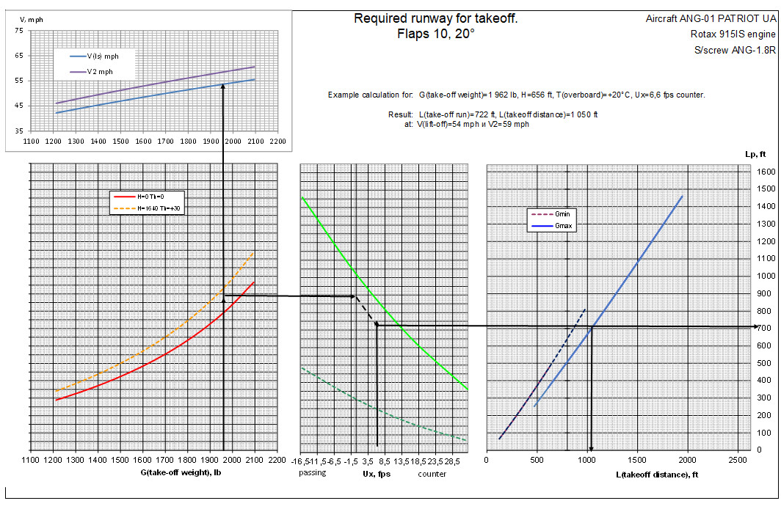

7.2.2 Distance of aborted takeoff

FLIGHT DATA

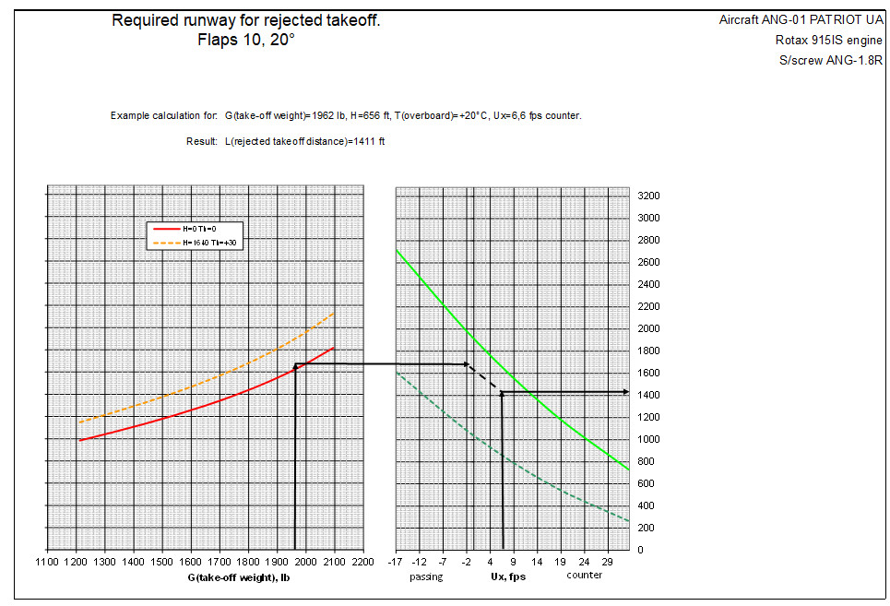

7.3 Landing

FLIGHT DATA

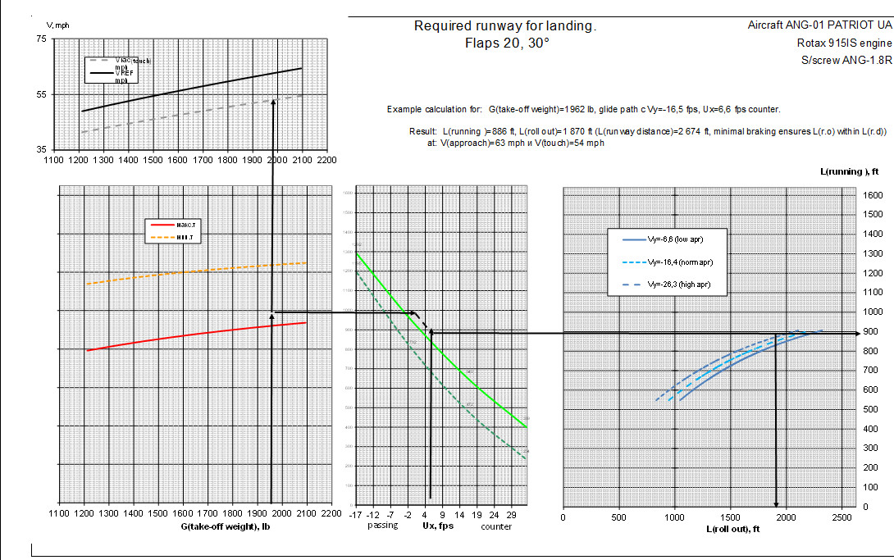

  - Climb
FLIGHT DATA

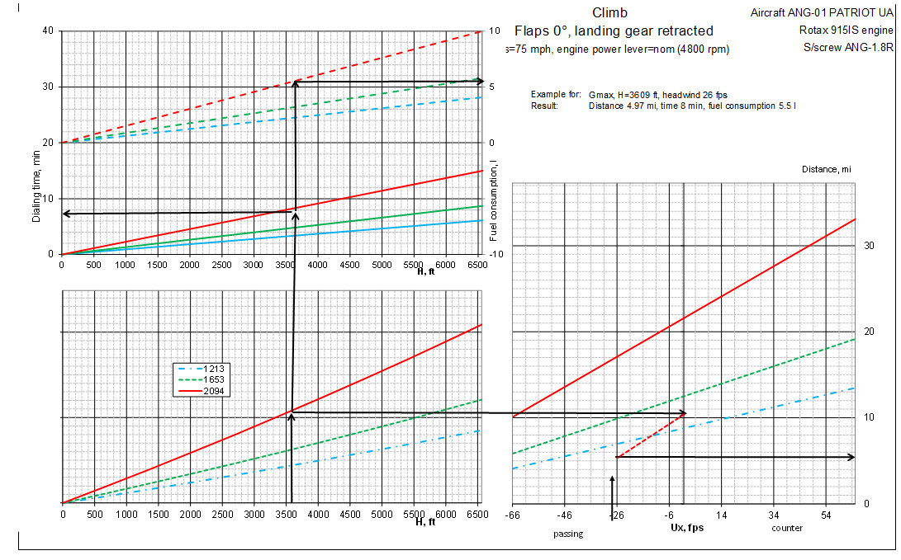
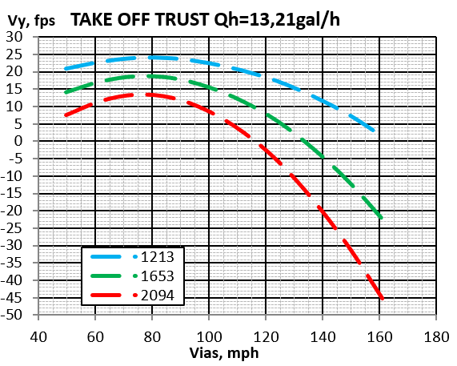
Additionally, the dependence of vertical velocity on IAS at the nominal EOM is shown:
  - Descent
FLIGHT DATA

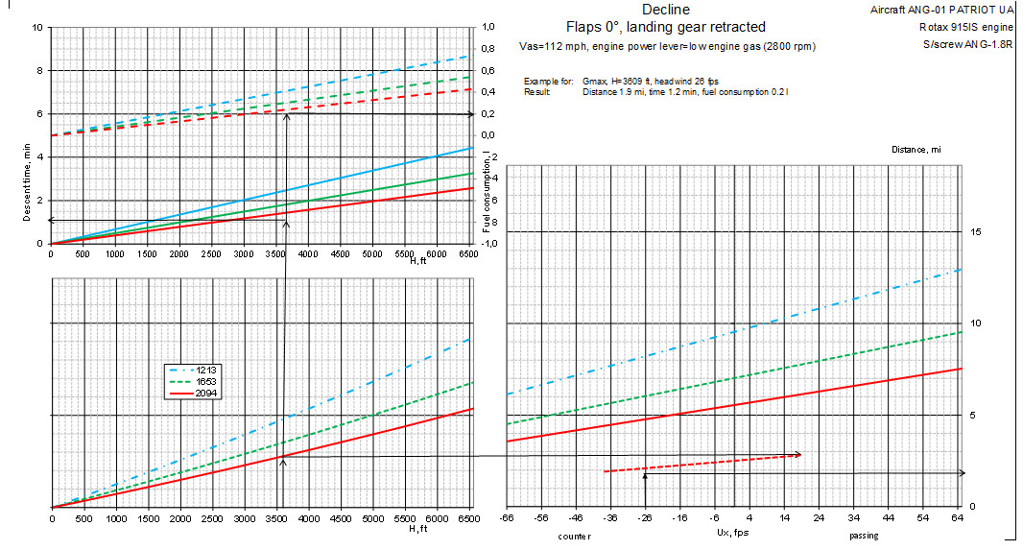
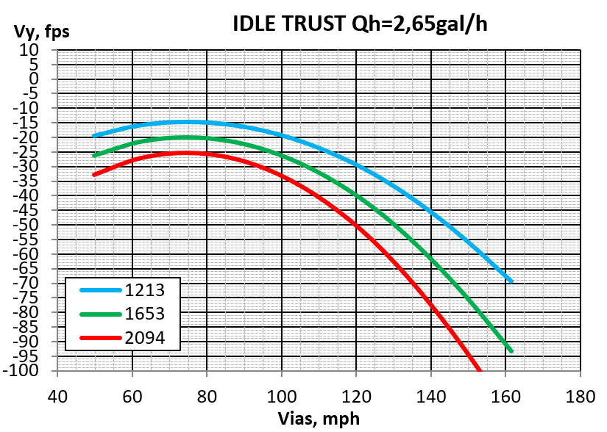
Additionally, the dependence of vertical velocity on IAS for low throttle EOM is shown:
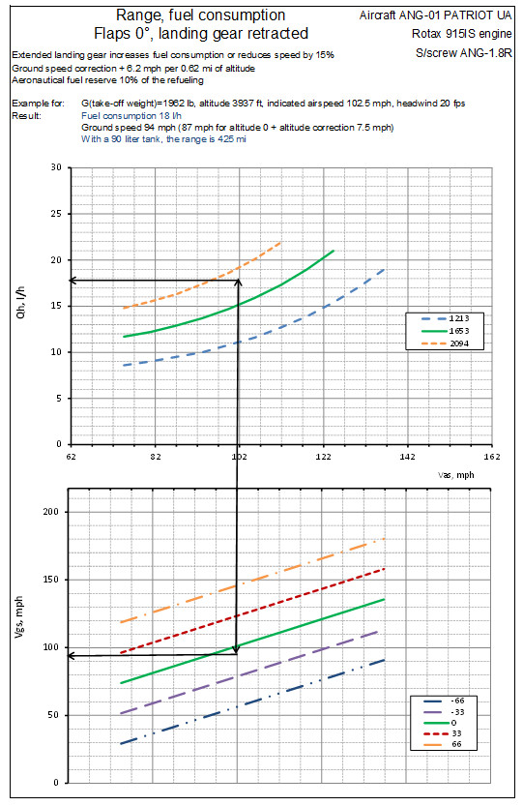
  - Flight range and duration
FLIGHT
DATA
Example for: Gc=1962 lb., altitude ,3937 ft., Indicated air speed 102.5 mph, headwind 20fps
Result: Fuel consumption 4.75 gallons/h
Ground speed:94mph (87mph for altitude 0 + 7.5mph altitude correction)
With 24 gallons of fuel, the range is 425 miles

CHECKLISTS
APPENDIX 1 CHECKLIST
BEFORE STARTING THE ENGINE
Airplane | PREPARED
Cold cranking of the prop 3 times by hand | DONE
The crew | ON THE GROUND
Pilots' seats | ADJUSTED
Seat belts for all crew members | BUCKLE UP
Covers and plugs | REMOVED
Doors, hatches | CLOSED
Operational documentation | CHECKED
Rescue system fuse | CHECKED
Aircraft control system | TESTED
Emergency Landing Gear | TESTED
Fuel level | CHECKED
Master switch | ON
Dynon displays | ON
Battery charge | 12V
Flight route | SET
Signal lamps "ECU A" "ECU B" | RED LIGHTS
WARN EMS "PITOT HEAT" warning light is green
Landing gear out position indicator lights LIT UP GREEN
Main fuel pump, backup fuel pump ON
Autopilot AS NEEDED
Pitot heating ENABLED
BANO, STROBE, Headlights ON
Fuel gauge CHECKED
Engine prop speed 1800 rpm CHECKED
Throttle set to 10% CHECKED
Transponder frequency_____ CHECKED
Radio communication frequency CHECKED
Radio communication RECEIVED
Airfield pressure on backup instruments
Parking Area CHECK FOR OBSTACLES
Wheel chocks REMOVED
Brake pedals PRESSED
Push the "START" button of the engine
Permission to start the engine CLEAR PREP
CHECKLISTS

BEFORE STEERING
Oil temperature, coolant temperature
Engine speed 2900 rpm
Signal lamps "ECU A" "ECU B"
Flaps in the "10°" position
Permission to taxi
NORM
SET
LIT GREEN
CHECKED
RECEIVED
Permission to enter the runway
Engine speed 5500 rpm
All light signaling lamps
Permission to take off
Motor control knob 100% Full throttle
RECEIVED
CHECK
LIT GREEN
RECEIVED
ESTABLISHED
BEFORE TAKOFF

CHECKLISTS

BEFORE THE LANDING APPROACH
Landing permission | RECEIVED
pressure | INSTALLED
Weather conditions of the airfield | RECEIVED
Visual contact with the runway | SEEN
Obstacles on the runway | CLEAR
Landing gear Lights | GLOWING GREEN
Landing gear out position indicator lights (red) | OFF
Flaps in the 20°/30° position | CHECK
Engine prop speed setpoint 5500 rpm | CHECK
THR set to the position required for the glide path | CHECK

AFTER LANDING
Turn off the runway | CHECK
Flaps position "0" | SET
Fuel switch | TURNED OFF
Engine | TURNED OFF
Light master | TURNED OFF
All toggle switches | TURNED OFF
Dynon displays | TURNED OFF
Door | LOCKED
Rescue System Fuse | TURNED OFF

