Document no: TW-0300- 00290175-000

Weight and Balance Manual

 | Name | Signature | Date.
Completed | Zhovtonog O.I. |  | 08.06.22
Completed | Process engineer |  | 08.06.22
Checked. | Ovchinnikov Y.M.
Checked. | Head of the airworthiness service
Approved | Sinitsa A.V.
Approved | Head of the development organization

List of Revisions
Revision | Description. | Section. | Date.
000 | New document | - | 08.06.22

Contents.
General provisions 4
1. Technical requirements. 4
2. Labor safety. 5
3. Performing mass determination. 5
4. Determining the mass and centering of the aircraft. 5
5. Quality control. 7
Appendix 1 8
Appendix 2 10

General provisions
This document is a guide for determining the weight of finished parts, subassemblies and the product as a whole. This document is also used to determine the centering of the finished product. Weighing and centering of the airplane is performed every time after repair and modification work, installation or removal of additional parts with a total weight of 11 lbs. or more.

1. Technical requirements.
1.1. Technological processes for determining the mass and centering shall be performed at an ambient temperature of -4°F to 95°F and relative humidity of no more than 75%, no wind, and in compliance with the requirements of safe working conditions, fire safety, and production culture. In the absence of the required environmental conditions, it is necessary to provide them artificially in the work area. To determine the centering, there must be a flat area.
1.2. Monitor the environmental parameters in the work areas using appropriate measuring devices in accordance with the instructions for their use.
1.3. The main measuring instruments shall comply with the specified list. The use of other materials with the same characteristics is permissible.
1.3.1. Scales 0-33 lbs. with an accuracy of 0.07 ounces.
1.3.2. Scales 0-660 lbs. with an accuracy of 3.5 ounces.
1.3.3. Construction level, 10 ft.
1.3.4. Ruler, 1000.
1.3.5. Tape measure, 33 ft.
1.3.6. Overhang.
1.4. Employees performing weighing and centering operations must be trained and certified to know how to perform technological operations and use equipment and tools.
1.5. Mass determination and centering must be performed in accordance with the technological processes, this manual and must be performed in the presence of a supervisor.
1.6. The actual weight must comply with the design documentation. The actual weight must be within the limits of:
+/- 5% for individual parts with PCM weighing up to 22 lbs.
+/- 2 % for individual assembly units with PCM ;
+/- 1% for the aircraft assembly;
+/- 1% for parts and assembly units made of metals;

1.7. In cases where the actual weight has significant deviations from that specified in the design documentation, changes shall be made to the documentation and in accordance with the current change procedure in force at the enterprise.

2. Occupational safety.
2.1. When organizing and carrying out all work, they must comply with the requirements of the instructions on labor protection and industrial sanitation, fire safety in force in the organization and provide for measures of protection against the effects of dangerous and harmful production factors:
- increased content of harmful vapors and aerosols, mixtures, solvents and other substances in the air of the work area.
- increased level of static current.
- sharp edges, burrs on the surfaces of parts and equipment.
2.2. The contractor shall be allowed to work if he/she has reached the age of 18, has no medical contraindications, has been trained in safe work practices, instructed in occupational protection and fire safety, and is certified to perform this type of work.

3. Determining Weight
3.1 Determination of the actual weight of parts and assembly units is intended to determine the deviation or confirmation of the theoretical weight with the actual weight of the parts and assemblies.
3.2. The parts and subassemblies that are allowed to determine the mass:
- manufactured in the full scope of their design, in accordance with the design and technological documentation;
- with removed process materials, separators, and process liquids;
- have been inspected and have no unacceptable deviations from the requirements of the design documentation.
3.3 Mass determination is performed by placing the finished part or assembly unit on the surface of the measuring device. If it is impossible to determine the mass with one device, it is permissible to use more than two devices, the results of which are summed up. It is permissible to determine the mass with suspended scales.
3.4. Record the actual mass value in the documentation. The actual mass value is marked on the surface of the part or assembly unit, along with the marking.

4. Determining the mass and centering of the aircraft.
4.1 Determination of the actual weight and centering of the aircraft is aimed at determining the deviation from or confirmation of the theoretical weight and centering of the actual manufactured aircraft.
4.2. An airplane is allowed to be weighed and centered if it:
- is manufactured in its entirety, in accordance with the design and process documentation;
- with installed devices and equipment;
- with fully completed finishing works and applied paints and varnishes;
- with all fluids in the systems fully filled. Fuel must be completely absent, except for the unproduced fuel residue;
- has passed the inspection and has no unacceptable deviations from the requirements of the design documentation, or fully documented the relevant deficiencies.
4.3. The mass determination and centering are performed simultaneously, with the actual data being entered into the documentation. It is forbidden to perform mass determination with suspended scales.
4.4. The works shall be carried out in sequence:
- determine the level of the site. The site should be flat and horizontal.
- set the scales on the platform, zero the value. If there are several units of measurement, select the "lbs." value.
- place the airplane on the scale, record the value, and enter the mass data in the documentation of each landing gear strut. The sum of the landing gear masses will be the gross weight of the airplane (M value).
- Determine the horizontal distance from the leading edge of the propeller roc to the axes of the front landing gear (d value) and the main landing gear struts (D value). Record the values and enter the data in the documentation.
- determine the value of the distance from the center of mass to the axis of the main landing gear struts (D2 value) by the formula:
D2 = (p1*D)/M
Where p1is the value of the weight of the nose landing gear; D is the horizontal distance from the leading edge of the rotor roc to the axis of the front landing gear; M is the gross weight of the aircraft.
- determine the distance between the centerlines of the landing gear struts (x value) using the formula:
x=d-D2
- determine the torque G relative to distance between the axes of the landing gear struts using formula:
G=M*x
- determine the distance of the center of mass of an empty airplane using the formula:
Cm= G/M
- Determine the position of the center of mass relative to the mean aerodynamic chord (MAC) using the formula:
C=Cm/MAC

4.5. In addition to determining the alignment for an empty airplane, loads are calculated:
- 1 pilot. The accepted weight of one pilot or passenger is 170 lbs.
- 2 pilots.
- 1 pilot + 1 passenger.
- 2 pilots + 1 passenger.
- 1 pilot + luggage. The maximum baggage weight is 132 lbs.
- 2 pilots + luggage.
- 2 pilots + 1 passenger + luggage.
- 2 pilots + 2 passengers.
- 2 pilots + 2 passengers + luggage.
- 2 pilots + 3 passengers.
4.6. After all the calculations have been made, all results shall be recorded in the mass and centering report. A sample form is given in Appendix 2. A sample of the completed form is given in Appendix 1.

5. Quality control.
Quality control and correctness of measurements and calculations is ensured by the presence and participation of a supervisory employee during the performance of work.

Appendix 1
Determining Weight and Balance
Aircraft ANG-01, Registration No. 005.
The ANG-01 aircraft was weighed to verify compliance with the design weight and balance data, and to determine the aircraft weight as well as the longitudinal and vertical center of gravity for approved operational configurations, depending on the number of occupants, ballast, and fuel load. This data is also used to calculate all possible in-service aircraft weight and balance configurations within the limits of the approved design and operational weight and balance envelope.
The ANG-01 was weighed indoors (hangar) on a flat, hard surface.
Equipment: the aircraft is painted, all standard equipment and interior are installed, 2 headsets, without pilots, without passengers, without ballast.
The aircraft was set in a horizontal position in pitch and roll, with a laser level set at the following points: the fuselage construction horizontal along the nose of the propeller and tail bayonet (for pitch) and along the root nerves of the left and right wing consoles (for roll).
All landing gear supports were simultaneously placed on a scale (load capacity up to 441 lbf) and the scales were read. A tape measure was used to measure the horizontal distance from the propeller nose to the axis of each corresponding landing gear wheel.
The weight of the empty equipped aircraft (in the weighing configuration) was determined by summing the weight from each landing gear strut, the centering was determined by a well-known method (method of moments), taking into account the above measurements and using the calculated geometric data (see Table 2).
 |  |  |  |  |  |  |  |  |  |  | Table 1
Calculation of the Longitudinal Component of Aircraft Centering in Flight, in % MAC
Load on left main landing gear, lbf |  | Load on right main landing gear, lbf |  | Load on nose landing gear, lbf |  | Distance to main landing gear,  ft. | Distance to nose landing gear, ft. |  | Total Mass,  lbs. |  | Center of gravity,  %MAC
320.6 |  | 303.8 |  | 272.3 |  | 9.55 | 3.05 |  | 896.6 |  | 5.89
Aircraft Geometry Table 2
Wing incidence angle | 0 | °
Fuel CG - X coordinate | 8.43 | feet
Fuel CG - Y coordinate | -1.64 | feet
Mean Aerodynamic Chord (MAC) | 3.83 | feet
Distance from Nose to MAC leading edge (X-axis) | 7.35 | feet
Distance from Reference line to MAC (Y-axis) | -1.64 | feet
Forward CG limit | 16.0 | %MAC
Aft CG limit | 38.0 | %MAC

Weight of objects and equipment: | Weight, lbs | x,ft. (from cockpit) | Weight*x, (lbs*ft.) |  | y, ft. (from CGF) |  | Weight*y, (lbs*ft.)
 | 896.6 | 7.58 | 6796 |  | 0 |  | 0
Pilot on the left (seat in middle position) | 170 | 6.40 | 1100 |  | -0.98 |  | -166.6
Pilot on the right (seat in middle position) | 170 | 6.40 | 1100 |  | -0.98 |  | -166.6
Rear row passenger | 170 | 9.09 | 1545 |  | -1.31 |  | -222.7
Rear row passenger | 170 | 9.09 | 1545 |  | -1.31 |  | -222.7
Rear row passenger | 170 | 9.09 | 1545 |  | -1.31 |  | -222.7
Luggage (in luggage compartment) | 132 | 16.4 | 2165 |  | 0 |  | 0
Fuel (unproduced balance) | 16.5 | 11.0 | 181.5 |  | -2.30 |  | -37.95
Total: | 1895 | 8.43 | 14,433 |  | -0.66 |  | -1039
 | Fuel quantity, gal, | Fuel weight, lbf |  | Total weight, lbs |  | Longitudinal CG position, %MAC |  | Lateral CG position, %MAC
 | 0 | 0 |  | 1894 |  | 27.9 |  | 28.5
 | 13.21 | 83.78 |  | 1977 |  | 27.9 |  | 27.3
 | 26.42 | 165.35 |  | 2059 |  | 27.9 |  | 26.2
 | 31.70 | 198.42 |  | 2092 |  | 27.9 |  | 25.8

For all aircraft loading options, please see the chart below:
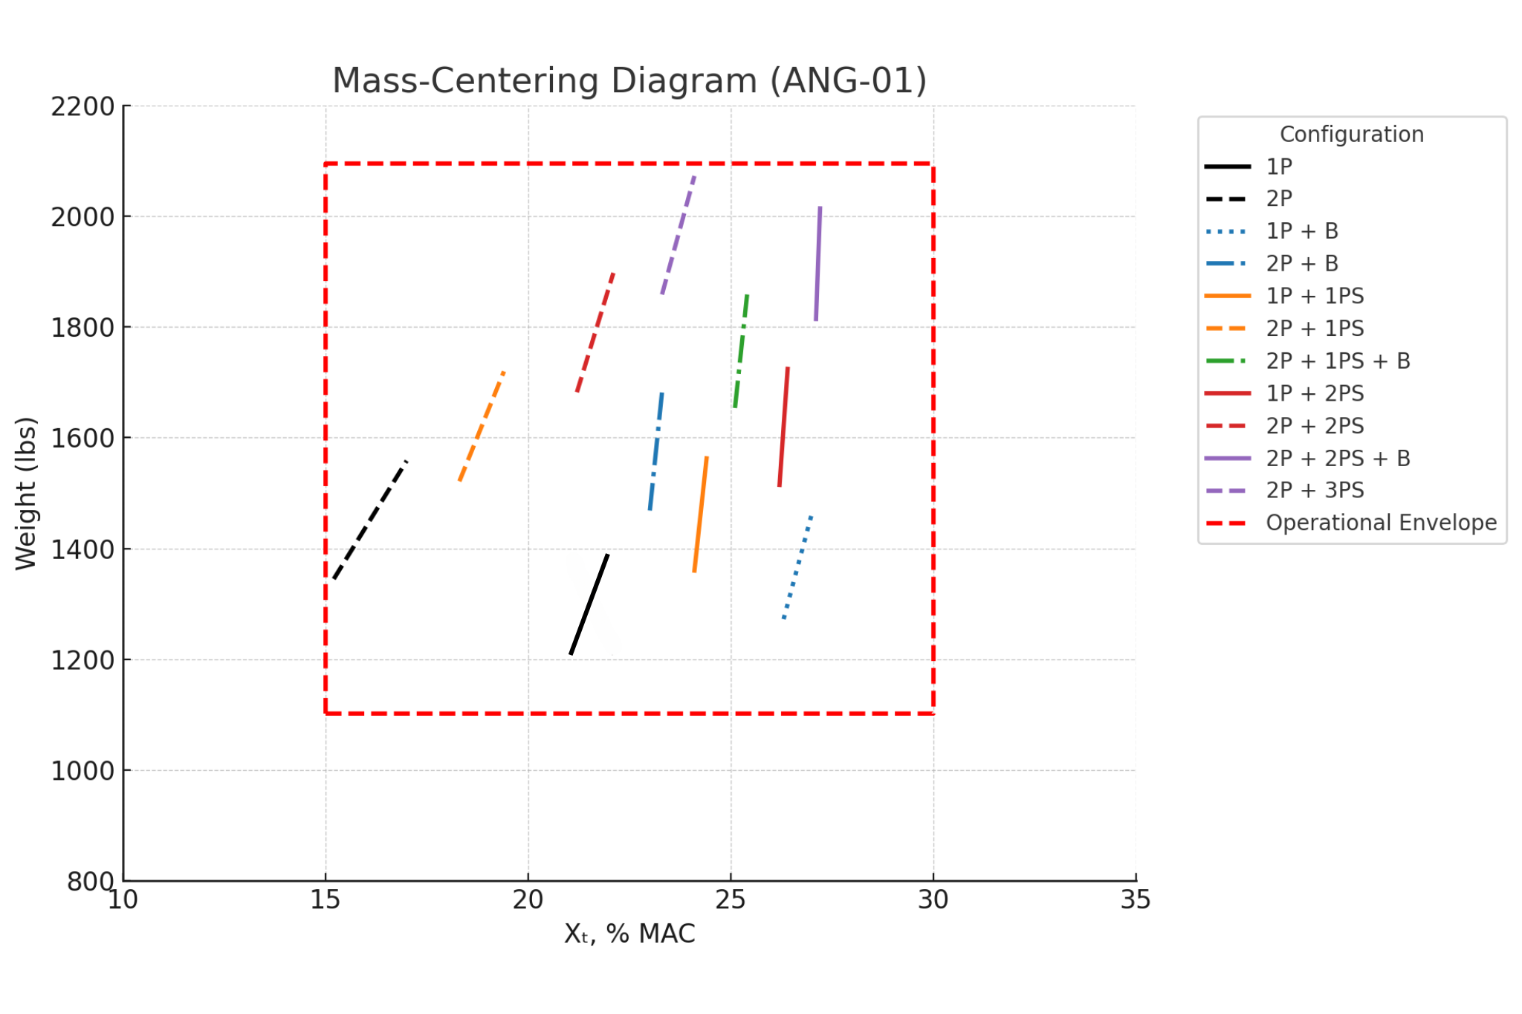

Appendix 2
Determining Weight and Balance
Aircraft _______ Registration No. _______
The ________aircraft was weighed to verify compliance with the design weight and balance data, and to determine the aircraft weight as well as the longitudinal and vertical center of gravity for approved operational configurations, depending on the number of occupants, ballast, and fuel load. This data is also used to calculate all possible in-service aircraft weight and balance configurations within the limits of the approved design and operational weight and balance envelope.
Weighing of the aircraft _______ was carried out indoors (hangar) on a flat hard surface.
Equipment: ____________________________________________________________________________________________________________________________________________________________________________________________________________________________________________________________
The aircraft was set in a horizontal position in pitch and roll, with a laser level set at the following points: the fuselage construction horizontal along the nose of the propeller and tail bayonet (for pitch) and along the root nerves of the left and right wing consoles (for roll).
All landing gear supports were simultaneously placed on a scale (load capacity up to _____ lbf) and the scales were read. A tape measure was used to measure the horizontal distance from the propeller nose to the axis of each corresponding landing gear wheel.
The weight of the empty equipped aircraft (in the weighing configuration) was determined by summing the weight from each landing gear strut, the centering was determined by a well-known method (method of moments), taking into account the above measurements and using the calculated geometric data (see Table 2).

 |  |  |  |  |  |  |  |  |  |  | Table 1
Calculation of the Longitudinal Component of Aircraft Centering in Flight, in % MAC
Load on left main landing gear, lbf |  | Load on right main landing gear, lbf |  | Load on nose landing gear, lbf |  | Distance to main landing gear,  ft. | Distance to nose landing gear,  ft. |  | Total Mass,  lbs. |  | Center of gravity,  % MAC
Aircraft geometry Table 2
Wing incidence angle |  | °
Fuel CG - X coordinate |  | Feet
Fuel CG - Y coordinate |  | Feet
Mean Aerodynamic Chord (MAC) | 3.83 | Feet
Distance from Nose to MAC leading edge (X-axis) |  | Feet
Distance from Reference line to MAC (Y-axis) |  | Feet
Forward CG limit | 16.0 | %MAC
Aft CG limit | 38.0 | %MAC

Weight of objects and equipment: | Weight, lbs. capacity | x, ft. (from cockpit) | Weight*x, lbs*ft. | y, ft. (from CGF) | Weight*y, lbs*ft.
Pilot on the left (seat in middle position). | 170.0
Pilot on the right (seat in middle position). | 170.0
Rear row passenger | 170.0
Rear row passenger | 170.0
Rear row passenger | 170.0
Luggage (in luggage compartment) | 132.3
Fuel (unproduced balance) | 16.5
Total: | 1894
 | Fuel quantity, gal, | Fuel weight, lbf | Total weight, lbs | Longitudinal CG position, %MAC | Lateral CG position, %MAC
 | 0 | 0 | 1894 | 27.9 | 28.5
 | 13.21 | 83.78 | 1977 | 27.9 | 27.3
 | 26.42 | 165.35 | 2059 | 27.9 | 26.2
 | 31.70 | 198.42 | 2092 | 27.9 | 25.8

For all aircraft loading options, please see the chart below:

